Yintao Ling

yintao_ling@compalbn.com

Abstract

The document show the technique about gateway for project – GW7557

Technique IntrO

Software Technique Document

History

|  |  |  |
| --- | --- | --- |
| Version | Author | Release |
| 0.1 | Nelson Chung | First release |
| 0.2 | Yintao Ling | Add chapter 1, 2, 3, 4, 5 |
| 0.3 | Yintao Ling | Complete chapter 1~5 from NTHU reference |
| 0.4 | Yintao Ling | Add portions of chapter 6, 7, 8, 9 |

1. 內容

Background 4

Technique 5

Chapter 1. Introduction 5

Ch.1-1 What is the internet? 5

Ch.1-2 Network Edge 7

Ch.1-3 Network Core 8

Ch.1-4 Network Access and physical media 9

Ch.1-5 Loss and Delay 10

Ch.1-6 Protocol Layers and Their Service Models 11

Chapter 2. Application Layer 13

Ch.2-1 Principles of network and application 13

Ch.2-2 Web and HTTP 15

Ch.2-3 FTP 19

Ch.2-4 SMTP, POP3, IMAP 20

Ch.2-5 DNS 22

Ch.2-6 P2P File Sharing 25

Ch.2-7 Socket Programming with TCP 26

Ch.2-8 Socket Programming with UDP 27

Chapter 3. Transport Layer 28

Ch.3-1 Introduction and Transport-Layer Services 28

Ch.3-2 Multiplexing and Demultiplexing 29

Ch.3-3 Connectionless Transport: UDP 29

Ch.3-4 Principles of Reliable data transfer 30

Ch.3-5 Connection-Oriented Transport: TCP 38

Chapter 4. Network Layer 47

Ch.4-1 Introduction 47

Ch.4-2 Virtual circuit and datagram networks 48

Ch.4-3 What’s Inside a Router 50

Ch.4-4 IP - Internet Protocol 52

Ch.4-5 ICMP – Internet Control Message Protocol 61

Ch.4-6 Routing Algorithms 62

Ch.4-7 Routing in the Internet 64

Ch.4-8 Broadcast and Multicast Routing 66

Chapter 5. The Link Layer: Links, Access Networks, and LANs 70

Ch.5-1 Introduction to the Link Layer 70

Ch.5-2 Error Detection and Error Correction 71

Ch.5-3 Multiple Access Links and Protocols 73

Ch.5-4 Link-Layer Addressing 78

Ch.5-5 Ethernet 78

Ch.5-6 Point to Point Protocols 79

Ch.5-7 Link Virtualization: ATM and MPLS 81

Chapter 6. Wireless Network 86

Ch.6-1 Introduction 86

Ch.6-2 Wireless Links and Network Characteristics 87

Ch.6-3 WiFi: IEEE 802.11 Wireless LANs 88

Ch.6-4 Cellular Internet Access 94

Chapter 7. Multimedia Networking 99

Ch.7-1 Multimedia Networking Applications 99

Ch.7-2 Streaming Stored Video 99

Ch.7-3 Voice-over-IP (VoIP) 99

Chapter 8. Security in Computer Networks 102

Ch.8-1 Operational Security: Firewalls and Instruction Detection Systems 102

Chapter 9. Network devices 107

Ch.9-1 Introduction 107

Ch.9-2 Hubs and Switches 107

Ch.9-3 Network Routers 107

Ch.9-4 Bridges, Gateways and Repeaters 108

Ex. Package or Code Manual 111

Ex. Uncategorized Memo 112

Abbreviation 112

Reference 114

# Background

This is an overview of computer networks for beginners. Beginning with the introduction of Internet structures and jargons, Chapter.1 briefly introduces the main frame of the Internet. According to the main reference we used for this technique document, we describes the structure of protocol layer with TCP/IP foundations, which is 5-layer. Each layer will be introduced from Chapter.2 to Chapter.5.

# Technique

## Introduction

### What is the internet?

The Internet is a computer network that interconnects hundreds of millions of computing devices. These computing devices are called **hosts** or **end systems** such as

PCs, Linux workstations, laptops, smartphones, tablets, TVs, gaming consoles, Web cams, automobiles, etc.

End systems are connected together by a network of **communication links** and

**packet switches**. There are many types of communication links with different transmission rates, called as bandwidth.

When one end system has data to send to another end system, the sending end system segments the data and adds header bytes to each segment. The resulting packages of information, known as **packets**, are then sent through the network to the destination end system, where they are reassembled into the original data.

A packet switch takes a packet arriving on one of its incoming communication

links and forwards that packet on one of its outgoing communication links. The two most remarkable types are routers and link-layer switches.

End systems access the Internet through **Internet Service Providers** (**ISPs**).

Each ISP is in itself a network of packet switches and communication links. ISPs provide a variety of types of network access to the end systems, including residential broadband access such as cable modem or DSL, high-speed local area network access, wireless access, and dial-up modem access.

A **protocol** defines the format and the order of messages exchanged between two or more communicating entities, as well as the actions taken on the transmission and receipt of a message. The **Transmission Control Protocol (TCP)** and the **Internet Protocol (IP)** are two most important protocols in the Internet. The IP protocol specifies the format of the packets that are sent and received among routers and end systems.

It’s important that everyone agree on what each and every protocol does, so that people can create systems that interoperate. This is where standards come into play. **Internet standards** are developed by the Internet Engineering Task Force (IETF). The IETF standards documents are called **requests for comments (RFCs)**. There are currently more than 6,000 RFCs. They define protocols such as TCP, IP, HTTP, and SMTP.

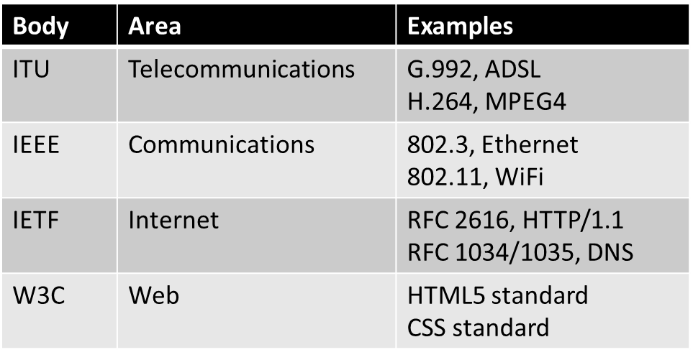

We can describe the Internet as *an infrastructure that provides services to applications*. End systems attached to the Internet provide an **Application Programming Interface (API)** that specifies how a program running on one end system asks the Internet infrastructure to deliver data to a specific destination program running on another end system.

Getting closer look at network structure, network edge is the components of applications and hosts. Network core represents router and network of networks in the internet. Access network or physical media describes communication links between each end systems.

### Network Edge

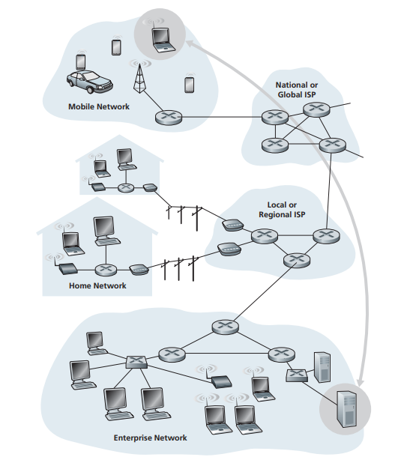

Figure 1-2‑1 Two end systems connect through network

To connect from edge A to edge B, hosts are sometimes further divided into two categories: **clients** and **servers**. Clients tend to be desktop PCs, whereas servers tend to be more powerful machines that store and distribute usable data. Hosts can be connected by each other through **peer-to-peer**, it can minimize the usage of dedicated server, while transfer data from every connected host.

We need a preparation for transferring data between server and client, handshaking is a technique of communication between two entities. It can be found in TCP service. TCP service needs to be reliable, in-order, flow controllable, congestion controllable, but UDP service does not. (More mentions in Ch.3-3 and Ch.3-5)

### Network Core

The network core is mesh of interconnected routers. There are two ways to transfer data through net.

#### Circuit switching and Packet switching

**Circuit switching** is the method that dedicated communication path between two stations. After network circuit established, data starts to transfer through the existed circuit. Their resources are *dedicated* and *no sharing*. A circuit in a link is implemented with either **Frequency-division multiplexing (FDM)** or **Time-division multiplexing (TDM)**. As circuit having low channel utilization, it required devices must transmit and receive at the same data rate.

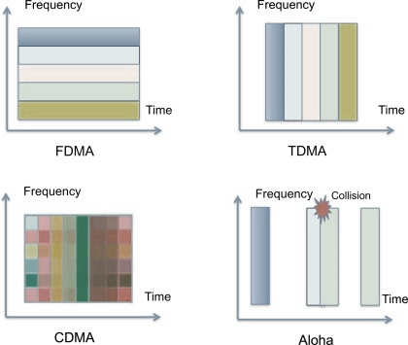

Figure 1-3‑1 Division multiplexing through same bandwidth

**Packet switching** makes end-end data stream divide into packets. Packets transmit randomly through the network until they arrived. Packets from different users share same network resources and use full of bandwidth. If extra packets cannot be transfer through the bandwidth, packets queue need to store the overwhelmed packets and wait for output link.

#### Datagram network and Virtual circuit network

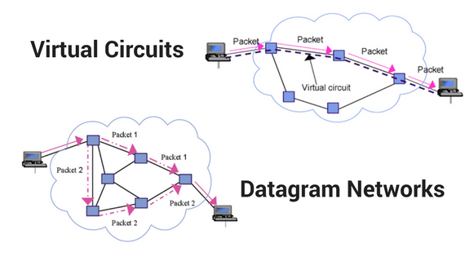

There are two kinds of method for packet forwarding: **datagram** network and **virtual circuit** network. The former determines next hop by destination address, whereas packets can find alternate route and avoid congestion, the latter determines next hop by packet carries tag, which easily to trace the packets state through the transmission.

|  |  |  |
| --- | --- | --- |
| ISSUE | Virtual Circuit | Datagram |
| Addressing | VC number | Sour. & dest. addresses |
| State Information | VC State | None |
| Routing | Fixed, follow route | Route independent |
| Congestion control | Easy (Buffer store state) | Difficult |
| Resource failure | All resource pass through are failure | Single packet loss |
| Suitability | Connected-oriented | Connected-oriented and Connectionless |
| User capacity | Less | More |

### Network Access and physical media

There are several types of network access for residential. Dialup modem can’t surf and phone at the same time; asymmetric digital subscriber line (ADSL) divides different frequencies for upstream, downstream and phone; cable modem uses cable and fiber attaching home to ISP router.

**Local area network (LAN)** connects end system to routers. Ethernet provide shared or dedicated link connects. Wireless area network provide access point for connection without wire. 802.11b, 802.11g and 802.11n are common sets of IEEE standards that govern wireless networking transmission methods for small area wireless access.

Physical media can be separate into guided media or unguided media. Twisted Pair is often used for phone and in purpose for reducing electromagnetic radiation. Coaxial cable is bidirectional. Fiber optic cable provides high-speed operation and is not affected by electromagnetic noise, which causes low error rate.

Radio is one kind of unguided media, which is omnidirectional and propagated by environment effects. There are several links of radio: terrestrial, LAN, wide-area and satellite.

### Loss and Delay

Most packet switches use **store-and-forward transmission** at the inputs to the

links. When packet arrival rate to link exceeds output link capacity, packet will stay in queue and wait for turn. When packet arrives to full queue, packet will be dropped, it called as packet loss. Lost packet may be retransmitted by previous node, or not retransmitted at all.

Delay occurred through four type of processing.

* Model processing: checking bit errors, determine output link.
* Queueing: waiting for output link transmission, congestion level of router.

queue delay is packet length*average packet arrival rate/link bandwidth.

* Transmission delay: packet length per link bandwidth.
* Propagation delay: physical link per propagation speed.

Every nodal delay is the sum of all kinds of delay in this article, and the message delay from A to B will check for all nodal the packets been through.

To get a hands-on feel for end-to-end delay in a computer network, we can make use of the Traceroute program. Traceroute is a simple program that provide delay measurement from source to router along end-end Internet path towards destination.

### Protocol Layers and Their Service Models

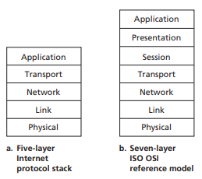

Figure 1-6‑1 Five-layer Internet protocol stack and seven-layer ISO OSI reference model

A layered architecture allows us to discuss a well-defined and complex system. As long as the layer provides the same service to the layer above it, and uses the same services from the layer below it, the remainder of the system remains unchanged when a layer’s implementation is changed. Changing the implementation of a service without affecting other components of the system is important advantage of layering.

Take a look at Figure 1-6‑1, on the left side is a standard protocol stack for Internet. The top of stack supports network application, including FTP, SMTP, HTTP, etc. Transport layer describes the format for data transferring from host to host, such as TCP, UDP. Network layer shows routing of datagrams from source to destination, e.g., IP, routing protocols. Link layer represents network elements between neighboring network, like Point-to-point protocol (PPP), Ethernet. Physical layer can be bits on the wire.

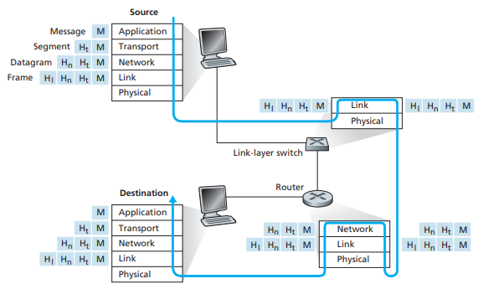

Figure 1-6‑2 Simulating network environment. Each contains a different set of layers.

Figure 1-6‑2 illustrates the concept of **encapsulation**. At the sending host, an **application-layer message** (M in Figure 1-6‑2) is passed to the transport layer. The transport layer takes the message and appends additional information (transport-layer header information, Ht in Figure 1-6‑2). The application-layer message and the transport-layer header information together constitute the **transport-layer segment**.

The transport-layer segment thus encapsulates the application-layer message. The added information might include the receiver-side information and error-detection bits. The transport layer then passes the segment to the network layer, which adds network-layer header information (Hn in Figure 1-6‑2) such as source and destination end system addresses, creating a **network-layer datagram**. The datagram is then passed to the link layer, which will add its own link-layer header information and create a **link-layer frame**.

In conclusion, we can see that at each layer, a packet has two types of fields: **header fields** and a **payload field**. The payload is typically a packet from the layer above.

## Application Layer

### Principles of network and application

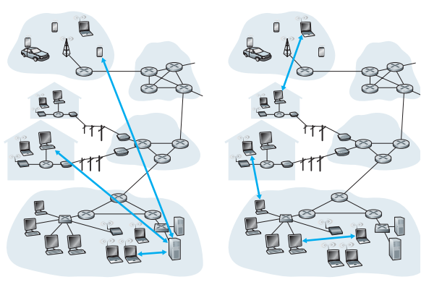

Figure 2-1‑1 Client-server architecture and peer-to-peer architecture

The application architecture is designed by the application developer and dictates how the application is structured over the various end systems. The two predominant architectural model used in modern network applications are the **client-server architecture** and the **peer-to-peer (P2P) architecture**.

In a client-server architecture, there is an always-on server, which services requests from other clients. The server has a well-known fixed IP address. When a server receives a request from a client host, it responds by sending the requested object to the client host. Clients do not directly communicate with each other. A large data center is often formed by several servers, in order to capable of keeping up with all requests from clients.

In a P2P architecture, there is minimal or no reliance on dedicated servers. Instead the application exploits direct communication between pairs of connected hosts, called peers. The advantages of P2P architectures are self-scalability and cost effective. But it can be challengeable to be *ISP Friendly, Secure* and *incentive.*

The process that initiates the communication is labeled as the client. The process that waits to be contacted to begin the session is the server. A process sends messages into, and receives messages from, the network through a software interface called a **socket**.

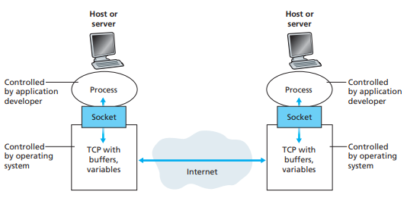

Figure 2-1‑2 Client-server architecture and peer-to-peer architecture

In Figure 2-1‑2, *socket is the interface between the application layer and the transport layer, as the Application Programming Interface (API)*. However, the application developer has little control of the transport-layer side of the socket. The only control that the application developer has on the transport-layer side is (1) the choice of transport protocol and (2) perhaps the ability to fix a few transport-layer parameters. Once the application developer chooses a transport protocol, the application is built using the transport-layer services provided by that protocol. Some application needs certain requirements from transport-layer service: data loss, timing and bandwidth.

After knowing the interface between application layer and transport layer, process need to record to a particular destination, a **certain address**. For example, an IP address is a 32-bit binary numbers that identifying the host. The receiving socket must also indicate to the identified host as many network applications running in the same host. It is the purpose of the **destination port**. For example, the port of HTTP is number 80. The TCP/IP port numbers below 1024 are special in that normal users are not allowed to run servers on them.

### Web and HTTP

A web page consists of objects, such as HTML, image file, audio file, etc., which are referenced different objects with objects’ URLs from the base HTML file.

HTTP is client-server architecture and using TCP port 80. HTTP is also stateless that servers maintain no information about past clients request.

HTTP connections are categorized into **non-persistent** **connection** and **persistent connection**. Non-persistent connection restricts *at most one object in one TCP connection*. Thus, if one Web page consists of a base HTML file and 10 JPEG images, 11 TCP connections are generated. Persistent connection leaves TCP connection open after three-way handshake is complete. Subsequent HTTP messages between same server and client are sent over the open connection.

To estimate the amount of time that elapses from when a client requests the base HTML file until the entire file is received by the client. We define the round-trip time (RTT), which is the time it takes for a small packet to travel from client to server

and then back to the client.

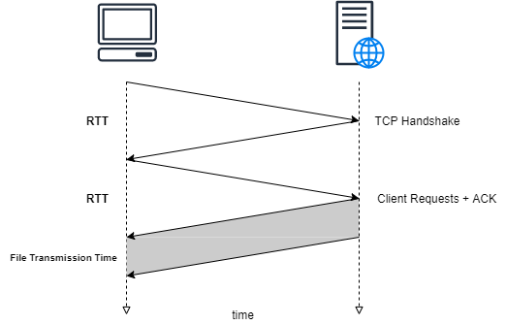

Figure 2-2‑1 Round-trip time between client and server

In Figure 2-2‑1, the first two parts of the three-way handshake take one RTT. After completing the first two parts of the handshake, the client sends the HTTP request message combined with the third part of the three-way handshake into the TCP connection.

Once the request message arrives at the server, the server sends the HTML file into the TCP connection. This HTTP request/response eats up another RTT. Thus, the total response time is two RTTs plus the file transmission time.

For non-persistent connection, each and every request must run for all sequences, which takes N*(2RTT + file Transmission Time). Meanwhile, persistent connection only takes RTT+N*(RTT + file Transmission Time). It can be much faster if persistent connection is pipelining.

Let’s take a look at HTTP message format. The HTTP specifications [RFC 1945; RFC 2616] include the definitions of the HTTP message formats. There are two types of HTTP messages, request messages and response messages.

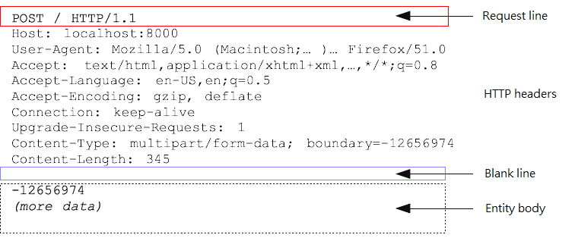

Figure 2-2‑2 HTTP request message format

Let’s take a look at the request message. The request line has three fields: the method field, the URL field, and the HTTP version field. The method field can take on several different values, including GET, POST, HEAD, PUT, etc. The version is self-explanatory; in this example, the browser implements version HTTP/1.1.

The header line is useful because server can send different versions of the same object to different types of user agents. Some information is required by Web proxy caches. The entity body is filled with data from client—for example, when a user provides search words to a search engine.

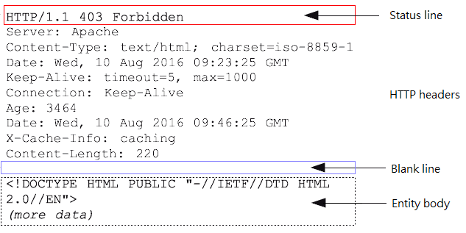

Figure 2-2‑3 HTTP response message format

In response message, the status line has three fields: the **protocol version** field, **a status code**, and a **corresponding status message**. In this example, protocol version is HTTP/1.1 and message is “Forbidden”, which status code is 403. The header lines show the information about response, e.g., servers, date, types, etc. The entity body is the meat of the message—it contains the requested object itself.

It is often desirable for a website to identify users. For these purposes, HTTP uses cookies. Cookies, defined in [RFC 6265], allow sites to keep track of users. Cookie technology has four components:

* a cookie header line in the HTTP response message;
* a cookie header line in the HTTP request message;
* a cookie file kept on the user’s end system and managed by the user’s browser;
* a back-end database at the website.

Each user will be distributed unique ID numbers. Server creates an entry in backend database according to ID. Thus, server can permit sites to users or gather information from users. It is helpful to ensure the authorization between server and client. Some website can analyze what users like and give advice to what they might want by cookies.

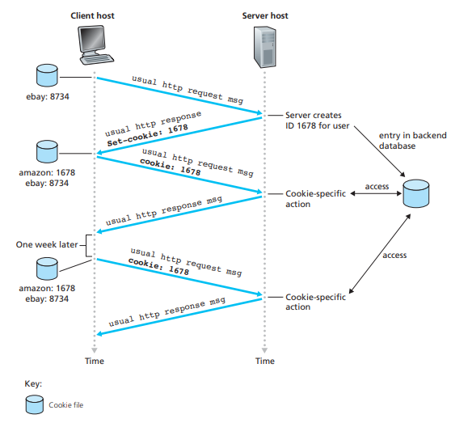

Figure 2-2‑4 Keep user state with cookies

To satisfy client request without involving origin server, which sometimes gives tremendous loads to origin server, Web caches is a network entity that satisfies HTTP

requests on the behalf of an origin Web server. A Web cache—also called a proxy server—has its own disk storage and keeps copies of recently requested objects in this storage. A cache is both a server and a client at the same time. Typically a Web cache is purchased and installed by an ISP.

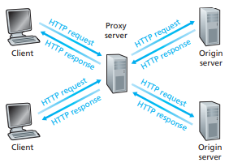

Figure 2-2‑5 A Web proxy server

Web caching has seen deployment in the Internet for two reasons. First, a Web

cache can substantially reduce the response time for a client request. Second, Web caches can substantially reduce traffic on an institution’s access link to the Internet, thereby improving performance for all applications.

### FTP

FTP, the **file transfer protocol**, is defined in [RFC 959]. This application support clients to transfer file to/from remote host. Client contact FTP server at port 21, sending message over control connection such as obtaining authorization with username and password, commands for browsing directory. Once the server receives a command from a client, it opens a data connection on port 20 to a port that is available for user, transferring one file per one connection.

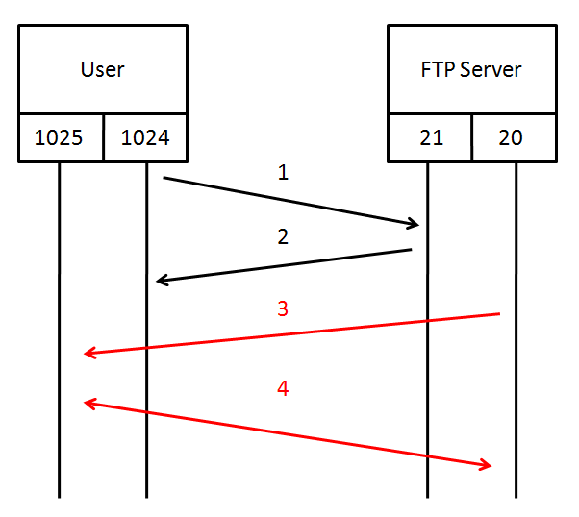

Figure 2-3‑1 FTP Active mode

There are two different modes in FTP: active mode or passive mode. The difference between two is the direction that arrow 3 and 4 in the Figure.

Sample commands over control channel are sent as ASCII text, e.g., USER, PASS, LIST, RETR, STOR. Similarly, FTP servers return the status or phrase code for different command results.

### SMTP, POP3, IMAP

There are three major components of a mail system: user agents, mail servers and **simple mail transfer protocol (SMTP)**. User agents are also known as mail reader, composing, editing and reading mail messages that stored on the mail server. Mail servers can be broke down into two categories by the direction of mail messages: **mailbox** or **message queue**. Mailbox contains incoming messages for the users as message queue holds outgoing messages and attempts to transfer them later.

As with most application-layer protocols, SMTP has two sides: a client side, which executes on the sender’s mail server, and a server side, which executes on the recipient’s mail server. It uses TCP to reliably transfer message from client to server at port 25.

As SMTP, defined in RFC 5321, is much older than HTTP, its archaic characteristics restrict all mail messages to simple 7-bit ASCII. As a result, it requires binary multimedia data to be encoded to ASCII before being sent over SMTP and be decoded back to binary after SMTP transport.

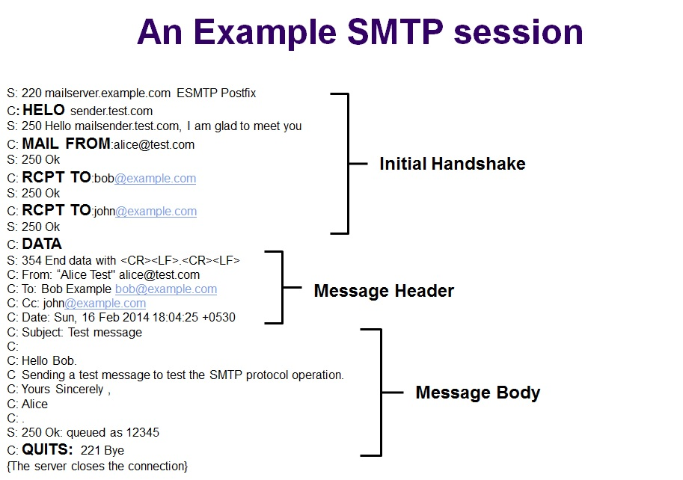

Figure 2-4‑1 Sample SMTP interactions

We defined the message format in [RFC 822]. Message header includes multiple envelope information, and message body only takes ASCII characters data.

There is an extension to SMTP that called **Multipurpose Internet Mail Extensions (MIME)**. Defined in [RFC 2045] and [RFC 2056], these additional lines in MIME content type can be added into the message header to declare more data in the messages, including text, image, audio, video, etc.

Once SMTP delivers the message from sender to receiver, the message is placed in recipient’s mailbox. As SMTP is a push operation, recipient has to find other methods to transfer the mail from mailbox to one’s own PC. It can be completed by introducing mail access protocols, including **Post Office Protocol—Version 3 (POP3)**, **Internet Mail Access Protocol (IMAP)**, and HTTP.

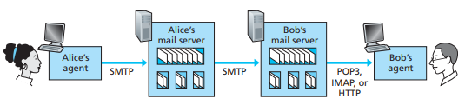

Figure 2-4‑2 E-mail protocols and their communicating entities

Let’s start at POP3. POP3 is an extremely simple mail access protocol, defined in [RFC 1939]. POP3 begins when the user agent opens a TCP connection to the mail server on port 110. With the TCP connection established, POP3 progresses through three phases: *authorization*, *transaction*, and *update*.

During the first phase, the user agent sends a username and a password to authenticate the user. During the second phase, transaction, the user agent retrieves messages, obtains mail statistics, and mark the messages for deletion. The third phase, update, occurs after ending the POP3 session; at this time, the mail server deletes the messages that were marked for deletion.

A problem with this download-and-delete mode is that the recipient may want to access his mail messages from multiple machines. When you retrieve new messages from a POP3 email account, the messages are deleted from the POP3 mail server and then saved on the computer that you are using. Because the message is no longer on the POP3 mail server, you can’t see it when you connect from another computer.

To solve this and other problems, the IMAP protocol, defined in [RFC 3501],

was invented. The IMAP protocol provides commands to allow users to create folders, move messages and search messages by keyword. It also has commands to obtain components of messages with a low-bandwidth connection.

### DNS

**Domain name system (DNS)** is a distributed database implemented in hierarchy of many name servers. It not only prevents the risk of single point failure but easily maintain. It is an application-layer protocol that allow hosts, routers, name servers to communicate to resolve names. There are several services provided by DNS: hostname to IP translation, host aliasing, mail server aliasing and load distribution.

In order to deal with the issue of scale, the DNS uses a large number of servers,

organized in a hierarchical fashion and distributed around the world. There are

three classes of DNS servers—*root DNS servers, top-level domain (TLD) DNS*

*servers, and authoritative DNS servers*— as shown in Figure 2-5‑1.

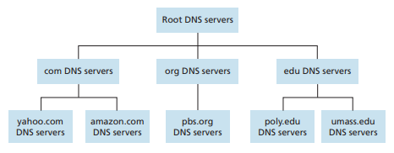

Figure 2-5‑1 Portion of the hierarchy of DNS servers

Fully Qualified Domain Name (FQDN)—also called as absolute domain name—is a domain name that specifies its exact location in the tree hierarchy of the DNS. By using FQDN, we can identify a host’s position from Root of the DNS namespace. Differenced from FQDN, Partially Qualified Domain Name (PQDN) starts with a host name, but it may not reach up to the root.

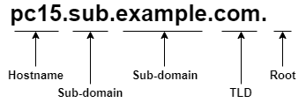

Figure 2-5‑2 A Fully Qualified Domain Name

Another important server is called local name server, which is not strictly belong to hierarchy. Each ISP has one of it. When a DNS query was made, query is sent to its local DNS server as a proxy server.

Query searching has two types of its behaviors: **iterative** or **recursive**. Iterative queries contact servers and wait for replies with name of server; Recursive queries put burden of name resolution on contacted name servers.

Once name server learns mapping, it can cache the mapping in its local memory. DNS caches improve the delay performance and to reduce the number of DNS messages ricocheting around the Internet.

The DNS servers that together implement the DNS distributed database store

**resource records** **(RRs)**, including RRs that provide hostname-to-IP address mappings. A resource record is a four-tuple that contains the following fields:

*(Name, Value, Type, TTL)*

The name field and the value field are decided by the type field. There are 4 kinds of records type: A, NS, CNAME and MX. A type A record is to map hostname into IP address; NS records tell how to obtain the IP addresses from name servers for hosts in the domain; CNAMEs record provide querying hosts the canonical name for a hostname; MX records allow the hostnames of mail servers to have simple aliases.

The TTL field is used for DNS cache. Time to Live (TTL) is the time to live of the resource record; it determines when a resource should be removed from a cache.

$TTL 3600 ; 1 hour

example.org. IN SOA ns1.example.org. admin.example.org. (

2006051501 ; Serial

10800 ; Refresh

3600 ; Retry

604800 ; Expire

86400 ; Minimum TTL

)

; DNS Servers

@ IN NS ns1.example.org.

@ IN NS ns2.example.org.

; MX Records

@ IN MX 10 mx.example.org.

@ IN MX 20 mail.example.org.

@ IN A 192.168.1.1

; Machine Names

localhost IN A 127.0.0.1

ns1 IN A 192.168.1.2

ns2 IN A 192.168.1.3

mx IN A 192.168.1.4

mail IN A 192.168.1.5

; Aliases

www IN CNAME @

Example of DNS resource record

After knowing DNS records, query message plays a critical role of transferring information. Both query and reply messages have the same format, as shown in Figure 2-5‑2.

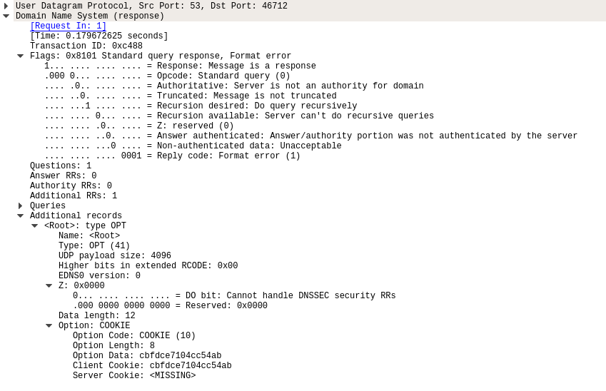

Figure 2-5‑3 A sample of DNS reply query

The first field is a 16-bit number that identifies the query, in this example, 0xc488. This identifier is copied into the reply message to a query, allowing the client to match received replies with sent queries.

There are a number of flags in the flag field, some of them shows the setting on the DNS server, the others indicate the information from the query. Further details are shown in the Figure 2-5‑2.

In the header, there are also four number-of fields. These fields indicate the number of occurrences of the four types of data sections that follow the header:

the question section contains information about the query that is being made;

the answer section contains the resource records for the name that was originally queried; the authority section contains records of other authoritative servers; the additional section contains other helpful records.

### P2P File Sharing

File distribution is a nice place to start our investigation of P2P, as it exposes the self-scalability of P2P architectures.

Consider a natural application, namely, distributing a large file from a single server to a large number of hosts. The server must send a copy of the file to each of the peers—placing an enormous burden on the server and consuming a large amount of server bandwidth. Each peer can redistribute any portion of the file it has received to any other peers, thereby assisting the server in the distribution process.

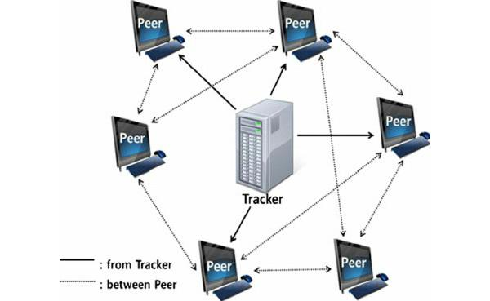

Figure 2-6‑1 BitTorrent structure

For example, BitTorrent is a popular P2P protocol for file distribution. There is a **tracker server** keeps track of where file copies reside on peer machines, which ones are available at time of the client request, and helps coordinate efficient transmission and reassembly of the copied file. Clients that have already begun downloading a file communicate with the tracker periodically to negotiate faster file transfer with new peers, and provide network performance statistics. After the initial peer-to-peer file download is started, peer-to-peer communication can continue without the connection to a tracker.

However, numbers problems have been found in a centralized server. Although file transferring progress is fully decentralized, locating content is still highly centralized. The centralized server like tracker servers may cause **single point of failure**, **performance bottleneck** and being punished for **copyright infringement**.

In order to fix the problem from tracker servers, we’ll consider to build a distributed, P2P version of this database that will store the (key, value) pairs over millions of peers. Each peer will only hold a small subset of the totality of the (key, value) pairs. Any peer can locate the peers that have the corresponding (key, value) pairs and return the key-value pairs with a particular key. Also, any peer will also be allowed to insert new key-value pairs into the database. It is referred to as a **distributed hash table (DHT)**.

### Socket Programming with TCP

Socket is a host-local, application-created and OS-controlled interface into which application process can both send and receive messages to/from another application. It is a door between user application and operating system.

Socket API has two types of transport service: **unreliable datagram** and **reliable, byte stream-oriented**. TCP service is the latter one. Client communicates with server by TCP socket in the transports layer. The TCP interaction between server and client is shown as Figure 2-7‑1.

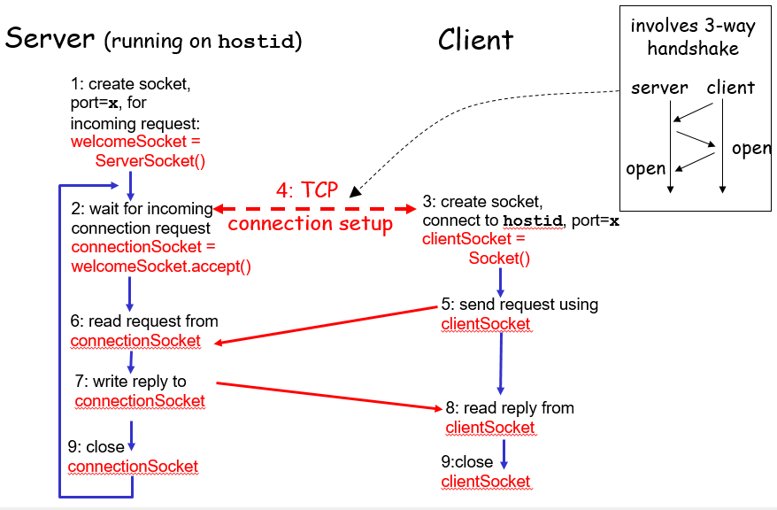

Figure 2-7‑1 Socket operation with TCP

### Socket Programming with UDP

There is no connection between client and server, therefore UDP socket may be received out of order or lost. Both server and client are listening to the socket request, responding to the request if they get one. The UDP interaction between server and client is shown as Figure 2-8‑1.

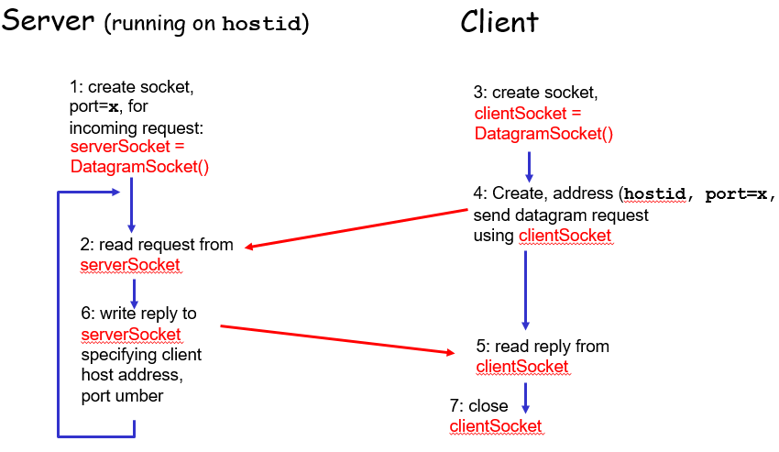

Figure 2-8‑1 Socket operation with UDP

## Transport Layer

### Introduction and Transport-Layer Services

A transport-layer protocol provides for **logical communication between application processes** running on different hosts. Transport-layer protocols are implemented in the end systems but not in network routers.

On the sending side, the transport layer converts the application-layer messages into transport-layer segments. It is done by breaking the application messages into smaller chunks and adding a transport-layer header to each chunk. The segment is then passed to the network layer at the sending end system and encapsulated within a network-layer packet and sent to the destination.

On the receiving side, the network layer extracts the transport-layer segment from the datagram and passes it up to the transport layer. The transport layer then processes the received segment, making the data in the segment available to the receiving application.

If transport-layer protocols, for example—TCP and UDP, are available to network applications, these protocols have to guarantee the functions will be executed properly and the errors will be detected. Transport-layer protocols must do these four principal functions: *multiplexing/demultiplexing, reliable data transferring, flow control* and *congestion control*.

### Multiplexing and Demultiplexing

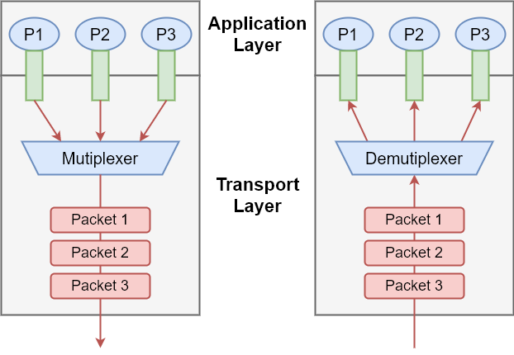

Figure 3-2‑1 Multiplexing and demultiplexing in transport layer

Transport layer in receiver’s host gathers chunks of data it receives from different sockets and encapsulate them with transport headers. Passing these resulting segments to the network layer is called **multiplexing**. Meanwhile, the reverse process which is delivering data to the correct socket by the transport layer is called **demultiplexing**.

Each segment have special fields that indicate the correct socket to which the segment is to be delivered. These special fields are the **source port number** field and the **destination port number** field. Each port number is a 16-bit number, ranging from 0 to 65535. The port numbers ranging from 0 to 1023 are called well-known port numbers and are restricted. The list of well-known port numbers is given in [RFC 1700] and is updated at http://www.iana.org [RFC 3232].

### Connectionless Transport: UDP

**User Datagram Protocol (UDP)**, defined in [RFC 768], does just the multiplexing and demultiplexing function and some light error checking as a transport protocol.

UDP takes messages from the application process, attaches source and destination port number fields for the multiplexing/demultiplexing service, adds two other small fields, and passes the resulting segment to the network layer. The network layer encapsulates the transport-layer segment into an IP datagram and then makes a attempt to deliver the segment to the receiving host.

If the segment arrives at the receiving host, UDP uses the destination port number to deliver the segment’s data to the correct application process. There is no handshaking with UDP between sending and receiving transport-layer entities before sending a segment. For this reason, UDP is said to be connectionless.

Many applications are better suited for UDP than TCP for the following reasons:

* **No connection establishment**: UDP does not use a three-way handshake and not introduce any delay to establish a connection.
* **No connection state**: UDP does not maintains connection state, including buffers, congestion-control parameters, and sequence and acknowledgment number parameters. This is one of reasons an application can typically support more active clients.
* **Small packet header overhead**: The TCP segment has 20 bytes of header overhead, whereas UDP has only 8.
* **No congestion control**: UDP can blast away as fast as desired.

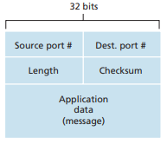

Figure 3-3‑1 UDP segment structure

The UDP segment structure, shown in Figure 3-3‑1, is defined in [RFC 768]. The application data occupies the data field of the UDP segment. The UDP header has only four fields, each consisting of two bytes. The **port numbers** identity the correct process. The **length** field specifies the number of bytes in the UDP segment (header plus data).

The last field is **checksum**. It can detect whether errors have been introduced into the segment. By adding each group of 2-byte length header, data and length of the segment, its 1s’complement must match to the checksum number.

### Principles of Reliable Data Transfer

The problem of implementing reliable data transfer occurs not only at the transport layer, but also at the link layer and the application layer.

This task is made difficult by the fact that the layer below the **reliable data transfer (rdt) protocol** may be unreliable. For example, TCP is a reliable data

transfer protocol that is implemented on top of an unreliable (IP) end-to-end network layer. When the underlying channel can corrupt bits or lose entire packets, the underlying channel will not reorder packets as it is unreliable.

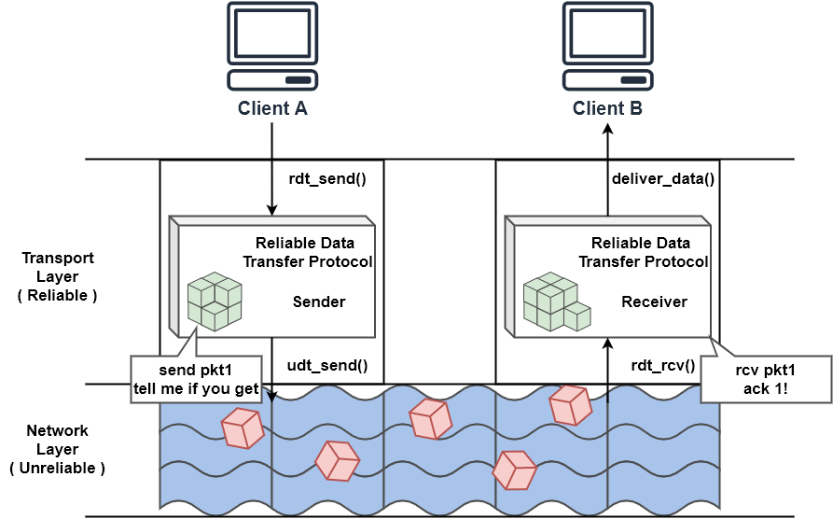

Figure 3-4‑1 Reliable data transfer protocol in transport layer

Figure 3-4‑1 illustrates the interfaces for our data transfer protocol. The sending side of the data transfer protocol will be invoked from above by a call to *rdt_send()*. It will pass the data to be delivered to the upper layer at the receiving side. On the receiving side, *rdt_rcv()* will be called when a packet arrives from the receiving side of the channel. When the rdt protocol wants to deliver data to the upper layer, it will do so by calling *deliver_data()*. Both the send and receive sides of rdt send packets to the other side by a call to udt_send().

Building a reliable data transfer protocol that fixed problems with bit errors and loss of packets, we have to add some control info for the error detection: **acknowledgements (ACKs)**, telling sender that receiver got the no-error packet or asking for a new packet because of the incorrect packet; mark the packet with a **sequential number** avoids duplicating packet during retransmission. Here is the finite-state machines for sender’s rdt protocol and receiver’s rdt protocol.

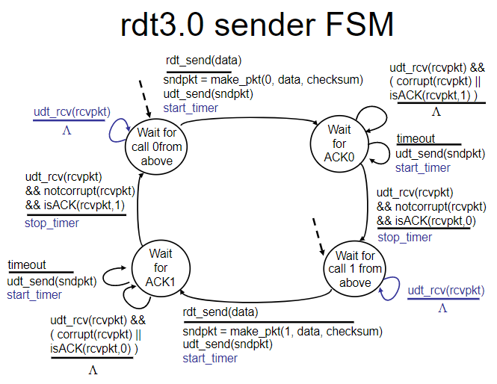

Figure 3-4‑2 Sender's finite-state machine of rdt3.0

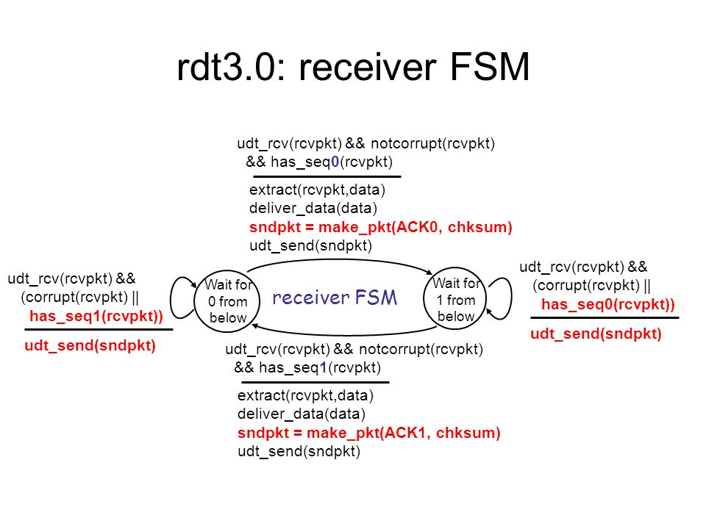

Figure 3-4‑3 Receiver's finite-state machine of rdt3.0

Or we can just found out how the protocol operates with no lost or delayed packets and how it handles lost data packets in Figure 3-4‑4. 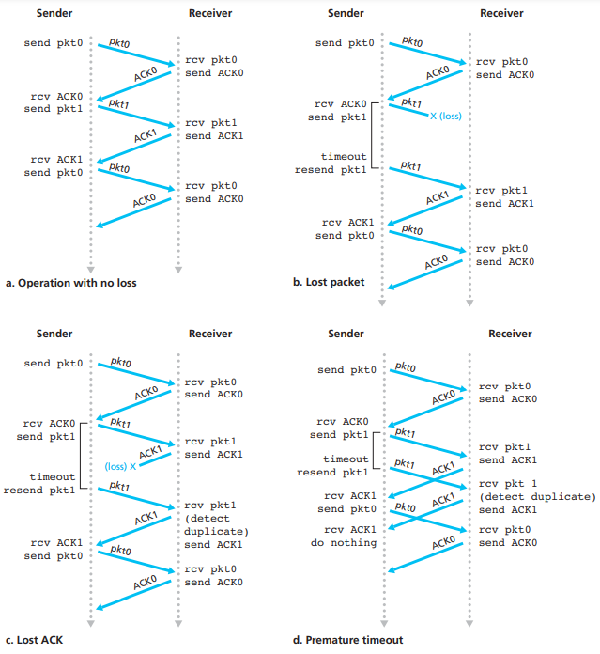

Figure 3-4‑4 Operation of rdt3.0

The 3.0 version of rdt protocol may now solve the problems of packet transfer in unreliable channel, but the performance stinks because network protocol limits use of physical resources. *The stop-and-wait protocol only process one packet per connection*. Introducing **pipelining**, its sending progress allow more yet-to-be-acknowledged packets at the same time. This technique has the following consequences for reliable data transfer protocols:

* *Sequence numbers must be increased*, since each in-transit packet must have a unique sequence number.
* The sender will have to *buffer packets* that have been transmitted but not yet acknowledged. Buffering of correctly received packets may also be needed at the receiver.

The range of sequence numbers needed and the buffering requirements will depend on the manner in which a data transfer protocol responds to lost, corrupted, and overly delayed packets. Two basic approaches toward pipelined error recovery can be identified: Go-Back-N and selective repeat.

#### Go-Back-N Protocol

In a **Go-Back-N (GBN) protocol**, the sender is allowed to transmit multiple packets without waiting for an acknowledgment. But before reading on, the interactive animation6 at the reference Website is a useful aid for comprehension.

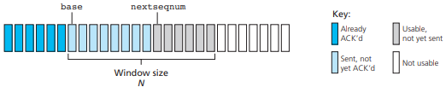

Figure 3-4‑5 Sender's view of sequence numbers

In Figure 3-4‑5, we define *base* to be the sequence number of the oldest unacknowledged packet and nextseqnum to be the smallest unused sequence number. Four intervals in the range of sequence numbers can be identified.

* [0, base-1] packets have already been transmitted and acknowledged.
* [base, nextseqnum-1] packets have been sent but not yet acknowledged.
* [nextseqnum, base+N-1] packets can be sent immediately.
* [base+N, ~] packets cannot be used until window opened.

The range of permissible sequence numbers for transmitted but not yet acknowledged packets can be viewed as a window of size N. N is often referred to as the window size and the GBN protocol itself as a sliding-window protocol.

Now we can program the packet events between sender and client.

The GBN sender must respond to three types of events:

* **Invocation from above**. The sender first checks to see whether the window is full or not. A packet is created and sent if the window is not full, or it may be returned back to the upper layer, resembling to try again later.
* **Receipt of an ACK**.
* **A timeout event**. If an ACK is received but there are still additional transmitted but not yet acknowledged packets, the timer is restarted. If there are no outstanding, unacknowledged packets, the timer is stopped.

The receiver’s actions in GBN are also simple. If a packet with sequence number n is received correctly and ***is in order***, the receiver sends an ACK for packet n and delivers the data portion of the packet to the upper layer. In all other cases, the receiver discards the packet and resends an ACK for the most recently received in-order packet.

Note that *if packet k has been received and delivered, then all packets with a sequence number lower than k have also been delivered*. Because all of the packets must be sent in order.

In our GBN protocol, the receiver discards out-of-order packets. Suppose now that packet n is expected, but packet n + 1 arrives. If packet n is lost, both it and packet n + 1 will eventually be retransmitted as a result of the GBN retransmission rule at the sender. The advantage of this approach is the simplicity of receiver buffering. The only piece of information the receiver need maintain is the sequence number of the next in-order packet.

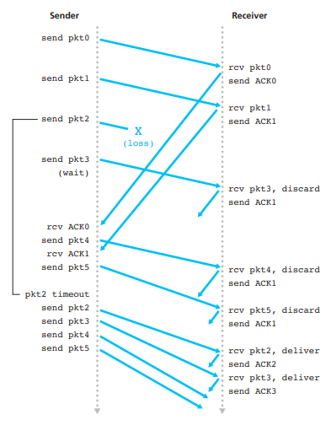

Figure 3-4‑6 Go-Back-N in operation

Take a look at an example of GBN protocol operation in Figure 3-4‑6.

Assumed the window size limitation from sender is 4, the sender sends out packets [0-3] and then wait for their acknowledged signals. As each successive ACK (for example, ACK0 and ACK1) is received, the window slides forward and the sender can transmit one new packet (pkt4 and pkt5, respectively).

On the receiver side, packet 2 is lost. So all of the packets the sequence numbers are larger than 2 are discarded. Without receiving the ACK2 signal from the receiver, the sender then retransmits from packet 2.

In conclusion, as all of the packets are in order, sender will sends out the packet from the minimal number that reported by receiver; Receiver will reports the packet with the maximum number that got from sender.

#### Selective-Repeat Protocol

However, a single packet error can thus cause GBN to retransmit a large number of packets. For example, sender may think the packets whose numbers are larger than send_base are lost during the sending process. But in the real situation, packets are received by receiver but the ACK packets are lost during the acknowledge process.

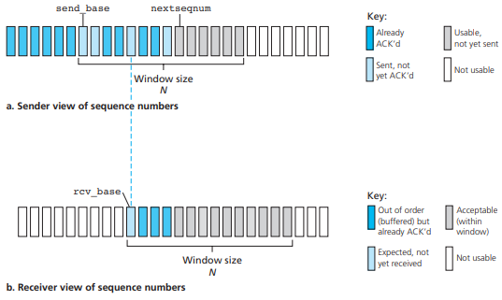

Figure 3-4‑7 Views of SR protocols

Selective-repeat protocols (SR) avoid unnecessary retransmissions by having the sender retransmit only those packets that it suspects were received in error at the receiver.

The SR receiver will acknowledge a correctly received packet whether or not it

is in order. Out-of-order packets are buffered until any missing packets are received, compared with GBN protocol, which discards out-of-order packets. Window is needed on the receiver’s side to upper bound the packet buffer size.

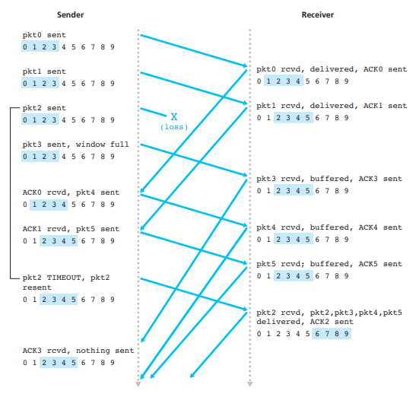

Figure 3-4‑8 SR protocol in operation

Figure 3-4‑8 illustrates the operation on SR protocol. 4 numbers are highlighted in both number sequences from sender and receiver represents the window for acceptable buffer queue. The location of window on sender side is decided by the minimal number of packet that is sent and acknowledged. The other window on receiver side is located at the expected but unreceived packet number.

Same example, shown as the GBN explanation, gets different responding from SR protocol. Besides to discard the packets from sequence number 2, the receiver on SR protocol buffers the packet 3 through 5 and wait for the packet 2 to be received. It can get rid of the retransmission process of sent-and-received packets.

Both protocols follow the rules by the window size, so how large should a window be? To prevent the dilemma that receiver can see no differences between retransmitted packet or new sending packet by the same sequence number, the total size of sequence numbers must be larger than the one of window. As Figure, the size of sequence numbers are 10 and the size of window are 4.

### Connection-Oriented Transport: TCP

Transmission Control Protocol (TCP) – a connection-oriented communications protocol that facilitates the exchange of messages between computing devices in a network. There are some characteristics about TCP:

* Unicast: TCP involves just one sender and one receiver.
* Reliable, in-order byte steam: Based in byte means no message boundary.
* Pipelined: Window size is set by TCP congestion and flow control.
* Buffer Transferable
* Full duplex data: Data flow in same connection is bidirectional.
* Connection-oriented: Handshaking initiate sender and receiver states before data exchange.
* Flow controllable: Sender will not overwhelm receiver.

#### TCP Segment Structure

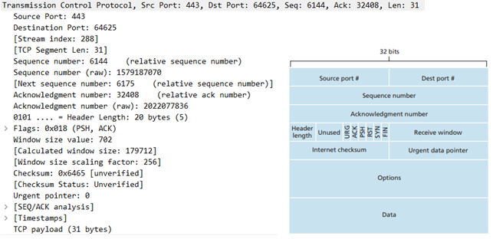

Figure 3-5‑1 TCP segment structure and example

Figure 3-5‑1 shows the structure of the TCP segment and an actual TCP segment.

A TCP segment header also contains the following fields:

* **Source and destination port numbers**, which are used for multiplexing/demultiplexing data from/to upper-layer applications.
* The header includes a **checksum** field as with UDP.
* The 32-bit **sequence number** field and the 32-bit **acknowledgment** number field are used by the TCP sender and receiver in implementing a reliable data transfer service.
* The 16-bit **receive window** field is used for flow control. It is used to indicate the number of bytes that a receiver is willing to accept.
* The 4-bit **header length** field specifies the length of the TCP header in 32-bit words. The TCP header can be of variable length due to the TCP options field.
* The optional **options** field is used when a sender and receiver negotiate the maximum segment size (MSS).
* The flag field contains 6 bits.
  + The **ACK** bit is used to indicate that the value carried in the acknowledgment field is valid.
* The **RST**, **SYN**, and **FIN** bits are used for connection setup and teardown.
* The **PSH** bit indicates that the receiver should pass the data to the upper layer immediately.
* The **URG** bit is used to indicate that there is data in this segment that the sending-side upper-layer entity has marked as “urgent.”

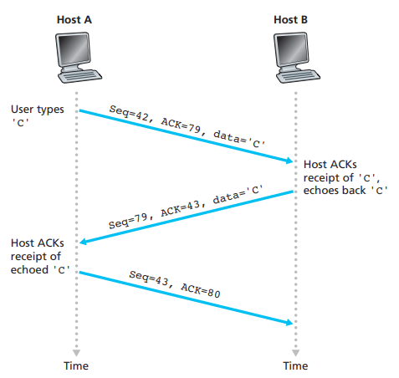

Figure 3-5‑2 Telnet connection between two hosts

To understand the use of TCP, we demonstrate how TCP works in Telnet, a popular application-layer protocol used for remote login. First segment from Host A to Host B shows sequence number 42, which data “C” is labeled as the number 42 from the sent bytes. ACK=79 means that Host A expects to get the return segment from Host B that assigning the sequence number as 79.

#### Timeout Interval

TCP, like our rdt protocol in Ch.3-4, uses a timeout/retransmit mechanism to recover from lost segments.

SampleRTT is the measured RTT from a transmitted segment. Based on the current IETF recommendations for managing TCP timers [RFC 6298], such an average is called an **exponential weighted moving average(EWMA)**.

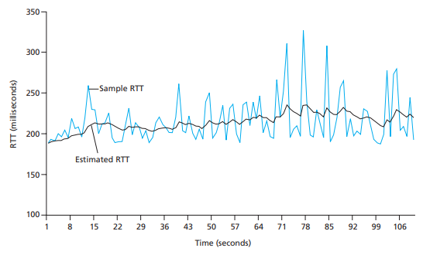

Figure 3-5‑3 Relationship between two RTTs

Also, we need to take a look at the RTT variation. It is also defined by [RFC 6298].

The timeout intervals of TCP should be larger than the connection’s round-trip time(RTT), where is EstimatedRTT in the above function. But how much larger?

The initial value of TimeoutInterval is 1 (No SampleRTT is measured).

What if TCP keeps retransmitting a not-yet-acknowledged segment? It will doubles up the TCP TimeoutInterval, grow exponentially! So the upper bound of TimeoutInterval is set. The modification is a limit form of congestion control.

#### Fast Retransmit

TCP ACK generation recommendation is defined in [RFC 5681]. It shows the reactions for TCP receiver according to segment coming events.

TCP receiver always acknowledge sender that what sequence number it is expected to get. If duplicate ACK is sent, it means there is a lost segment. Example of seq=100 in the figure.

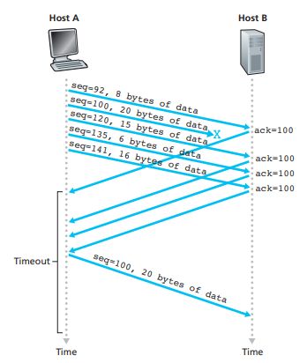

Figure 3-5‑4 ACK responds same expected number

Because a sender often sends a large number of segments back to back, if one segment is lost, there will likely be many back-to-back duplicate ACKs.

If the TCP sender receives three duplicate ACKs for the same data, it takes this as an indication that the segment has been lost. In the case that three duplicate ACKs are received, the TCP sender performs a **fast retransmit** [RFC 5681], *retransmitting the missing segment before that segment’s timer expires*.

#### Flow control

Both TCP sender and receiver have buffers. Receiver has to inform sender amount of free buffer space. Sender also has to limit the UnACKed data to receiver’s spare room.

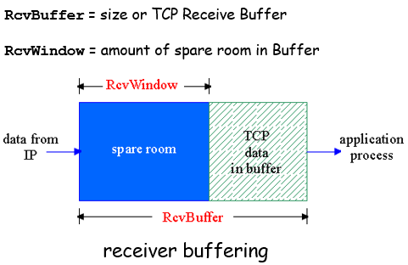

Figure 3-5‑5 Example for TCP receiver buffer

#### Connection management

TCP sender, receiver establish “connection” before exchanging data segments.

Initialize TCP variables from each other: seq. #s buffers, flow control info. Handshaking procedure is shown below.

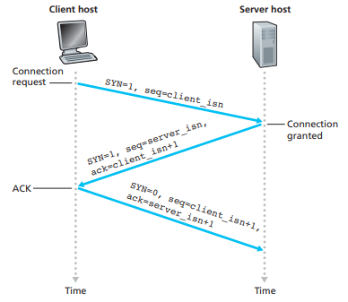

Figure 3-5‑6 TCP handshake procedure

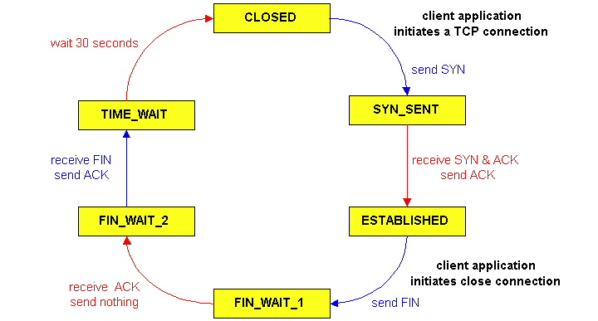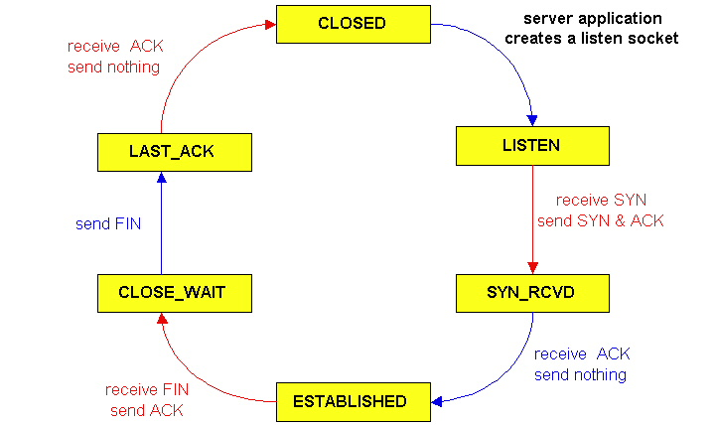

Figure 3-5‑7 TCP flow charts for client and server applications

#### Principles of Congestion Control

Congestion control inform that too many sources sending too much data too fast for network to handle. It is different from flow control, as it limits amount of data. Congestion may increase the delay time and decrease the throughput of transmission.

Situation1: As we mentioned in Section. *Timeout Interval, if there is an infinite buffer in the router that collects all the go-through packets, large delays occur causing TCP connecter’s RTT estimation growing exponentially.

Situation2: Router has a finite buffer. Packets from TCP connecters may be lost or delayed by limited resource. It cause more work and unnecessary packets sending during the process.

Situation3: Multiple routers were used through the connection. If one of the packet dropped, any upstream transmission capacity used for that packet was wasted.

Two approaches towards congestion control:

* **End-to-end congestion control**: *Without explicit feedback from network*, connecters *observe transmission status such as loss or delay*, checking network congestion inferring or not.
* **Network-assisted congestion control**: *Routers provide feedback to end systems*. By assigning a single bit for indicating congestion in the packet, router can inform sender what rate sender should send at.

An example for network-assisted congestion control: Asynchronous Transfer Mode (ATM) ABR congestion control. ABR, available bit rate, is set to control sender’s path load. The sender uses the available bandwidth or minimum guaranteed rate whether the path is underloaded or congested. In ATM structure, ATM use data cells for data transmission. One of the data cells is called RM cell. It has NI bit and CI bit for network congested indication.

#### TCP Congestion Control

TCP uses end-to-end congestion control. Sender increases transmission rate (window size) probing for usable bandwidth until loss occurs.

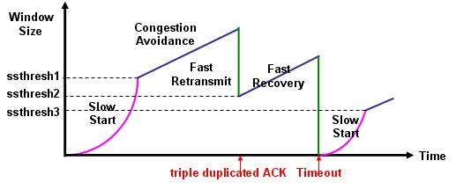

There are three mechanisms for TCP congestion control:

* **Additive increase, Multiplicative decrease (AIMD)**: It increases congestion window by 1 MSS every RTT until loss detected. If loss detected, it cut congestion window in half.
* **Slow start**: Initial congestion window is small, which is only 1 MSS. When connection begins, increase rate exponentially until first loss event to check for the congestion limit. It can then be set again from 1 MSS to threshold MSS and go for AIMD.
* **Conservative after timeout events**: When timeout event happened, threshold is cut in half and slow start procedure is triggered instead of AIMD procedure.

Assumed window size is W, then the throughout rate is W/RTT. But if packet loss is detected, throughout rate will drop down to W/2RTT. Combined this two findings, the average throughout rate will be 0.75W/RTT.

Two TCP connections are established through the same router, can the throughput separate equally to each connecter? Yes, according to AIMD rule, they will reset the bandwidth dynamically and find the balance between two connecters.

## Network Layer

### Introduction

The role of the network layer is simple—to move packets from a sending host to a receiving host. Network layer can be found in every host and routers. On the sending host, it encapsulates segments into datagrams; on the receiving host, it delivers segments to transport layer; for router, it examines headers fields in all IP datagrams that passing through it.

Two important network-layer functions can be identified:

* **Routing**. Determining the route taken by packets from a sender to a receiver.
* **Forwarding**. Moving packets from router’s input to appropriate router output.

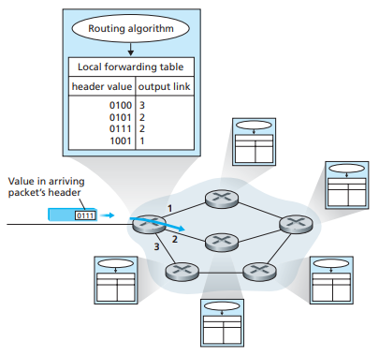

Figure 4-1‑1 A packet go through a router

Every router has a **forwarding table**. A router forwards a packet by examining the arriving packet’s header, and then using this header value to index into the router’s forwarding table. The value in the forwarding table indicates the router’s outgoing link interface to which that packet is to be forwarded.

In example Figure 4-1‑1, a packet with a header field value of 0111 arrives to a router. The router indexes into its forwarding table and determines that the output link interface for this packet is interface 2. The router then internally forwards the packet to interface 2.

The routing algorithm determines the values that are inserted into the routers’ forwarding tables. The routing algorithm may be centralized or decentralized.

Before datagrams flow, two end hosts and intervening routers establish virtual connection. Depending on different network services, some must guarantee the in-order delivery for individual datagrams, others must guarantee minimum bandwidth to flow, the others provide restrictions on change in inter-packet spacing (gaps between packets).

### Virtual circuit and datagram networks

Network-layer services have two type of connections: connection or connectionless. Network-layer service has to choose only one of them.

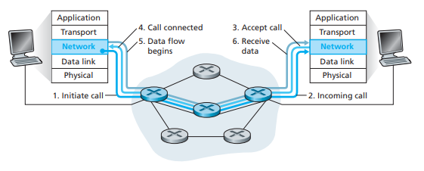

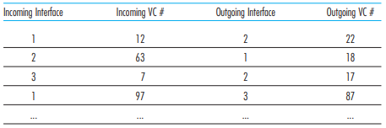

Figure 4-2‑1 Virtual circuit and its forwarding table

Virtual circuit has source-to-destination path and behaves much like telephone circuit. Its call need to be setup before data flowing. Each packet carries VC identifiers but not the destination host ID. They can be modified on link based on forwarding tables. Every router on the path maintain the “state” for each passing connection, while transport-layer connection only involve two end systems. Resources from links and routers may be allocated to virtual circuit.

It is demanded for strict timing and reliability requirement, causing the complex inside network.

ATM, frame-relay, X.25 uses virtual circuit.

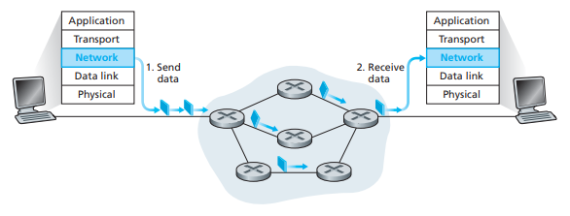

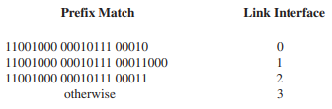

Figure 4-2‑2 Datagram network and its forwarding table

Datagram network is totally different from virtual circuit. There is no call setup at network layer. Routers would not care about the end-to-end connection, as it is no network-level concept of connection. The direction of packets is declared in the packet header as destination host ID. Packet types can be various but asked for a smart end system and some completed rules to process them correctly.

### What’s Inside a Router

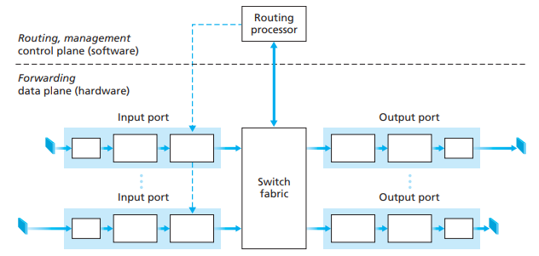

Figure 4-3‑1 A view in a generic router

What router does has two key functions: running routing algorithms and protocols such as RIP, OSPF, BGP and forwarding datagrams from incoming to outgoing link.

A high-level view of a generic router architecture is shown in Figure 4.6. Four

router components can be identified:

* **Input ports**. An input port performs several key functions.

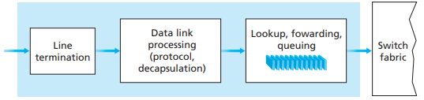

* + Performs the **physical layer** function of terminating an incoming physical link at a router.
  + Performs **link-layer** functions needed to interoperate with the link layer at the other side of the incoming link.
  + Performs the lookup function at the input port.

It is here that the forwarding table is consulted to determine the router output port to which an arriving packet will be forwarded via the switching fabric. Allow queuing.

* 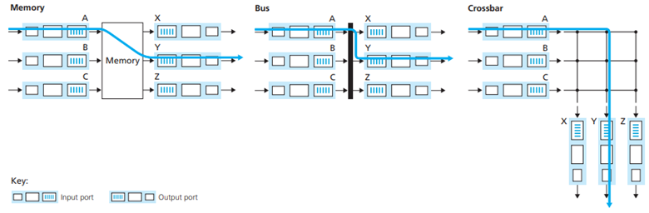**Switching fabric**. The switching fabric connects the router’s input ports to its output ports.

Several types of connection can be designed. First-generation routers use **memory** for coping packets. The main problem is *speed limited by memory bandwidth*. **Shared bus** may cause bus contention problem. The bus bandwidth will be the main point to put in. **Crossbar** connects all the input and output. Interconnection network is one of the modern design, it is known for Banyan network.

* **Output ports**.

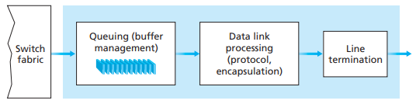

An output port stores packets received from the switching fabric and transmits these packets on the outgoing link by performing the necessary link-layer and physical-layer functions. When a link is bidirectional, an output port will typically be paired with the input port for that link on the same line card.

* **Routing processor**. The routing processor executes the routing protocols, maintains routing tables and attached link state information, and computes the forwarding table for the router. It also performs the network management functions.

**Head-of-the-Line (HOL) blocking** can be found in queued datagram. At front of queue prevents others in queue from moving forward, resulting queuing delay and loss. In example Figure, only one of red packet can be transferred, and the green packet experiences HOL blocking.

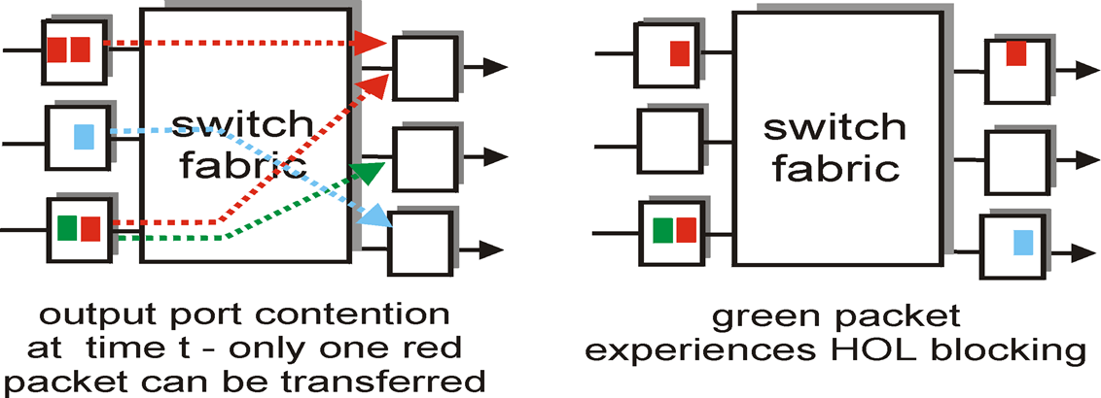

Figure 4-3‑2 Example for HOL blocking

### IP - Internet Protocol

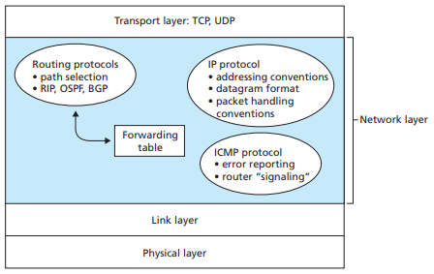

The network layer of the Internet has three main components: the IP protocol, the Internet routing protocols (including RIP, OSPF, and BGP), and ICMP.

#### IPv4 Datagram Format

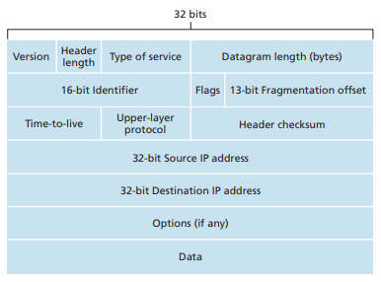

IPv4 datagram format is shown in Figure 4.13. The key fields in the IPv4 datagram are the following:

* **Version number**. 4 bits specify the IP protocol version. **0100 = IPv4, 0110 = IPv6**
* **Header length**. 4 bits determine where in the IP datagram the data actually begins. The typical IP datagram has a 20-byte header.
* **Type of service**. 8 bits allow different types of IP datagrams to be distinguished from each other.
* **Datagram length**. Total length of the IP datagram, measured in bytes. Datagrams are rarely larger than 1,500 bytes.
* **Identifier, flags, fragmentation offset**. These bits identify the order of related fragments. Network links have different max transfer sizes (MTU). Large IP datagram is fragmented within net and reassembled at destination.

Example for the fragments of a 3,980 bytes IP datagram.

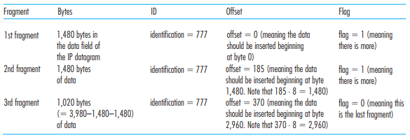

* **Time-to-live**. Ensure that datagrams do not circulate forever in the network.

This field is decremented by one each time the datagram is processed by a router. If the TTL field reaches 0, the datagram must be dropped.

* **Protocol**. Indicates the specific transport-layer protocol. TCP=6, UDP=17.
* **Header checksum**. Aids a router in detecting bit errors in a received IP datagram. As discussed in Section 3.3, routers typically discard datagrams for which an error has been detected.
* **Source and destination IP addresses**. Often the source host determines the destination address via a DNS lookup.
* **Options**. The options fields allow an IP header to be extended. Used rarely.
* **Data** **(payload)**. The transport-layer segment (TCP or UDP) or ICMP messages.

#### IPv4 Addressing

A host typically has only a single link into the network. The boundary between the host and the physical link is called an **interface**. A router has multiple interfaces, one for each of its links. Each host and router interface to have its own IP address.

Each IP address is 32 bits long, and there are about 4 billion possible IP addresses. These addresses are typically written in so-called **dotted-decimal notation**, like 223.1.3.27.

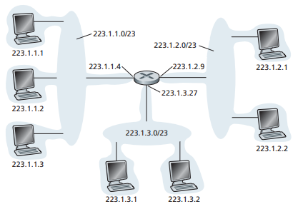

A **subnet** [RFC 950] can physically reach each other without intervening router. IP addressing assigns an address to this subnet: 223.1.1.0/24, where the /24 notation, known as a **subnet mask**, indicates that the leftmost 24 bits of the 32-bit quantity define the subnet address. The rest part of IP address is to indicate the hosts.

**Classless Interdomain Routing (CIDR)** generalizes the notion of subnet addressing. Based on **Variable Length Subnet Mask (VLSM)**, the x most significant bits of an address of the form a.b.c.d/x constitute the network portion of the IP address, referred to as the **prefix** of the address.

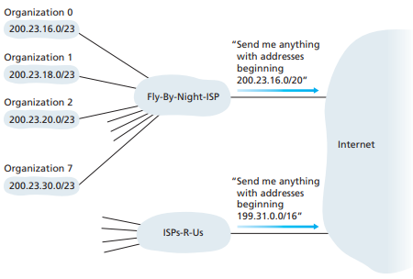

According to allocated portion of provider ISP’s address space, we can grab the packets from Internet that send to us. ISP gets block of addresses from ICANN, the Internet Corporation for Assigned Names and Numbers. ICANN allocates addresses, manages DNS and resolves disputes about them.

#### DHCP

Once an organization has obtained a block of addresses, it can assign individual IP addresses to the host and router interfaces in its organization. Host addresses can be configured manually or using the **Dynamic Host Configuration Protocol (DHCP)** [RFC 2131].

DHCP allows a host to obtain an IP address **dynamically**, so it is often referred to as a **plug-and-play protocol**. It can allow reuse of addresses and support hosts who connect shortly (Mobile users).

DHCP also allows a host to learn additional information, such as its subnet mask, the default gateway, and the address of its local DNS server.

|  |  |
| --- | --- |
| 鳥哥的Linux 私房菜-- DHCP 伺服器 | Overview for UDP messages transfer   1. Host broadcasts “DHCP discover” 2. Server responds “DHCP offer” 3. Host requests IP address “DHCP request” 4. Server responds “DHCP ACK” |
| https://images.slideplayer.com/16/4900880/slides/slide_4.jpg | |

#### NAT

IPv4 address exhaustion is HUGE problem in early 21st century. There is no reserved blocks left from IANA on 11, February 2011. Less than a block is available for each registries of RIR. **Network Address Translation (NAT)** is one of the solution for reducing the usage of public IPv4 address.

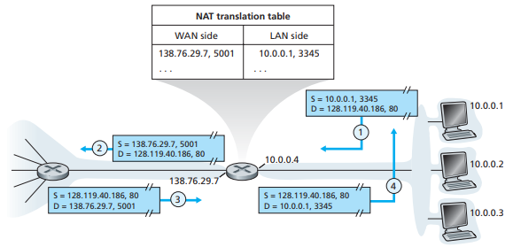

Local network (as figure, subnet 10.0.0.0/24) uses just one IP address (138.76.29.7) as far as outside world is concerned. There is no need to get range of addresses from ISP anymore. Addresses of devices can be modified without bothering outside world or ISP. In the other hand, addresses of devices in local network are not visible for the outside world, which gaining security.

To provide this service, NAT router must replace the header of outgoing IP datagram with the relaying address and ports, as same as the incoming IP datagram. Router also needs an additional translation table to store the statement from each local host.

The controversial part about NAT is that it violates the end-end argument for transport-layer service. The address shortage is solved by IPv6.

For NAT traversal problem that outside device communicates with inside host, there are multiple methods to solve this problem.

* **Forwarding**. If outside devices want to access a certain local host, administrator needs to assign the forwarding table for them.
* **UPnP**. UPnP, **Universal Plug-and-Play**, has a protocol named **Internet Gateway Device (IGD)**. IGD allows NATed host to learn the public IP address and modify port mapping through LAN.
* **Relay server**. This is how Skype does.

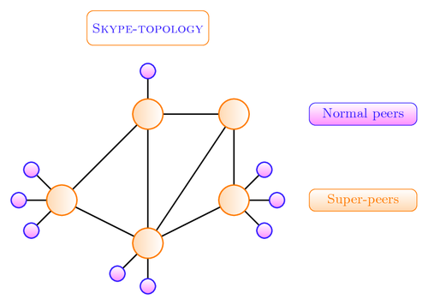

#### IPv6 Datagram Format

The motivation of IPv6 is 32-bits address space soon to be completely allocated.

Also, improving IPv4 problems such as re-designing datagram format to speed up processes and forwarding, facilitating Quality of Service (QoS).

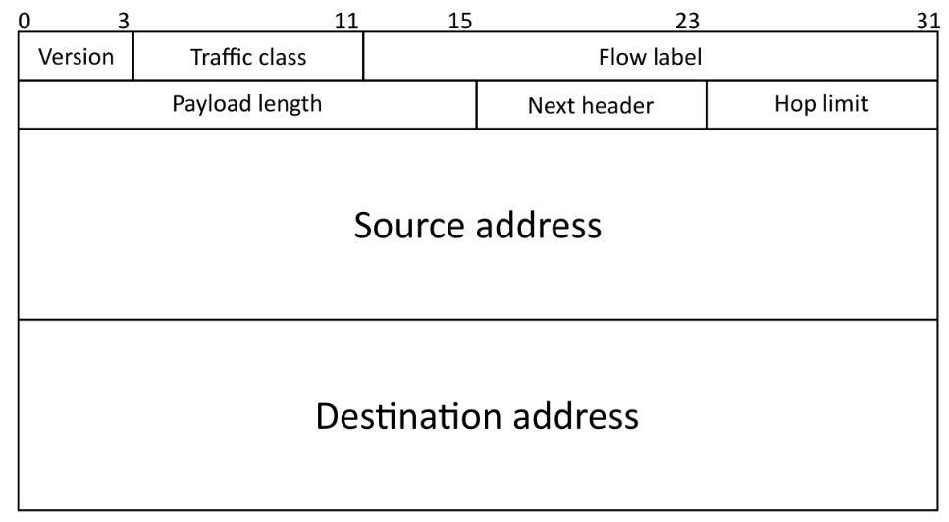

IPv6 datagram has fixed-length 40 bytes header and no fragmentation.

* **Version number** (4 bits) **0100 = IPv4, 0110 = IPv6**
* **Traffic Class** (6+2 bits) The bits of this field hold two values.
  + **Differentiated Services (DS)** (6bits) Classify packets.
  + **Explicit Congestion Notification (ECN)** (2bits) priority values subdivide into ranges: traffic where the source provides congestion control and non-congestion control traffic.
* **Flow Label** (20 bits)

An identifier of group of packets between a source and destination.

* **Payload Length** (16 bits)
* **Next Header** (8 bits) Specify the type of the next header. This field usually specifies the transport layer protocol used by a packet's payload.
* **Hop Limit** (8 bits)

Replaces the time to live field of IPv4.

* **Source Address** (128 bits)
* **Destination Address** (128 bits)

Checksum is removed to improve the efficiency.

Options is moved outside the header and still can be used.

#### IPv6 Addressing

IPv6 addresses are 128-bit identifiers for interfaces and sets of interfaces. There are three types of addresses:

* Unicast: An identifier for a single interface. One-to-one.
* Anycast: A packet sent to an anycast address is delivered to **the "nearest" one** of the interfaces identified by that address.
* Multicast: A packet is delivered to all interfaces identified by that address.

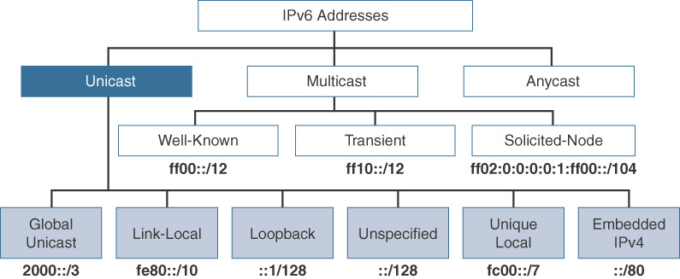

The most generic way of dividing up the 128 bits of the unicast address space is into three sections, as shown in Figure.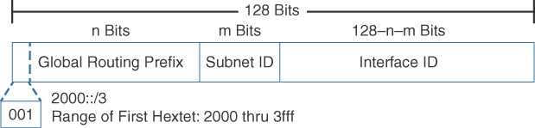

Detailed in <https://www.youtube.com/watch?v=HCTl3UJ9FlE>

#### Transitioning from IPv4 to IPv6

There is no possible to declare a flag day when all the Internet machines must upgrade from IPv4 to IPv6. The network must operate with mixed IPv4 and IPv6 routers and hosts. Two proposed approaches for the goal are introduced.

* Tunneling: The IPv6 is carried as payload in IPv4 datagram among IPv4 routers.

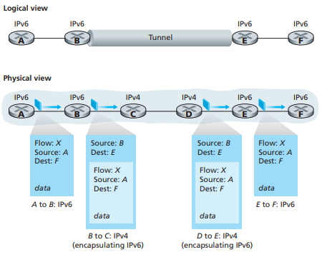

* Dual-Stack: Some routers with dual stack (v6, v4) can “translate” between formats.

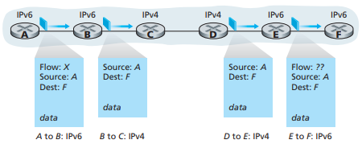

|  |
| --- |
| DS-Lite:  Home user provide IPv4 private IP. Users connect to B4, transmitting Tunneling packets, which IPv4 is inside the IPv6 datagram (or just transferring private IPv6 packet without tunneling. No problem is involved!).  Then there is an AFTR inside the ISP that connected between CPE and outer network. AFTR has function of NAT that translating private IPv4 address to public IPv4 address. |

### ICMP – Internet Control Message Protocol

ICMP is used by hosts and routers to communicate network-level information. Error reporting and echo reply are the familiar usages for all users.

ICMP carried IP datagram’s message, so it is “above” IP in network-layer. The ICMP message includes type, code and first 8 bytes of IP datagram causing error.

ICMPv6 has additional message types about packet sizes and multicast group management functions based on IPv6.

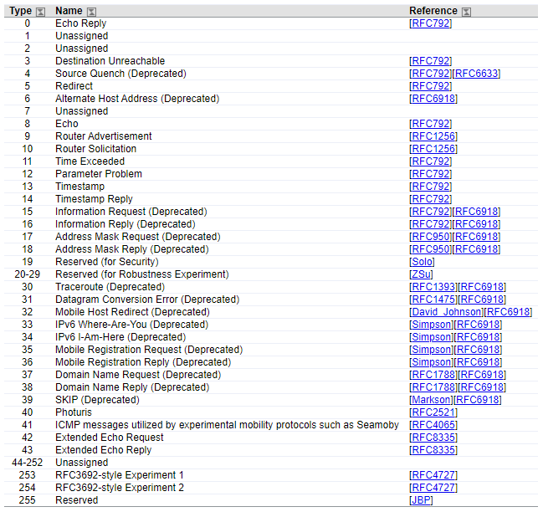

### Routing Algorithms

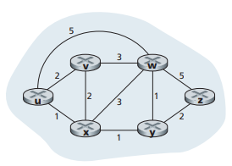

Routing algorithms do the interplay between routing and forwarding. We can resemble the routing architecture as the graph in computer science. Every node in graph can be presented as router. Cost of paths is assigned as there are limit bandwidth and congestion during the transmission.

Different classifications can be informed depending on change, view, or management. It can be global or local, based on the knowledge of network; it can be centralized or decentralized, whether there is a node maintaining the whole network; it can be static or dynamic, by the frequency of the route exchange.

#### The Link-State Routing Algorithm

A link state algorithm is based on a well-known graph algorithm: Dijkstra’s algorithm. Computing the minimum cost paths from source node to all the other nodes, it is accomplished via “link state broadcast” for all the nodes in network.

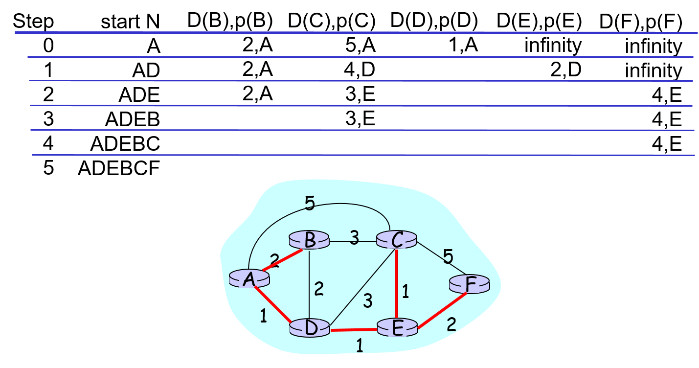

After Dijkstra’s algorithm, a short-path tree can be found. It will be the reference of the forwarding table. The complexity of the algorithm with the efficient implementation will be O(nlogn) (Affected by comparison algorithm: merge sort, quick sort or heap sort).

However, there is possible that oscillation may happen as the link costs are dynamic in the network, resulting resources wasted.

#### The Distance Vector Routing Algorithm

Bellman-Ford Equation is one type of dynamic programming. It can compute all the least costs from a single source node. The resulting table will be used for forwarding table.

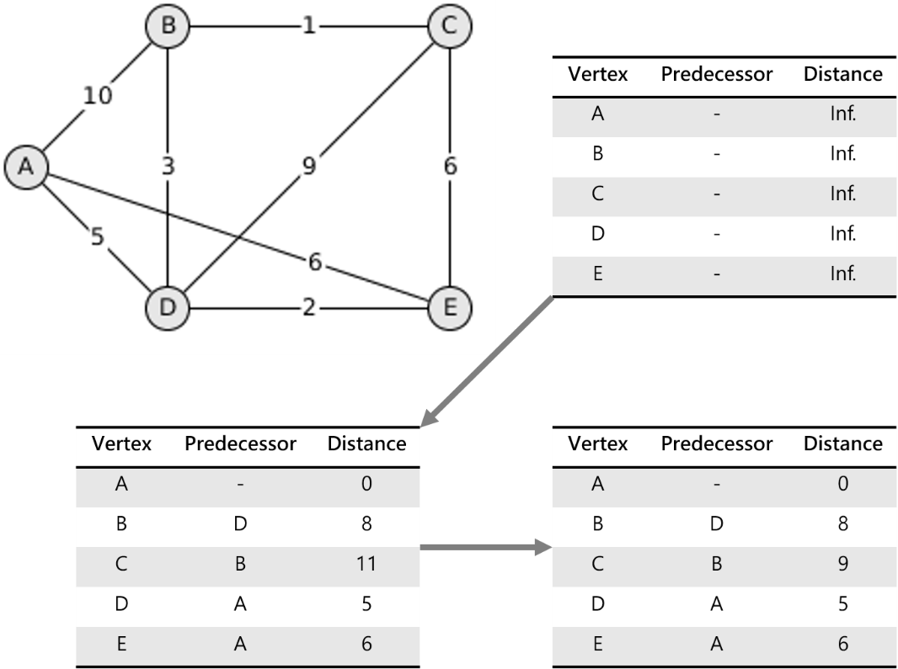

Bellman-Ford algorithm is iterative and asynchronous. Every time the local link cost changes, node has to notify the neighbor node for another cost update. An observation is that cost decreasing path may be recalculated rapidly as cost increasing path may be recalculated slowly. Node would not know about other node’s shortest path is conflicted with the new cost. This dilemma is can be solved by poisoned reverse, but it has its own disadvantage.

The main point for distance vector routing algorithm is “good news converge rapidly, as bad news converge slowly”.

|  |  |  |
| --- | --- | --- |
| ISSUE | LS algorithm | DV algorithm |
| Message Complexity | need to go through all nodes and all links | Neighbors only |
| Speed Convergence | O(n2) | It depends |
| A node malfunction | Advertise incorrect link cost. Each node computes its own wrong table | Advertise incorrect path cost. Node’s wrong table may affect the others |

#### Hierarchical Routing

The scale is too big for network to calculate the efficient path. Storage of destinations and exchange of routing data may paralyze the internet. Our routing study will prefer with the idealization of network: all routers are identical and network is flat. We divide the Internet into many inter-networks. Each administrator may want to control routing for its own network.

The divided and organized routers are called as **autonomous systems (ASs).** Routers in the same AS run same routing protocol, as “intra-AS” routing protocol. Routers not in the same AS may run different routing protocol. The router connected different AS router is called **gateway Router.**

It is possible that multiple gateway routers exist in the same subnet. Inter-AS routing must check for which destinations are reachable through the correct gateway router. One approach for this purpose is **hot potato routing**, sending packet towards closest of two routers.

### Routing in the Internet

Intra-AS routing is also known as **Interior Gateway Protocols (IGP)**. Most common Intra-AS routing protocols are: **Routing Information Protocol(RIP)** and **Open Shortest Path First (OSPF)**.

#### RIP

RIP uses distance vector algorithm which we introduced at last chapter. Additional step for RIP is that every path cost equals to 1, that is, the distance metric is equal to the number of hops between two routers. The maximum number of hops is 15 to prevent ping-pong loop.

Distance vectors exchange among neighbors every 30 second via Response Message, which is also called as advertisement. Each advertisement includes at most 25 destination subnets within AS.

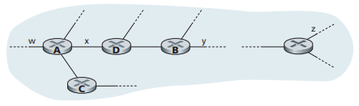

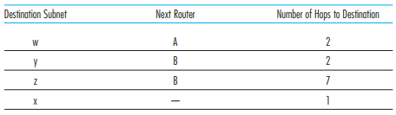D

If no advertisement is heard after 180 seconds, it declares the neighbor or link is dead. Routes without the dead router will be recalculated and advertised to entire net again.

RIP routing tables are managed by application-level process called route-d (daemon). The transferring segment for it is UDP.

#### OSPF

Open Shortest Path First, as its name, is publicly available for everyone. It use the Link-State algorithm. OSPF link cost is calculated by the congestion of network. It also advertises link cost to neighbor routers. The OSPF messages is carried by IP datagram, spreading to entire AS via flooding.

Multiple advanced features about OSPF include:

* All OSPF messages authenticated.
* Multiple same-cost paths allowed.
* Multiple cost metrics for different types of service.
* Integrated support for unicast and multicast routing.
* Support for hierarchy within a single domain.

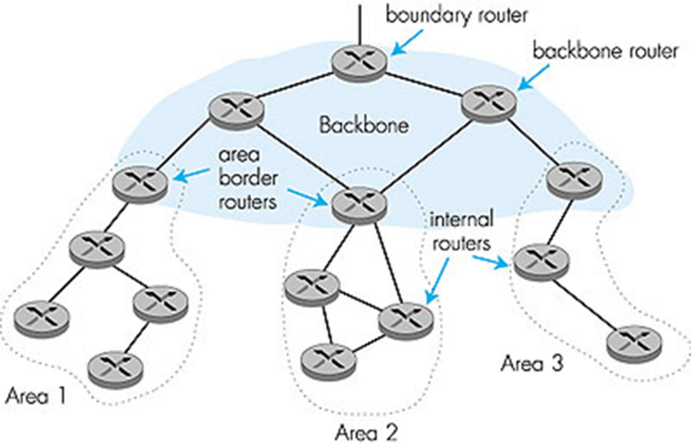

#### BGP

**Border gateway protocol** is the de facto standard. BGP obtains and provides AS the reachability information to other AS, and determines a good route to reachable subnets. BGP uses TCP for stable advertising.

BGP message is consisted of prefix and attributes. In BGP jargon, it is called route. Prefix represents a subnet or a collection of subnets. Attributes include AS-PATH and NEXT-HOP; the former prevents looping advertisement by saving the go-through history, the latter indicates specific internal-AS router to next-hop router. These advertisements are received by gateway router, and gateway router can decide whether to accept or to decline based on import policy.

|  |  |  |
| --- | --- | --- |
| ISSUE | Intra-AS routing | Inter-AS routing |
| Definition | In same domain | Between two domains |
| Policy | No needed | Admin wants control over how its traffic is routed, and who routes through its net |
| Scale | Hierarchical routing saves table size, reduced update traffic | |
| Performance | Can focus on performance | Policy may dominate over performance |

### Broadcast and Multicast Routing

In broadcast routing, the network layer provides a service of delivering a packet sent from a source node to all other nodes in the network; multicast routing enables a single source node to send a copy of a packet to a subset of the other network nodes (specific hosts).

#### Broadcast Routing

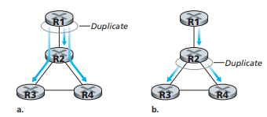

In broadcast routing, duplication source packet is need for all receiving nodes. Two kind of duplication happens in different places: **in-source** or **in-network**. In-source duplication is simple but inefficient. In-network is the one we can stick into it.

Uncontrolled flooding sends copy to all neighbors when node received broadcast packet. It may cause the broadcast storm and cycle for networks to digest. Controlled flooding sends copy only when node received an unseen packet. It can be assigned by setting broadcast ID or using **reverse path forwarding (RPF)**. Spanning tree is the other method we apply for the broadcast packets.

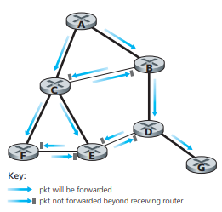

Figure illustrates reverse path forwarding. Relying on router’s knowledge of unicast shortest path from it to sender, if the received datagram on incoming link is on the shortest path back to source, then flood the datagram onto all the outgoing links.

#### Multicast Routing

A tree represents the connected routers having local multicast group members.

Not all the nodes and paths are used in a tree. To find a tree for multicast routing, source-based tree and group-shared tree are different approaches for it.

**Source-based tree** is that every source node have its own tree. They are shortest path trees and using reverse path forwarding. It can be found by using Dijkstra’s algorithm. The reverse path forwarding is attached with pruning function to avoid the unnecessary packet transmission.

**Group-shared tree** by its meanings the tree is shared by the same group. It is a minimal spanning tree and center-based. The tree is also called **Steiner Tree**, a minimal cost tree connecting all routers with attached group. It is a NP-complete problem so we prefer to get the excellent heuristics.

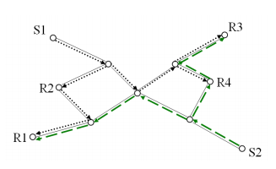 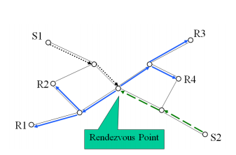

#### DVMRP & PIM

**Distance Vector Multicast Routing Protocol** is defined by [RFC 1075]. Based on source-based tree, nodes start to flood the multicast packets to entire network, then prune the unnecessary route. The unattached group router must send out the prune messages periodically, or the source data will flow into the unpruned branch. The approach of periodic prune signal is called soft-state.

**Protocol Independent Multicast (PIM)** is not depend on a particular protocol. For instance, DVMRP is based on the RIP. It explicitly recognizes two multicast distribution scenarios: sparse or dense nodes. The difference between two scenarios is to establish nodes one by one (set RP as a proxy of router) or to eliminate nodes one by one.

Both protocols need **Internet Group Management Protocol (IGMP)** to rule new router for joining to the tree.

#### Internet Group Management Protocol

The IGMP protocol version 3 [RFC 3376] operates between a host and its directly attached router, as shown in Figure 4.48. IGMP provides the means for a host to inform its attached router that an application running on the host wants to join a specific multicast group.

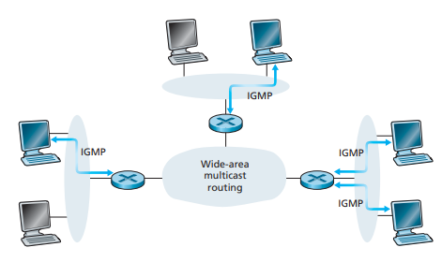

Network-layer multicast consists of two complementary components: IGMP and multicast routing protocols. IGMP has different message types. Like ICMP, IGMP messages are carried within an IP datagram, with an IP protocol number of 2.

membership_query message is broadcasted by a router, hosts passively respond or actively call router with an IGMP membership_report message. It is the only function in IGMPv1. The router checks for leaving host by soft-state method. If a host no longer sends the membership_report each 60 seconds, the router then determines that this host has left the multicast group.

IGMPv2 is commonly used nowadays. The leave_group message let hosts actively tell the leaving statement. Additional function for IGMPv2 is that router can broadcast the membership message in some certain groups of multicast members instead of all of them (group-specific query).

IGMPv3 adds the function that allow hosts to receive membership message from a certain source router (Group-and-Source-Specific Query).

**Multicast Listener Discovery (MLD)** is a component of the Internet Protocol Version 6 (IPv6) suite. MLD is used by IPv6 routers for discovering multicast listeners on a directly attached link, much like Internet Group Management Protocol (IGMP) is used in IPv4.

## The Link Layer: Links, Access Networks, and LANs

### Introduction to the Link Layer

In this layer, we call routers, end systems, switches or any devices as **node**, and the communication channel for nodes as **link**. A transmitting node encapsulates the datagram in a **link-layer frame** and transmits the frame into the link is the same console we have introduced before. Datagram is transferred by different link protocols over different links with different services. Possible services that can be offered by a link-layer protocol include:

* **Framing**: Adding error checking bits, rdt, flow control, etc., and encapsulating a datagram into a frame.
* **Link access**: A medium access control (MAC) protocol specifies the rules by which a frame is transmitted onto the link. Multiple nodes may share the same link.
* **Reliable delivery**: Similar to a transport-layer reliable delivery service, but it prone to correct an error locally if we use for wireless connection. Low-bit-error links may not provide this service, such as fiber, coax or twisted-pair copper links.
* **Error detection and correction**: Signal attenuation and electromagnetic noise may introduce bit errors. The full-designed hardware can detect bit errors by checking error-detection bits. It is similar to Internet Checksum, but more sophisticated.

The link layer is implemented in a **network adapter**, also sometimes known as a **network interface card (NIC)**, e.g., Ethernet card, PCMCI card or 802.11 card. They are combination of hardware, software and firmware, attached into host’s system buses.

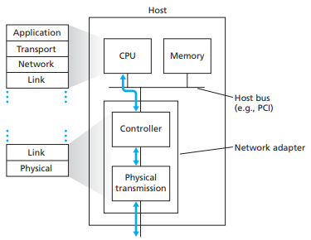

### Error Detection and Error Correction

As we mentioned, **error detection and correction bits (EDC)** are attached inside a frame. Although the detection is not 100% reliable, protocol may miss some errors rarely. Providing larger EDC field yields better detection.

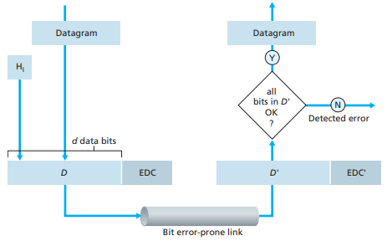

#### Parity Checking

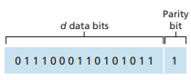

For single bit parity, an additional bit is attached behind data bits. Bit number is decided according to even parity or odd parity. For example, Figure has 10 numbers of bit 1, which is an even number. If the error occurs, the final numbers will not be even and the error will be detected. Multiple bits error and location of wrong bits cannot be declared.

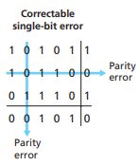

Two dimensional bit parity is combined with two single bit parity mapping into x-axis and y-axis. The wrong bit row and column will then be indicated as the coordination of wrong bit.

#### Checksumming

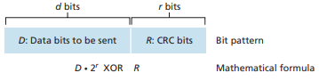

An error-detection technique used widely in today’s computer networks is based on **cyclic redundancy check (CRC)** codes. CRC codes are also known as

**polynomial codes**, with operations on the bit string interpreted as polynomial arithmetic.

Try to find the *R* in the equation:

Let’s take a example. We have a data “101110”.

If we pick G4 (4-bits) for the calculation, which is provided as “1001”.

There will be a 3-bit R (dG4-1), so we append 3 zero behind our data to “101110000”

Now we do the POLYNOMIALS calculation of

The reminder 011 will be our R for CRC error detection.

Thus, we get our data with CRC 101110011.

If receiver gets the data from us, he just needs to grab G4 from the standards and do polynomials calculation:

If remainder is zero, we will know the data is correct.

International standards of G:

<https://en.wikipedia.org/wiki/Cyclic_redundancy_check#Polynomial_representations_of_cyclic_redundancy_checks>

### Multiple Access Links and Protocols

Two categories for access links: **point-to-point** or **broadcast**. A Point-to-point link uses a distributed link between connecters, for instance, PPP or HDLC. A broadcast link can have multiple sending and receiving nodes all connected to the same, single, shared broadcast channel. The common examples are Ethernet, 802.11.

A single shared broadcast channel must do two or more simultaneous transmissions by nodes. Collision may happen if node receives two or more signals at the same time. In order to correct this problem, designing a distributed algorithm that determines how nodes share channel and when nodes can transmit. Notes that the communication about sharing control also uses this channel.

An ideal multiple access link satisfies these characteristics: *simple, fully decentralized, full usage of bandwidth* and *equally dividing the transmission rates*. Dozens of multiple access protocols have been implemented. We can classify just about any multiple access protocol as belonging to one of three categories: channel partitioning protocols, random access protocols, and taking-turns protocols.

#### Channel Partitioning Protocols

Channel partitioning protocols divide channel into small pieces. Allocating these pieces to node for exclusive usage is how it satisfies multiple access through a same channel. Simple methods for dividing are **time-division multiplexing (TDM)** and **frequency-division multiplexing (FDM)**.

The third channel partitioning protocol is called **code-division multiplexing access (CDMA)**. Each node uses its unique code to encode the public data. There is an example for learning CDMA.

Assume 4 users (A,B,C,D) have their own CDMA codes. For mathematical convenience, we represent a data bit with a 0 value as –1, as shown in right side.

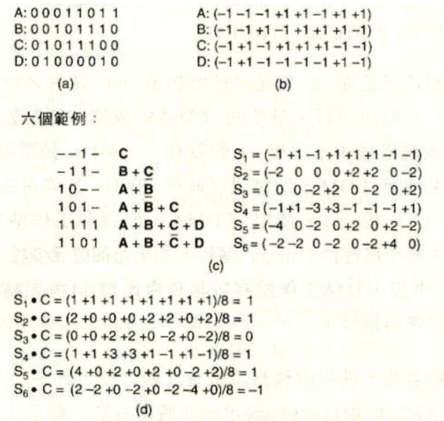

Now if they want to access to the same channel, we set six examples for that some of the users send out their own code (1-bit). The transmission code that go through the channel will be summed up by user’s signals.



Now we have six kinds of public CDMA code. If we want to declare the bit for a certain user, for example, user C, all we need is to inner product the public code and user C’s code. The answer will be the bit for user C. The code from the other users will be 0 after inner product calculation. It’s based on the mathematical theory about orthogonal.



#### Random Access Protocols

Slotted ALOHA, ALOHA, CSMA, CSMA/CD, CSMA/CA belong in here. When node has a packet to send, it sends out immediately to a full data rate channel. Note that there is no priority on these nodes. As the result, collisions happen.

How to detect collisions and how to recovery from them are the topics to dig into.

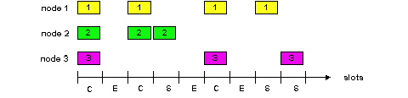

In Slotted ALOHA, time is divided into equal size slots. Every node transmits their own packet at the next slot. If collision happens, retransmit it again. If each transmits in slot with probability p, the channel use for useful transmissions at most 37% of time.

In Pure ALOHA, no synchronization is needed. The possibility of packet collision doubles as no time slot can control the incoming gate. The channel use for useful transmissions at most 18% of time. It is even worse.

**Carrier Sense Multiple Access (CSMA)** does a checking process before transmitting a packet. If channel sensed idle, CSMA transmit entire frame. The interesting thing is that channel might be occupied but sensed idle because of signal transmission time. In Figure, B sends out a packet at time t0 but the signal has not been transmitted to D yet. However, D sends out a packet before getting the signal from B’s packet. The strip part in Figure represents packets collision. CDMA has no remedy procedure for it.

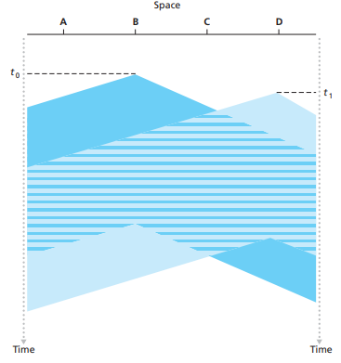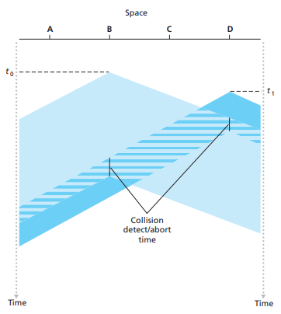

**Carrier Sense Multiple Access with Collision Detection (CSMA/CD)** includes the latency signal detection from transmitting packets. It can abort the collision packet transmission, send jam signal and defer exponential backoff.

#### Taking Turns Protocols

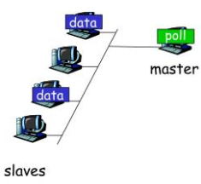 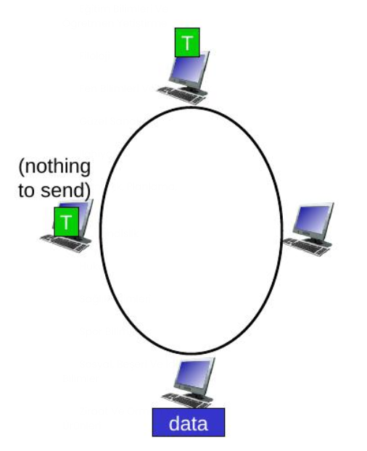

Two approaches for taking turns protocols: **polling** and **token passing**. Devices are grouped with a master device. Master node invites slave nodes, asking whether they need to transmit packets. This is in polling method, which is seldom used right now.

Control token is an important key in token passing method. If a node has nothing to send, control token is then passed to the next node. If a node has a packet to send, it send out the packet all around nodes. The passing nodes have to determine whether it need to copy the packet. The original packet then goes back to the sender and is removed from network. The sending authority will then give to the next node. Because of the single token, single point failure, take-turn latency and token overhead are problems it faces.

#### DOCSIS: The Link-Layer Protocol for Cable Internet Access

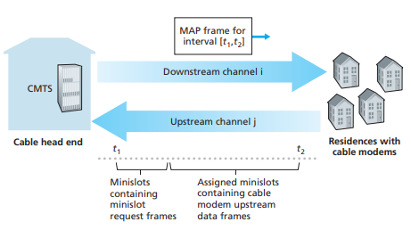

A cable access network typically connects several thousand residential cable modems to a **cable modem termination system (CMTS)** at the cable network headend. The **Data-Over-Cable Service Interface Specifications (DOCSIS)** specifies the cable data network architecture and its protocols. DOCSIS uses FDM to divide the downstream and upstream network segments into multiple frequency channels.

Each upstream and downstream channel is a broadcast channel. Frames transmitted on the downstream channel by the CMTS are received by all cable modems receiving that channel. There is no multiple access problem. Multiple cable modems share the same upstream channel to the CMTS, and thus collisions can potentially occur.

As illustrated in Figure, each upstream channel is divided into intervals of

time (TDM-like), each containing a sequence of mini-slots during which cable

modems can transmit to the CMTS. The CMTS explicitly grants permission to individual cable modems to transmit during specific mini-slots by sending a control message known as a MAP message on a downstream channel to specify which cable modem can transmit during which mini-slot.

These mini-slot-request frames are transmitted in a random access manner and so may collide with each other. The cable modem infers that its mini-slot-request frame experienced a collision if it does not receive a response to the requested allocation in the next downstream control message. When a collision is inferred, a cable modem uses binary exponential backoff to defer the retransmission of its mini-slot -request frame to a future time slot.

DOCSIS 1.0 : included functional elements in cable modems.

DOCSIS 1.1 : standardized quality of service (QoS) mechanisms.

DOCSIS 2.0 : enhanced upstream data rates for symmetric services (IP telephony).

DOCSIS 3.0 : increased data rates (US and DS) and support for IPv6.

DOCSIS 3.1 :

10 Gbit/s downstream and 1 Gbit/s upstream using 4096 QAM.

do away with 6 MHz and 8 MHz wide channel spacing

and use narrower (25 kHz or 50 kHz wide) OFDM subcarriers.

new energy management features reduce its energy usage

DOCSIS-PIE algorithm reduce bufferbloat….

DOCSIS 4.0 : DOCSIS 3.1 Full Duplex + Full spectrum (0 MHz to ~1.8 GHz)

### Link-Layer Addressing

A link-layer address is variously called a LAN address, a physical address, or a MAC address. For most LANs, the MAC address is 6 bytes long. Every adapter has an unique MAC address and portable.

**Address Resolution Protocol (ARP)** provides searching MAC address of neighbor nodes. Each IP node on LAN has ARP table, which includes IP address, MAC address and TTL for address mapping. If user A doesn’t have user B’s MAC address, user A broadcasts ARP query with B’s IP address. User B receives ARP packet and replies to A with its MAC address. User A may update its ARP table with new data.

Assumed two subnets is connected through a router. User from one subnet try to send datagram to the other subnet user. Knowing the default gateway of the middle router, user then creates link-layer frame with router’s MAC address as destination and attaches it on datagram. Router can follow the datagram’s header to find the real destination user.

### Ethernet

Ethernet has dominated wired LAN technology nowadays by its features: simple, cheap and speedy from 10Mbps to 10Gps. Ethernet is connectionless and unreliable. The MAC protocol it uses is **CSMA/CD**. Its frame structure is shown below.

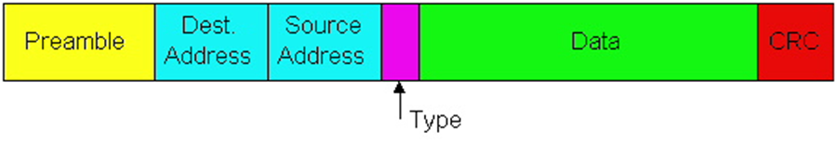

* **Data field** (46 to 1,500 bytes). This field carries the IP datagram or stuffed things.
* **Destination address** (6 bytes). This field contains the MAC address of the destination adapter.
* **Source address** (6 bytes). This field contains the MAC address of the adapter that
* **Type field** (2 bytes). The type field permits Ethernet to multiplex network-layer protocols. These fields serve to glue a protocol at one layer to a protocol at the layer above.
* **Cyclic redundancy check** (CRC) (4 bytes). As discussed in Ch.5-2, the purpose of the CRC field is to allow the receiving adapter to detect bit errors in the frame.
* **Preamble** (8 bytes). The preamble field serve to “wake up” the receiving adapters and to synchronize their clocks to that of the sender’s clock.

Manchester encoding combines clocks and data in the signal. There will be a bit change between each gap of time interval. It helps receiving device to synchronize with sending device.

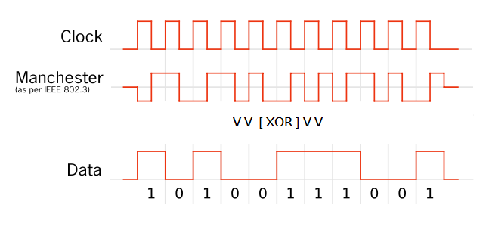

### Point to Point Protocols

One sender, one receiver and one link. Because of distribution from multiple users environment, there is no need for MAC. Popular point to point data link control protocols are PPP and HDLC. Example usages for these kinds of technique are dialup link, ISDN line.

#### Point-to-Point Protocol

PPP is defined in [RFC 1557]. Several design requirements for it are:

* Packet framing: Encapsulation of network-layer datagram. It has ability to demultiplex upwards and carry any layer-3 protocol at the same time.
* Bit transparency: Carry any bit pattern in data field.
* Error detection: Note that it has no ability for correction.
* Connection liveness: Detect signal link failure to network layer.
* Network layer address negotiation: endpoint can learn and configure other’s network address.

PPP can’t do error correction or recovery, flow control, in-order delivery and multipoint links. The three former problems can be relegated to higher layers.

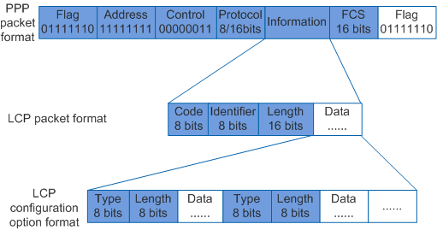

PPP data frame is shown as above:

* Flag: Indicates the end of a PPP frame.
* Address: Destination of the frame. Does nothing in PPP. Always set to “0xFF”.
* Control: For various control purposes. Does nothing in PPP. Always set to “0x03”.
* Protocol: Upper layer protocol to which frame delivered.
* Information: Upper layer data.
* Frame Check Sequence (FCS): CRC for error detection.

However, if data in the Information field has a substring as same as the flag, how can PPP detect it is not the exact flag? Here comes byte stuffing.

Byte stuffing is to stuff additional data bits for distinguishing data or flag. It adds extra <01111110> data bytes after the <01111110> DATA byte. PPP then can recognize that <0111 1110 0111 1110> is in data field and <0111 1110> is in flag field.

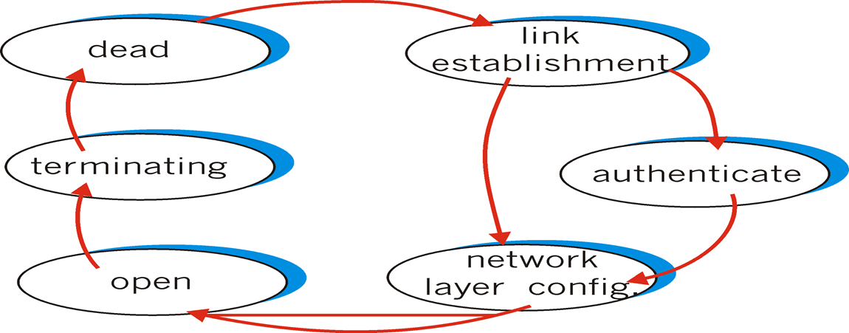

PPP’s FSM is shown in above. Starting with dead state, PPP must establish and authenticate link, then configure the network layer information before exchanging data from upper layer. For IP, the messages for IP configuration is controlled by IP Control Protocol (IPCP).

### Link Virtualization: ATM and MPLS

Virtualization of resources simplifies the complicated structure that is easier to manage them.

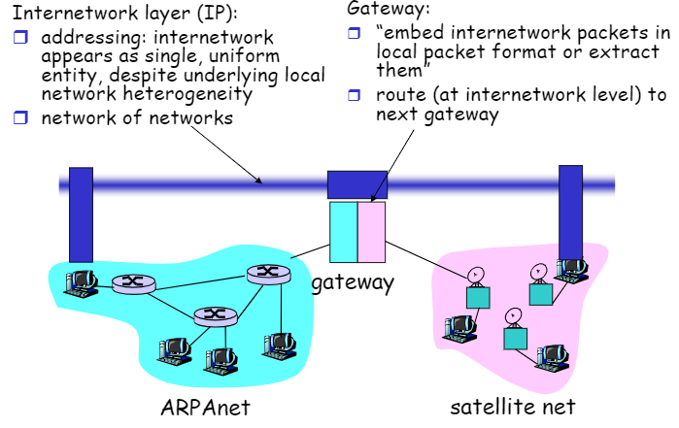

Assume two different nets with different addressing conventions, packet formats, error recovery or routing. For this example, ARPA net and satellite net are introduced. Network Gateway can connect two different net by transforming one protocols to another protocols. It can be really difficult to transform between satellite protocol and ARPA protocol. Virtualizing hosts from two different nets with Internetwork layer, in this example, IP, achieves to communicate in a same language.

In this section, ATM and MPLS will be introduced for a detailed example. They are totally different from Internet with service models, addressing and routing.

#### Asynchronous Transfer Mode

Being a 1980s/1990’s standard for high-speed (155Mbps to 622 Mbps and higher) with Broadband Integrated Service Digital Network architecture, ATM integrates, end-end transport of carry voice, video and data. It requires meeting time/QoS of voice and data, unlike IP’s best effort method. To approach this goal, virtual circuits is the proper choice for the plan.

We have mentioned virtual circuits in Ch4.2. Beside to the basic features of VC, two way for connected methods are listed through VC: permanent or switched. The transmission route is decided permanently or dynamically.

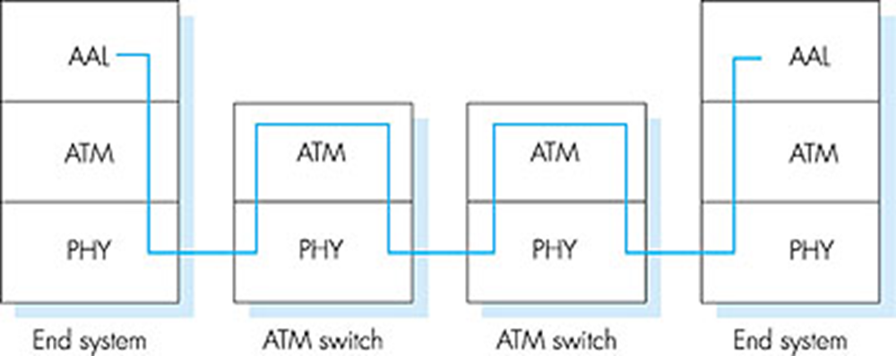

ATM layer, providing switch and route function for cells, which are similarly fixed-length packets from Internet, is in data link layer in OSI reference model. Adaption layer only exists at the edge of ATM network, doing data segmentation and reassembly. AAL promises to provide a unique channel for each service. For example, AAL1 for CBR (Constant Bit Rate) services, AAL2 for VBR (Variable Bit Rate) services, all the other data will be assigned to AAL5.

Two sublayers can be found in physical layer:

* Transmission Convergence Sublayer (TCS): rewrite ATM layer to PMC sublayer.
* Physical Medium Dependent: depends on physical mediums.

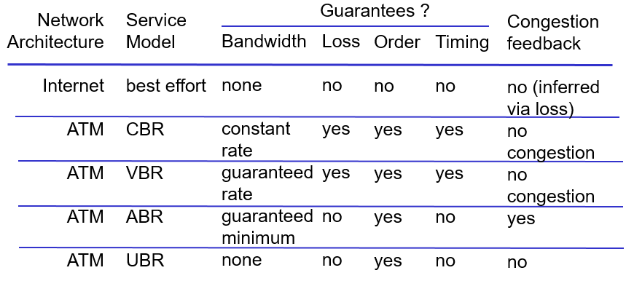

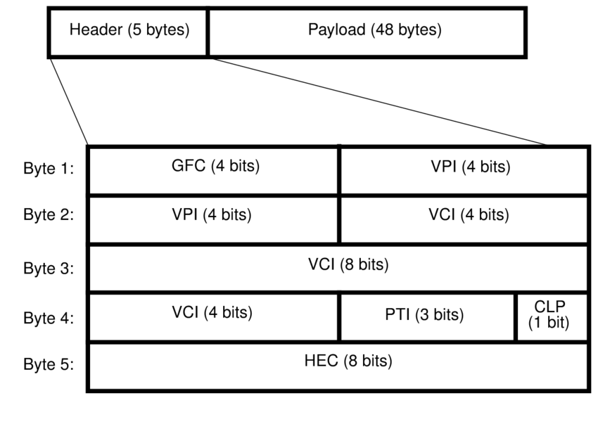

Small payload shorts cell-creation delay for digitized voice. Header includes:

* GFC: Generic flow control.
* VPI: Virtual Path Identifier. Choice for virtual path.
* VCI: Virtual channel ID is changed from link to link.
* PT: Payload Type.
* CLP: Cell Loss Priority bit. Decision which cell can be thrown out first due to congestion.
* HEC: Header Error Correction. Based on CRC-8.

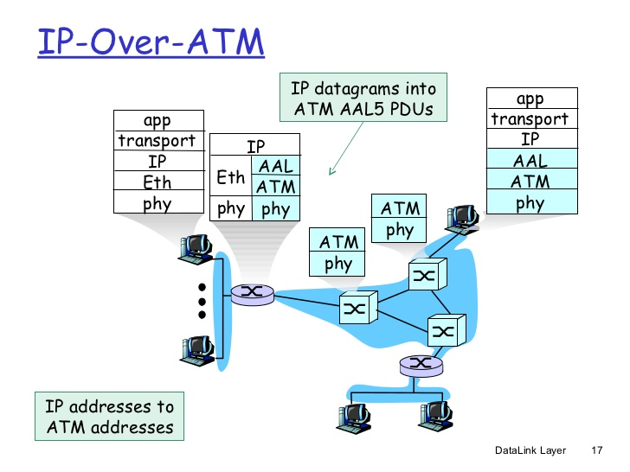

As ATM cannot prevent the growing of Ethernet in LAN, compatible with IP network is the turnaround for being survive from Ethernet. Generally, IP datagrams embed into AAL5 protocol data units (PDU). All the hosts no matter they are in ATM network or not can communicate with each other through IP.

#### Multiprotocol label switching (MPLS)

The initial goad of MPLS is to speed up IP forwarding by using fixed length label to do forwarding. This label field allows different protocols to put their own destination expression.

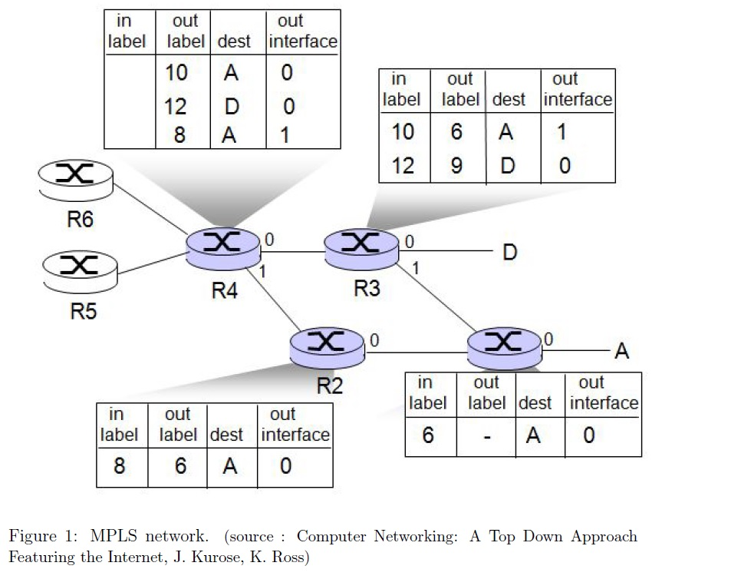

MPLS capable routers is known as label-switched router. It forwards packets to outgoing interface based only on label value.

## Wireless Network

### Introduction

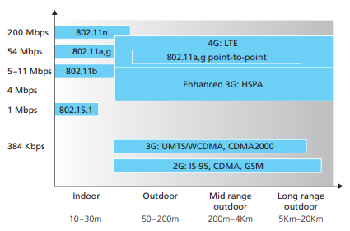

We can identify the following elements in a wireless network: **wireless hosts**, **wireless links** and **base station**(Cell towers or Access Point).

Two mode are shown for wireless hosts to connect each other: **Ad-hoc mode** and **infrastructure mode**. Ad-hoc is P2P mode and infrastructure mode needs a central access point to connect all hosts.

A mobile host moves from base station A to base station B is called **handoff**.

At the highest level we can classify wireless networks according to two

criteria: (i) whether a packet in the wireless network crosses exactly one wireless

hop or multiple wireless hops, and (ii) whether there is infrastructure such as a base

station in the network:

* Single-hop, infrastructure-based.

All communication is between this base station and a wireless host over a single wireless hop. ex. The 802.11 networks and the 3G cellular data networks.

* Single-hop, infrastructure-less.

No base station that is connected to a wireless network. One of the nodes in this single-hop network may coordinate the transmissions of the other nodes. Ex. Bluetooth networks and 802.11 networks in ad hoc mode.

* Multi-hop, infrastructure-based.

Some wireless nodes may have to relay their communication through other wireless nodes in order to communicate via the base station.

* Multi-hop, infrastructure-less.

There is no base station in these networks, and nodes may have to relay messages among several other nodes in order to reach a destination.

Mobile ad hoc networks (MANETs) or Vehicular ad hoc network(VANET).

### Wireless Links and Network Characteristics

We can find a number of important differences between a wired link and a wireless link:

* **Decreasing signal strength.**

Electromagnetic radiation attenuates as it passes through matter or in free space, resulting in decreased signal strength as the distance between sender and receiver increases.

* **Interference from other sources.**

Radio sources transmitting in the same frequency band will interfere with each other. Electromagnetic noise within the environment also can result in interference.

* **Multipath propagation.**

Electromagnetic wave reflect off objects and the ground results in the blurring of the received signal at the receiver. Moving objects between the sender and receiver can cause multipath propagation to change over time.

The **signal-to-noise ratio (SNR)** is a relative measure of the strength of the

received signal and the noise. The Figure shows the relationship between the **bit error rate (BER)** and the SNR.

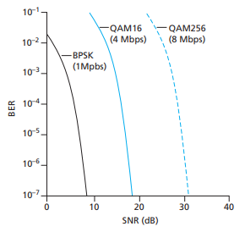

* the higher the SNR, the lower the BER.

But it cause more battery usage for phone user or interference with other transmission

* For a given SNR, a modulation technique with a higher bit transmission rate

will have a higher BER.

* Dynamic selection of the physical-layer modulation technique can be used to adapt the modulation technique to channel conditions.

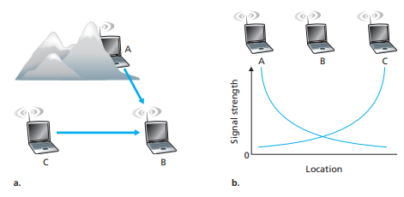

Another problem for wireless connection is called **hidden terminal problem**.

physical obstructions in the environment may prevent A and C from hearing each other’s transmissions, even though A’s and C’s transmissions are indeed interfering at the destination, B. This is shown in Figure 6.4(a). A second scenario that results in undetectable collisions at the receiver results from the **fading** of a signal’s strength as it propagates through the wireless medium.

### WiFi: IEEE 802.11 Wireless LANs

There are several 802.11 standards for wireless LAN technology, including

802.11b, 802.11a, and 802.11g. Table 6.1 summarizes the main characteristics of

these standards. 802.11g is by far the most popular technology. A number of dualmode (802.11a/g) and tri-mode (802.11a/b/g) devices are also available.

They all use the same medium access protocol, CSMA/CA, frame structure, allow for both “infrastructure mode” and “ad hoc mode,” ability to reduce their transmission rate in order to reach out over greater distances.

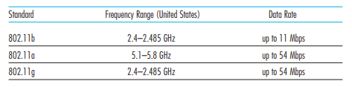

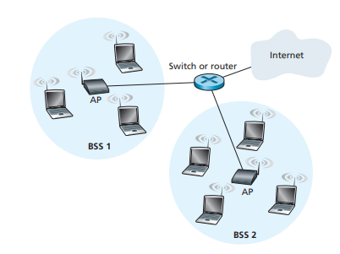 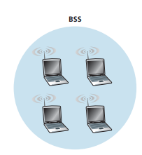

Figure 6.7 illustrates the principal components of the 802.11 wireless LAN architecture. The fundamental building block of the 802.11 architecture is the **basic service set (BSS)**. The base station in 802.11 Wireless LAN with infrastructure mode is **access point(AP)**. 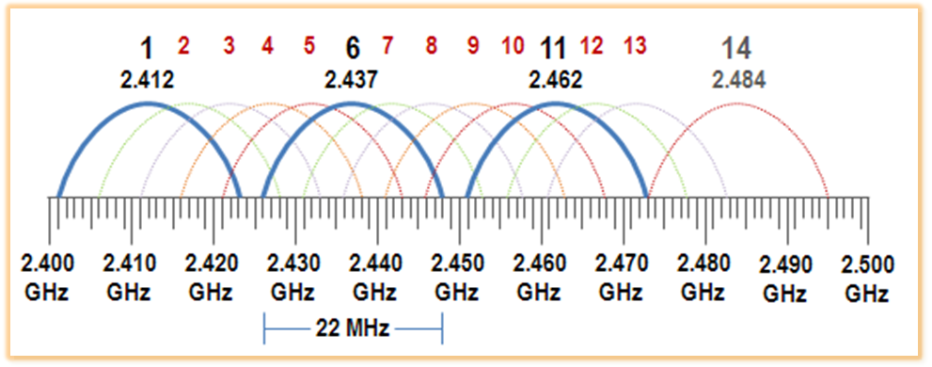

The administrator assigns a Service Set Identifier (SSID) and a channel number to the AP to the access point. To understand channel numbers, recall that 802.11 operates in the frequency range of 2.4 GHz to 2.485 GHz. The set of channels 1, 6, and 11 is the only set of three non-overlapping channels.

Assume that you are in a WiFi jungle－any physical location where a wireless station receives a sufficiently strong signal from APs. You need to associate with exactly one of the APs. AP periodically send beacon frames, each of which includes the AP’s SSID and MAC address, for your wireless station scanning channels and associating with it.

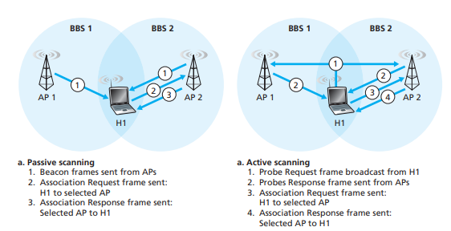

The process of scanning channels and listening for beacon frames is known as

passive scanning. A wireless host can also perform active scanning, by broadcasting a probe frame that will be received by all APs within the wireless host’s range. APs respond to the probe request frame with a probe response frame. The wireless host can then choose the AP with which to associate from among the responding APs.

#### CSMA/CA

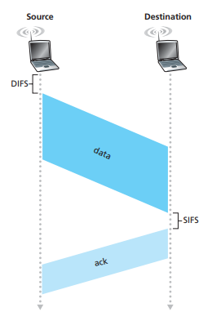

As discussed in Chapter 5, broadly speaking there are three classes of multiple access protocols: channel partitioning, random access, and taking turns. The 802.11 random access protocol is referred to as CSMA with collision avoidance (CSMA/CA).

Because of the relatively high bit error rates of wireless channels, 802.11 uses a link-layer acknowledgment/retransmission (ARQ) scheme. Note that every frame will be sent to network entirely.

If initially the source station senses the channel idle, it transmits its frame after a short period of time known as the **Distributed Inter-frame Space (DIFS)**; When the destination station receives a frame that passes the CRC, it waits a short period of time known as the **Short Inter-frame Spacing (SIFS)** and then sends back an acknowledgment frame.

If the transmitting station does not receive an acknowledgment in time, it assumes that an error has occurred and retransmits the frame using CSMA/CA protocol. If an acknowledgment is not received after some fixed number of retransmissions, the transmitting station gives up and discards the frame.

#### Hidden Terminal Problem

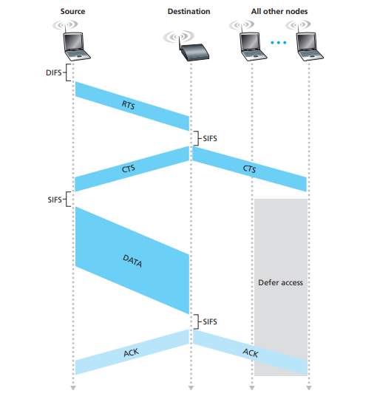

In order to avoid hidden terminal problem, the IEEE 802.11 protocol allows a station to use a short **Request to Send (RTS)** control frame and a short **Clear to Send (CTS)** control frame to reserve access to the channel. When a sender wants to send a DATA frame, it can first send an RTS frame to the AP, indicating the total time required to transmit the DATA frame and the acknowledgment (ACK) frame. When the AP receives the RTS frame, it responds by broadcasting a CTS frame. This CTS frame serves two purposes: It gives the sender explicit permission to send and also

instructs the other stations not to send for the reserved duration.

#### 802.11 frame

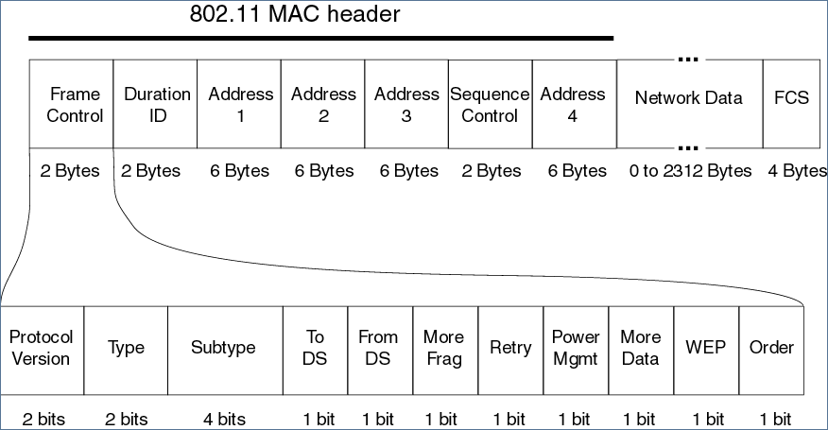

Let’s talk about the frame of 802.11.

* Address1: MAC address of the wireless station that is to receive the frame.
* Address2: MAC address of the wireless station that is to transmit the frame.
* Address3: MAC address of the router interface connecting to different subnets.

It asks this router for determining the appropriate destination MAC.

* SequenceControl: Seq# of rdt2.1. Determine this frame or next frame.
* Type, Subtype: Distinguishthe association, RTS, CTS, ACK, and data frames.
* WEP: encryption is being used or not.
* …… Go find others in Internet! Sorry.

|  |  |
| --- | --- |
|  | How do switch detect the change from H1 being in BSS1 to BSS2?  One solution is for AP2 to send a broadcast Ethernet frame with H1’s source MAC address to the switch  just after the new association |

802.11 rate adaptation is the determination of the optimal data transmission rate most appropriate for current wireless channel conditions. It is similar to TCP facing congestion problem. (Probing the best value)

Power management in 802.11 is that there is a power-management bit in header of 802.11 frame. If a mobile slept, AP will store the message and not send any message to mobile again until awake.

#### Bluetooth

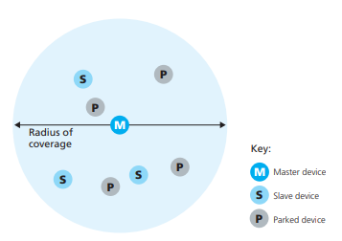

An IEEE 802.15.1 network operates over a short range, at low power, and at low

cost. 802.15.1 networks are sometimes referred to as **wireless personal area networks (WPANs)**. It operates in the 2.4 GHz unlicensed radio band in a

TDM manner, with time slots of 625 microseconds. During each time slot, a sender

transmits on one of 79 channels, with the channel changing in a known but pseudorandom manner from slot to slot. This form of channel hopping, known as

**frequency-hopping spread spectrum (FHSS)**, spreads transmissions in time over

the frequency spectrum. 802.15.1 can provide data rates up to 4 Mbps.

802.15.1 networks are ad hoc networks. 802.15.1 devices are first organized into a **piconet** of up to eight active devices. One of these devices is designated as the master, with the remaining devices acting as slaves. The master node truly rules the piconet—its clock determines time in the piconet, it can transmit in each odd-numbered slot, and a slave can transmit only after the master has communicated

with it in the previous slot and even then the slave can only transmit to the master.

### Cellular Internet Access

In our description of cellular network architecture, we’ll adopt the terminology of the **Global System for Mobile Communications** **(GSM)** standards.

The earliest generations were designed primarily for voice traffic. First generation (1G) systems were analog FDMA systems designed exclusively for voice-only communication. These 1G systems are almost extinct now, having been replaced by digital 2G systems.

The original 2G systems were also designed for voice, but later extended (2.5G) to support data (i.e., Internet) as well as voice service. The 3G systems that currently are being deployed also support voice and data, but with an ever increasing emphasis on data capabilities and higher-speed radio access links.

#### 2G: Voice Connections to the Telephone Network

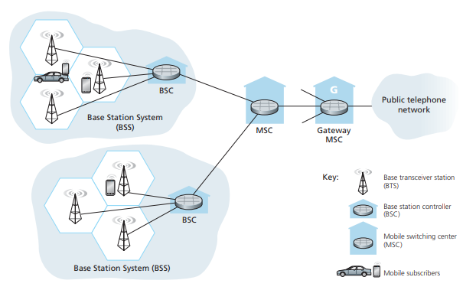

The region covered by a cellular network is partitioned into a number of geographic coverage areas, known as cells. GSM has its own particular nomenclature. Each cell contains a **base transceiver station (BTS)** that transmits signals to and receives signals from the mobile stations in its cell. The coverage area of a cell depends on many factors, including the transmitting power of the BTS, the transmitting power of the user devices, obstructing buildings in the cell, and the height of base station antennas.

The GSM standard for 2G cellular systems uses combined FDM/TDM (radio) for the air interface. GSM systems consist of 200-kHz frequency bands with each band supporting 8 TDM calls. GSM encodes speech at 13 kbps and 12.2 kbps. A GSM network’s **base station controller (BSC)** will typically service several tens of base transceiver stations. The role of the BSC is to allocate BTS radio channels to mobile subscribers, perform paging (finding the cell in which a mobile user is resident), and perform handoff of mobile users.

The base station controller and its controlled base transceiver stations collectively constitute a GSM **base station system (BSS)**. The **mobile switching center (MSC)** plays the central role in user authorization and accounting, call establishment and teardown, and handoff. A single MSC will typically contain up to five BSCs, resulting in approximately 200K subscribers per MSC. A cellular provider’s network will have a number of MSCs, with special MSCs known as gateway MSCs connecting the provider’s cellular network to the larger public telephone network.

#### 3G Cellular Data Networks: Extending the Internet to Cellular Subscribers

We want our smartphone run a full TCP/IP protocol stack and connect into the Internet via the cellular data network. Note that there’s no single official body that sets requirements for 2.5G, 3G, 3.5G, or 4G technologies, making it hard to sort out the differences among competing standards. In our discussion below, we’ll focus on the UMTS (Universal Mobile Telecommunications Service) 3G standards developed by the 3rd Generation Partnership project (3GPP).

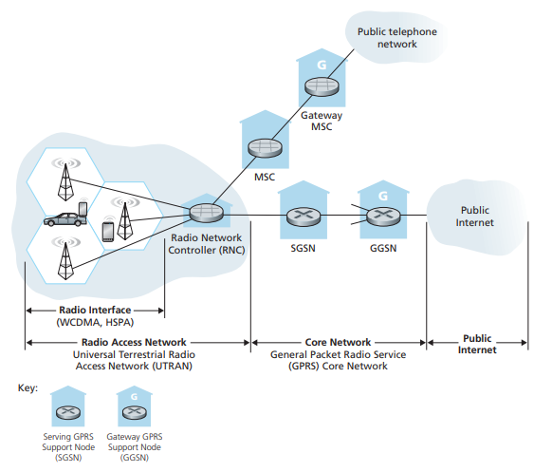

Given the existing cellular voice network, the approach taken by the designers of 3G data services is clear: leave the existing core GSM cellular voice network untouched, adding additional cellular data functionality in parallel to the existing cellular voice network.

There are two types of nodes in the 3G core network: **Serving GPRS Support Nodes (SGSNs)** and **Gateway GPRS Support Nodes (GGSNs)**. An SGSN is responsible for delivering datagrams to/from the mobile nodes in the radio access network to which the SGSN is attached. The SGSN interacts with the cellular voice network’s MSC for that area, providing user authorization and handoff, maintaining location (cell) information about active mobile nodes, and performing datagram forwarding between mobile nodes in the radio access network and a GGSN.

The GGSN acts as a gateway, connecting multiple SGSNs into the larger Internet. A GGSN is thus the last piece of 3G infrastructure that a datagram originating at a mobile node encounters before entering the larger Internet. To the outside world, the GGSN looks like any other gateway router; the mobility of the 3G nodes within the GGSN’s network is hidden from the outside world behind the GGSN. The 3G radio access network is the wireless first-hop network that we see as a 3G user.

The Radio Network Controller (RNC) typically controls several cell base transceiver stations similar to the base stations that we encountered in 2G systems. Each cell’s wireless link operates between the mobile nodes and a base transceiver station, just as in 2G networks. *The RNC connects to both the circuit-switched cellular voice network via an MSC, and to the packet-switched Internet via an SGSN.*

A significant change in 3G UMTS over 2G networks is that rather than using GSM’s FDMA/TDMA scheme, UMTS uses a CDMA technique known as Direct Sequence Wideband CDMA (DS-WCDMA, or UTRA) within TDMA slots. The data service associated with the WCDMA specification is known as HSP (High Speed Packet Access) and promises downlink data rates of up to 14 Mbps.

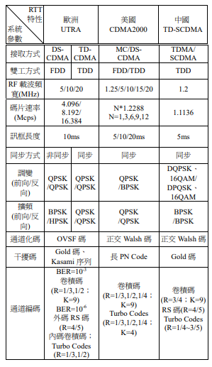

#### On to 4G: LTE

The 4G Long-Term Evolution (LTE) standard put forward by the 3GPP has two important innovations over 3G systems:

* Evolved Packet Core (EPC)

The EPC is a simplified all-IP core network that unifies the separate circuit-switched cellular voice network and the packet-switched cellular data network. It is an “all-IP” network in that both voice and data will be carried in IP datagrams.

A key task of the EPC is to manage network resources to provide this high quality of service on the “best-effort” IP module. The EPC also makes a clear separation between the network control and user data planes.

* LTE Radio Access Network.

LTE uses a combination of FDM and TDM on the downstream channel, known as orthogonal frequency division multiplexing (OFDM).

In LTE, each active mobile node is allocated one or more 0.5 ms time slots in one or more of the channel frequencies. By being allocated increasingly more time slots, a mobile node is able to achieve increasingly higher transmission rates. Slot allocation among mobile nodes can be performed as often as once every millisecond. Different modulation schemes can also be used to change the transmission rate.

Another innovation in the LTE radio network is the use of sophisticated multiple-input, multiple output (MIMO) antennas. The maximum data rate for an LTE user is 100 Mbps in the downstream direction and 50 Mbps in the upstream direction, when using 20 MHz worth of wireless spectrum.



### Mobility Management: Principles

* *From the network layer’s standpoint, how mobile is a user?*

A physically mobile user may move between points of attachment to the network. In the same wireless AP, or on the high speed rail!

* *How important is it for the mobile node’s address to always remain the same?*

The answer to this question will depend strongly on the applications being run.

For an uninterrupted TCP connection, or temporary receiving e-mail.

* *What supporting wired infrastructure is available?*

Difference between infrastructure and ad hoc networking.

#### Addressing

How about a node with permanent address change to other network? One option is for the foreign network to advertise to all other networks that the mobile node is resident in its network. This could be via the usual exchange of intradomain and interdomain routing information and would require few changes to the existing routing infrastructure.

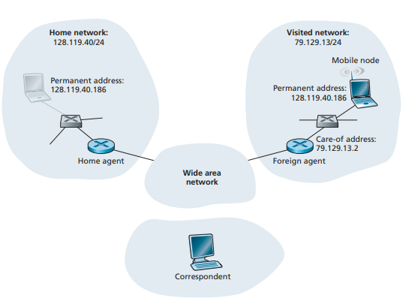

The conceptually simplest approach is to locate foreign agents at the edge routers in the foreign network. One role of the foreign agent is to create a so-called care-of address (COA) for the mobile node. In the example in Figure 6.22, the permanent address of the mobile node is 128.119.40.186. When visiting network 79.129.13/24, the mobile node has a COA of 79.129.13.2. A second role of the foreign agent is to inform the home agent that the mobile node is resident in its network and has the given COA. We’ll see shortly that the COA will be used to “reroute” datagrams to the mobile node via its foreign agent.

#### Routing to a Mobile Node

We know how a mobile node obtains a COA and how the home agent can be informed of that address. Now we need to declare how should datagrams be forward to the mobile node.

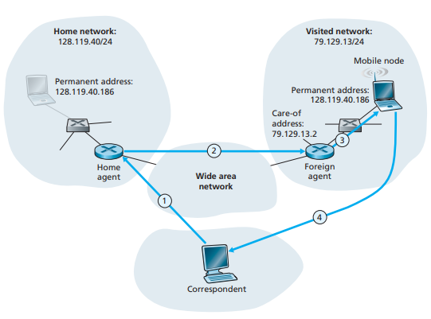

In the **indirect routing approach**, the correspondent simply addresses the datagram to the mobile node’s permanent address and sends the datagram into the network, whether the mobile node is resident in its home or a foreign network.

The home agent has to lookout for arriving datagrams addressed to nodes whose home network is that of the home agent but that are currently resident in a foreign network. The home agent intercepts these datagrams and then forwards them to a mobile node in a two-step process.

The datagram is first forwarded to the foreign agent, using the mobile node’s COA and then forwarded from the foreign agent to the mobile node in step 3.

Since datagrams have been sent to the mobile node, mobile node knows the correspondent address and can address to it directly.

Thus, four additional protocols have to be designed. A mobile-node–to–foreign-agent protocol, a foreign-agent–to–home-agent registration protocol, a home-agent datagram encapsulation COA protocol and a foreign-agent decapsulation protocol.

Triangle routing problem is an inefficiency from indirect routing approach.

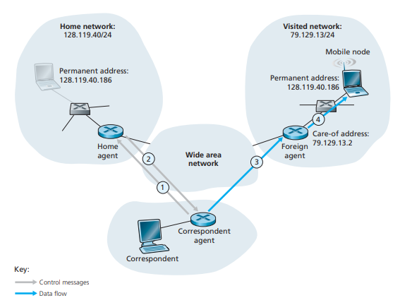

Direct routing overcomes the inefficiency of triangle routing, but does so at the

cost of additional complexity. In the **direct routing approach**, a correspondent agent in the correspondent’s network first learns the COA of the mobile node. This can be done by having the correspondent agent query the home agent. It is also possible for the correspondent itself to perform the function of the correspondent agent, just as a mobile node could perform the function of the foreign agent. This is shown as steps 1 and 2 in Figure. The correspondent agent then tunnels datagrams directly to the mobile node’s COA, in a manner analogous to the tunneling performed by the home agent, steps 3 and 4 in Figure.

Protocols is needed for this approach. A mobile-user location protocol and a protocol used in GSM nowadays for agent moving from one network to another.

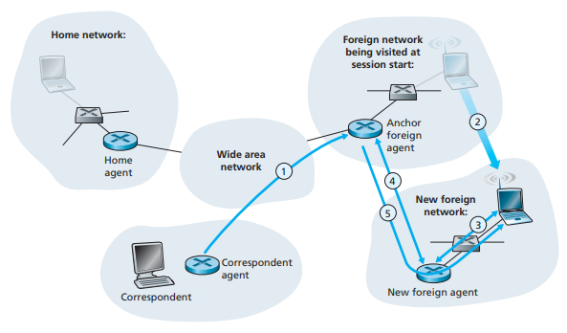

Suppose data is currently being forwarded to the mobile node in the foreign network where the mobile node was located when the session first started (step 1). We’ll identify the foreign agent in that foreign network where the mobile node was first found as the **anchor foreign agent**. When the mobile node moves to a new foreign network (step 2), the mobile node registers with the new foreign agent (step 3), and the new foreign agent provides the anchor foreign agent with the mobile node’s new COA (step 4). When the anchor foreign agent receives an encapsulated datagram for a departed mobile node, it can then re-encapsulate the datagram and forward it to the mobile node (step 5) using the new COA.

### Mobile IP

The Internet architecture and protocols for supporting mobility, collectively known as mobile IP, are defined primarily in RFC 5944 for IPv4.

The mobile IP standard consists of three main pieces:

* **Agent discovery.**

Mobile IP defines the protocols used by a home or foreign agent to advertise its services to mobile nodes, and protocols for mobile nodes to request the services of a foreign or home agent. 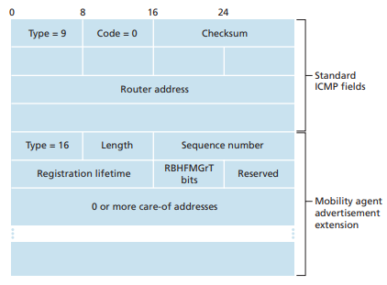

With agent advertisement, a foreign or home agent advertises its services using an extension to the existing router discovery protocol by ICMP type field 9. With agent solicitation, a mobile node wanting to learn about agents without waiting to receive an agent advertisement can broadcast an agent solicitation message, which is simply an ICMP message with type value 10.

* **Registration with the home agent.**

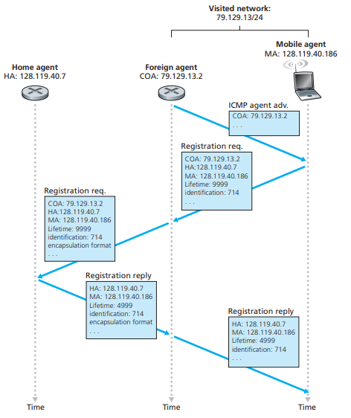

Mobile IP defines the protocols used by the mobile node and/or foreign agent to register and deregister COAs with a mobile node’s home agent.

* **Indirect routing of datagrams.**

The standard also defines the manner in which datagrams are forwarded to mobile nodes by a home agent, including rules for forwarding datagrams, rules for handling error conditions, and several forms of encapsulation.

### Managing Mobility in Cellular Networks

Like mobile IP, GSM adopts an indirect routing approach first routing the correspondent’s call to the mobile user’s home network and from there to the visited network. The home network is the cellular provider with which the mobile user has a subscription. The visited PLMN, which we’ll refer to simply as the visited network, is the network in which the mobile user is currently residing.

As in the case of mobile IP, the responsibilities of the home and visited networks are quite different.

* The home network maintains a database known as the **home location register (HLR)**, which contains the permanent cell phone number and subscriber profile information and locations for each of its subscribers.
* A special switch in the home network, known as the **Gateway Mobile services Switching Center (GMSC)** is contacted by a correspondent when a call is placed to a mobile user.
* The visited network maintains a database known as the **visitor location register (VLR)**. The VLR contains an entry for each mobile user that is currently in the portion of the network served by the VLR. VLR entries thus come and go as mobile users enter and leave the network.

A VLR is usually co-located with the mobile switching center (MSC) that coordinates the setup of a call to and from the visited network.

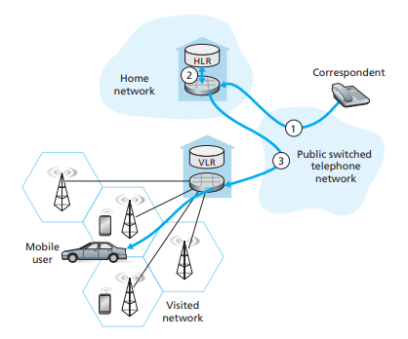

Let’s describe how a routing call is placed to a mobile GSM user in a visited network.

1. The correspondent dials the mobile user’s phone number. The leading digits in the number are sufficient to globally identify the mobile’s home network. The call is routed from the correspondent through the PSTN to the home MSC in the mobile’s home network.
2. The home MSC receives the call and interrogates the HLR to determine the location of the mobile user, returning the **mobile station roaming number (MSRN)**, which we will refer to as the roaming number. The roaming number is temporarily assigned to a mobile when it enters a visited network, like the COA. If HLR does not have the roaming number, it returns the address of the VLR in the visited network.

|  |
| --- |
| How HLR determines the location of the mobile user?  When a mobile telephone is switched on or enters a part of a visited network that is covered by a new VLR, the mobile must register with the visited network.  The visited VLR, in turn, sends a location update request message to the mobile’s HLR with the HLR roaming number and the address of the VLR. As part of this exchange, the VLR also obtains subscriber information from the HLR about the mobile and determines what services should be accorded the mobile user by the visited network. |

1. Given the roaming number, the home MSC sets up the second leg of the call through the network to the MSC in the visited network. The call is completed, being routed from the correspondent to the home MSC, and from there to the visited MSC, and from there to the base station serving the mobile user.

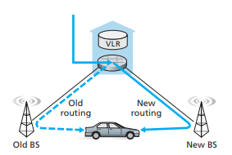

A **handoff** occurs when a mobile station changes its association from one base station to another during a call. As shown in Figure, a mobile’s call is initially routed to the mobile through one base station, and after handoff is routed to the mobile through another base station. It results not only in the mobile transmitting/receiving to/from a new base station, but also in the rerouting of the ongoing call from a switching point within the network to the new base station.

A mobile periodically measures the strength of a beacon signal from its current base station as well as beacon signals from nearby base stations that it can “hear.” Handoff in GSM is initiated by the old base station based on these measurements, the current loads of mobiles in nearby cells, and other factors.

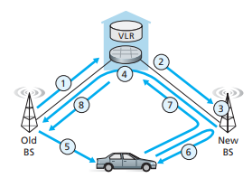

1. The old base station (BS) informs the visited MSC that a handoff is to be performed and the BS to which the mobile is to be handed off.
2. The visited MSC initiates path setup to the new BS, allocating the resources needed to carry the rerouted call, and signaling the new BS about handoff.
3. The new BS allocates and activates a radio channel for use by the mobile.
4. The new BS signals back to the visited MSC and the old BS that the visited-MSC-to-new-BS path has been established. The new BS provides all of the information that the mobile will need to associate with the new BS.
5. The mobile is informed that it should perform a handoff.
6. The mobile and the new BS exchange one or more messages to fully activate

the new channel in the new BS.

1. The mobile sends a handoff complete message to the new BS, which is forwarded up to the visited MSC. The visited MSC then reroutes the ongoing call

to the mobile via the new BS.

1. The resources allocated along the path to the old BS are then released.

But what if the mobile moves to a BS that associated with different MSC?

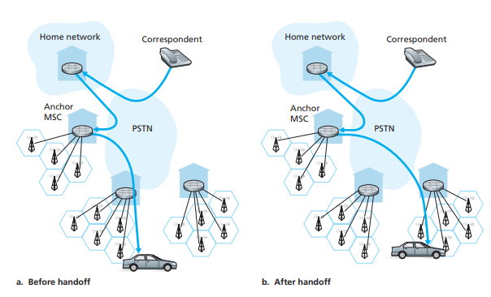

As shown in Figure, GSM defines the notion of an **anchor MSC**. The anchor MSC is the MSC visited by the mobile when a call first begins; the anchor MSC thus remains unchanged during the call.

The call is routed from the home MSC to the anchor MSC, and then from the anchor MSC to the visited MSC where the mobile is currently located. When a mobile moves from the coverage area of one MSC to another, the ongoing call is rerouted from the anchor MSC to the new visited MSC containing the new base station. Thus, at all times there are at most three MSCs between the correspondent and the mobile.

Rather than maintaining a single MSC hop from the anchor MSC to the current

MSC, an alternative approach would have been to simply chain the MSCs visited by

the mobile, having an old MSC forward the ongoing call to the new MSC each time

the mobile moves to a new MSC.

### Wireless and Mobility: Impact on Higher-Layer Protocols

We’ve seen that wireless networks differ from their wired counterparts at both the link layer and at the network layer. But are there important differences at the transport and application layers?

Recall that TCP retransmits a segment that is either lost or corrupted on the path between sender and receiver. In the case of mobile users, loss can result from either network congestion or handoff. Researchers realized in the early to mid 1990s that given *high bit error rates on wireless links and the possibility of handoff loss*, TCP’s congestion-control response could be problematic in a wireless setting. Three broad classes of approaches are possible for dealing with this problem:

* **Local recovery.**

Local recovery protocols recover from bit errors when and where they occur.

* **TCP sender awareness of wireless links.**

The TCP sender and receiver to be aware of a wireless or wired link, to invoke congestion control only in response to congestive wired-network losses.

* **Split-connection approaches.**

The end-to-end connection is broken into two transport-layer connections: one from the mobile host to the wireless access point, and one from the wireless access point to the other communication end point.

## Multimedia Networking

### Multimedia Networking Applications

To be added.

### Streaming Stored Video

To be added.

### Voice-over-IP (VoIP)

Real-time conversational voice over the Internet is often referred to as **Internet**

**telephony**, also commonly called **Voice-over-IP (VoIP)**.

Due to TCP congestion control, packet loss may result in a reduction of the TCP sender’s transmission rate to a rate that is lower than the receiver’s drain rate, possibly leading to buffer starvation. Most existing VoIP applications run over UDP by default.

Some UDP packets can be lost and most packets will not have the same end-to-end delay in a lightly congested Internet. For this reason, the receiver must take care in determining (1) when to play back a chunk, and (2) what to do with a missing chunk.

#### Playout Delay

**End-to-end delay** or **one-way delay (OWD)** is the accumulation of delays from routers, links and end systems. Half the RTT is often used as an approximation of OWD if the forward and backward paths are same situation. For VoIP example, end-to-end delays smaller than 150 msecs are not perceived by a human listener; delays between 150 and 400 msecs can be acceptable but are not ideal. The receiver then can disregard the packets delayed more than a certain threshold, in this example, 400msecs.

Because of the varying delays in network environment, **packet jitter** is happened that the time of receiving a source packet can be fluctuate from packet to packet. Fortunately, jitter can often be removed by using **sequence numbers**,

**timestamps**, and **a playout delay**.

**Timestamps**: The sender stamps each chunk with the generation time.

**Playout delay**: There are two types of playout delay algorithm: fixed or adaptive. Fixed playout delay usually deploys a large delay to make sure all the packet arrived and not lost. Adaptive playout delay is to estimate the delay time as the TCP estimated RRT we mentioned in Ch.3-5 Timeout Interval.

#### Packet Loss

Conversational multimedia applications are loss-tolerant— occasional loss only causes occasional glitches in audio/video playback. There is no need to retransmit the lost packet, which is not suitable for real-time conversational applications. Setting point on avoid losing crucial packets, two types of loss anticipation schemes are **forward error correction (FEC)** and **interleaving**.

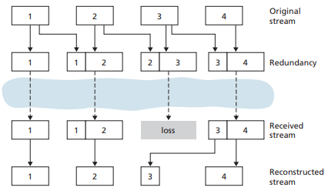

The basic idea of FEC is to add redundant information to the original packet stream. The redundant information can be used to reconstruct approximations or exact versions of some of the lost packets.

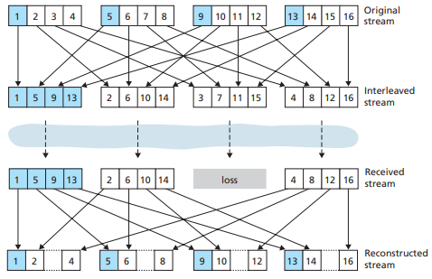

A VoIP application can send interleaved audio. As shown in Figure 7.9, the sender resequences units of audio data before transmission, so that originally adjacent units are separated by a certain distance in the transmitted stream. Interleaving can lighten the effect of packet losses.

A major advantage of interleaving is that it does not increase the bandwidth requirements of a stream. The obvious disadvantage is that it increases latency.

### Protocols for Real-Time Conversational Applications

#### RTP

Real-time Transport Protocol (RTP), defined in RFC 3550, is used for transporting common formats such as PCM, ACC, and MP3 for sound and MPEG and H.263 for video. It can also be used for transporting proprietary sound and video formats.

RTP typically runs on top of UDP, sending a media chunk within an RTP packet.

RTP allows each source to be assigned its own independent RTP stream of packets.

RTP packets can also be sent over one-to-many and many-to-many multicast trees.

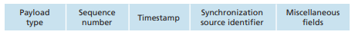

The four main RTP packet header fields are the payload type, sequence number, timestamp, and source identifier fields.

* Payload type field (7 bits): indicate the type of audio encoding or video encoding
* Sequence number field (16 bits): increment by one for each RTP packet sent, and may be used by the receiver to detect packet loss and to restore packet sequence.
* Timestamp field (32 bits): reflects the sampling instant of the first byte in the RTP data packet. The timestamp is derived from a sampling clock at the sender.
* Synchronization source identifier (SSRC)(32 bits): identifie the source of the RTP stream. The SSRC is a number that the source assigns randomly when the new stream is started.

#### SIP

The Session Initiation Protocol (SIP), defined in [RFC 3261; RFC 5411], is an open and lightweight protocol that does the following:

* Establishing calls between a caller and a callee over an IP network. It allows the caller to notify the callee that it wants to start a call. It allows the participants to agree on media encodings or closing calls.
* Determining the current IP address of the callee. Users do not have a single, fixed IP address because they may be assigned addresses dynamically or different IP address by multiple devices.
* Call management. Adding new media streams, changing the encoding, inviting new participants, call transfer, and call holding.

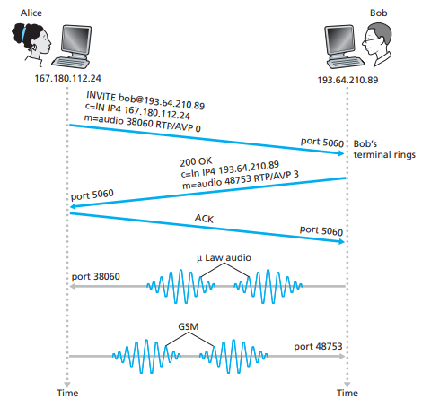

Alice sends Bob an INVITE message, which resembles an HTTP request message. This INVITE message is sent over UDP (or TCP) to the well-known port 5060 for SIP. The INVITE message includes an identifier for Bob(bob@193.64.210.89), an indication of Alice’s current IP address, an indication that Alice desires to receive audio, which is to be encoded in format AVP 0 and encapsulated in RTP, and an indication that she wants to receive the RTP packets on port 38060.

After receiving Alice’s INVITE message, Bob sends an SIP response message at port 5060. Bob’s response includes a 200 OK as well as an indication of his IP address, his desired encoding and packetization for reception, and his port number to which the audio packets should be sent.

After receiving Bob’s response, Alice sends Bob an SIP ACK message. Bob and Alice can talk and send audio packets to each others.

In the previous example, Bob’s SIP address is sip:bob@193.64.210.89. However,

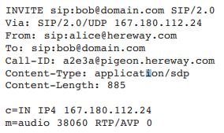

SIP addresses can be resembled as e-mail addresses, phone number or simply unique name, even a Web pages. Let us suppose that Alice knows only Bob’s e-mail

address, bob@domain.com, and that this same address is used for SIP-based calls.

To find this out, Alice creates an INVITE message that begins with INVITE bob@domain.com SIP/2.0 and sends this message to an SIP proxy. The proxy will respond with an SIP reply that might include the IP address, voicemail box, or a

URL of a Web page.

The result returned by the proxy might depend on the caller. Every SIP user has an associated **SIP registrar**. Whenever a user launches an SIP application on a device, the application sends an SIP register message with current IP address to the registrar.

It is just like a DNS authoritative name server: The DNS server translates fixed host names to fixed IP addresses; the SIP registrar translates fixed human identifiers to dynamic IP addresses! Often SIP registrars and SIP proxies are run on the same host.

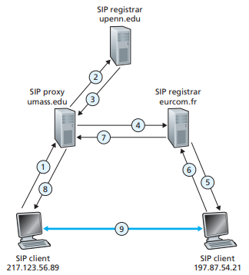

As an example, person A on 217.123.56.89 wants to initiate a Voice-over-IP (VoIP) session with person B on 197.87.54.21.

1. A sends an INVITE message to the umass SIP proxy.
2. The proxy does a DNS lookup on the SIP registrar upenn.edu and then forwards the message to the registrar server.
3. The upenn registrar sends a redirect response, indicating eurecom.fr SIP registar.
4. The umass proxy sends an INVITE message to the eurecom SIP registrar.
5. The eurecom forwards the INVITE message to the host 197.87.54.21.
6. An SIP response is sent back through registrars/proxies to the SIP client on 217.123.56.89.
7. Media is sent.

## Security in Computer Networks

### What is Network Security?

We can identify the following desirable properties of secure communication:

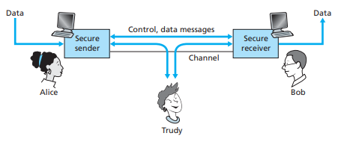

* **Confidentiality**: Only the sender and receiver can understand the message. This requires the method for encryption.
* **Message integrity**: Ensure the content of communication is not changed.
* **End-point authentication**: Confirm the identity of the other party involved in the communication.
* Operational security: Attackers can deposit worms, map the internal network configurations and launch DoS attacks in the public network.

### Principles of Cryptography

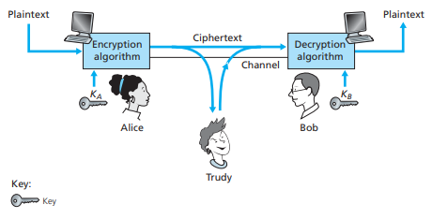

Let’s take a look at crytography. Alice’s message in its original form is known as plaintext, or cleartext. Alice encrypts her plaintext message using an encryption algorithm so that the encrypted message, known as ciphertext, looks unintelligible

to any intruder. However, encryption algorithm is known publicly, even for intruder!

Key is the secret information that’s prevent intruder. Normally there is one for encrypting messages and one for decrypting messages.

#### Symmetric Key Cryptography

In symmetric key systems, both keys from sender and receiver are identical and are secret.

Caesar cipher is the old and simple encryption. Taking each letter in the plaintext message and substituting the letter that is k letters later is what it does. However, only 25 possible key values means it is easily to decrypt.

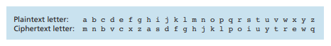

Monoalphabetic cipher builds up the random pattern for substituting space. Every alphabetic can be substituted for any other letter independently. The combination is now become 1026. However, by statistical analysis of the plaintext language, it is still relatively easy to break this code.

Polyalphabetic encryption is to use multiple monoalphabetic ciphers based on different position in the plaintext messages. For example, C1 is used for odd position and C2 is used for even position.

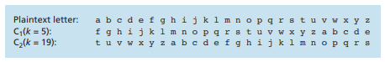

We can distinguish three different scenarios, depending on what information the intruder has: Ciphertext-only attack, Known-plaintext attack and Chosen-plaintext attack.

#### Block Cipher

Block ciphers and stream ciphers are the modern symmetric key encryption. **Block ciphers** are used in PGP, SSL and IPsec. In a block cipher, the message is broken into k-bit blocks, and each block is encrypted independently by one-to-one mapping.

For example, the message in 3-bit block with block number 23 is encrypted by following mapping.

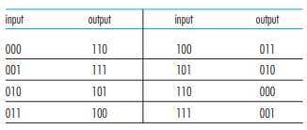

There are 2k! kinds of block mapping table in block cipher. Normally it will go through a typical function for encryption, for instance:

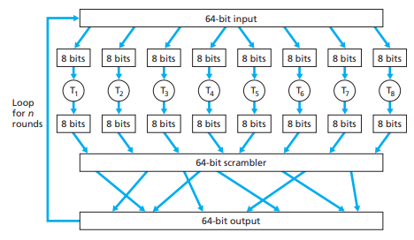

Today there are a number of popular block ciphers, including DES, 3DES, and AES. Each of these standards uses **functions**, rather than predetermined tables. Each of these algorithms uses a string of bits for a key to determine the specific “mini-table” mappings and permutations within the algorithm’s internals.

NIST estimates that a machine that could try all 256 keys in one second in 56-bit DES would take approximately 149 trillion years to crack a 128-bit AES key.

However, if every same plaintext go through the same encryption algorithm, intruder can still find the encryption pair no matter how complicated algorithm is. For example, intruder may find out the change from “HTTP/1.1” as it shows a lot of times.

**Cipher-Block Chaining** can make identical plaintext produce different cipher blocks. Instead of importing random function for every block number, which increases the message bits, we assign the Initialization Vector for first block to process XOR operation. In each block, the origin block bits will do XOR operation with the former result block bits, and translate with the encryption table. The only addition information to be sent is the IV.



Assume Alice has code “010 010 010” and all blocks is using upper showing table. Without CBC, intruder will found out 3 blocks are the same as result ”101 101 101”.

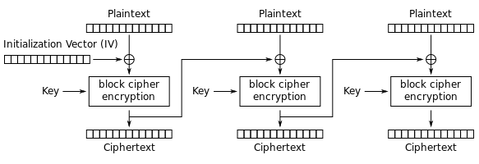

#### Stream Cipher

Stream Cipher can be found in some modern technique, such A5/1 for GSM mobile phone system, RC4 for wireless LANs.

A stream cipher is a symmetric key cipher where plaintext digits are combined with a keystream. In a stream cipher, each plaintext digit is encrypted one at a time with the corresponding digit of the keystream, to give a digit of the ciphertext stream. Since encryption of each digit is dependent on the current state of the cipher, it is also known as state cipher. In practice, a digit is typically a bit and the combining operation is an exclusive-or (XOR).

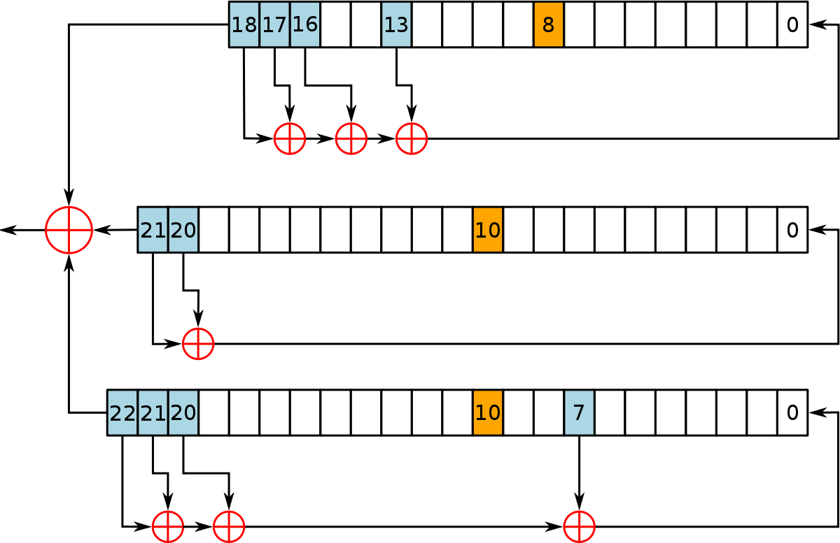

Assume a 64bit space, storing 3 shift registers with 19 bits, 22bit and 23bits(A5/1). In each step, there will be a major vote m, decided by orange bits XOR-ing from three registers. If X8 bit has the same bit as m, register X does the step. Three registers will be decided whether it need to do the step.

Suppose X register needs to do the step. Each register has the fixed XOR function for “new” bit. For X register, new bit will be

X0 then shifts all the other bits backward 1 bit becoming the new statement.

Keystream bit will be , no matter they do the step.

#### Public Key Encryption

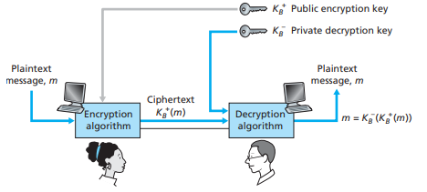

Suppose Alice tries to communicate with Bob. Bob has two keys—a public key that is available to everyone in the world and a private key that is known only to Bob.

**Alice encrypts her message, m, to Bob using Bob’s public key** and a known encryption algorithm. Then, Bob is the only person can decrypt the message with his private key.

First, the intruder knows the public key and the algorithm for encryption. The key selection and decryption must be impossible to determine. Second, since Bob’s encryption key is public, anyone can send an encrypted message to Bob, claiming to be Alice. Sender’s identification can be declared with a digital signature.

Being a well-known public key cryptography, the RSA algorithm uses of arithmetic operations using modulo-n arithmetic. The following steps are performed.

1. Choose two large prime *p* and *q*. (RSA lab recommends p*q>1024-bits)
2. Compute *n = pq* and *z = (p – 1)(q – 1)*. z is known as Carmichael function.
3. Choose a number *e*, which *e<n* and *(e,z)=1*.
4. Find a number *d*, which .
5. Public key is (n, e). Private key is (n, d).

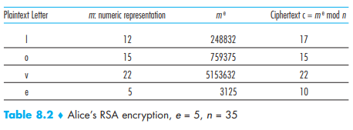.

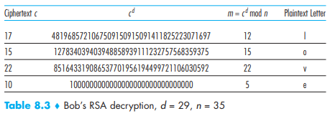

The security of RSA relies on the fact that there are no known algorithms for quickly factoring a number, in this case the public value n, into the primes p and q. Without RSA time-consuming process, DES is much more faster. As this result, symmetric key cryptography also take place in the RSA improvement. Besides encrypting large data through the RSA, they instead encrypt data with symmetric shared key and transfer the shared key through the RSA encryption. The symmetric key is called **session key**.

Another popular public-key encryption algorithm is the **Diffie-Hellman** algorithm. It uses the multiplicative group of integers modulo p, where p is prime, and g is a primitive root modulo p. These two values are chosen in this way to ensure that the resulting shared secret can take on any value from 1 to p–1.

Here is an example of the protocol, with non-secret values in blue, and secret values in red.

Alice and Bob publicly agree to use a modulus p = 23 and base g = 5.

Alice chooses a secret integer a = 4, then sends Bob A = ga mod p

A = 54 mod 23 = 4

Bob chooses a secret integer b = 3, then sends Alice B = gb mod p

B = 53 mod 23 = 10

Alice computes s = Ba mod p

s = 104 mod 23 = 18

Bob computes s = Ab mod p

s = 43 mod 23 = 18

Alice and Bob now share a secret (the number 18).

Both Alice and Bob have arrived at the same values because under mod p,

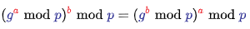

Private Key a is difficult to find by g, p, ga mod p.

#### Elliptic Curve Cryptography

Before going through the key exchange, let us know what elliptic curve is.

|  |  |
| --- | --- |
| In a Weierstrass equation, EC is  where | Bluetooth Hacking: Cheating in Elliptic Curve Billiards | by Tal Be'ery |  HackerNoon.com | Medium |

Here are how points on elliptic curve calculate.

|  |  |
| --- | --- |
| **Addition Rules with abelian group** | Line cross point P and point Q will also cross point R. |
| **Point at infinty** | This is the basic definition for discrete mathematical group.  It is the **identity element**. |
| **Point Negation** | https://upload.wikimedia.org/wikipedia/commons/thumb/c/c1/ECClines.svg/600px-ECClines.svg.png |
| **Point Addition**  The coefficient of x2 is opposite sum of roots. | Part 2 — Is Elliptic Curve Cryptography (ECC) a step towards something more  — Understanding ECC | by Peter Reid | Medium |
| **Point doubling** | Figure 3 from Implementation of point addition & point doubling for Elliptic  Curve | Semantic Scholar |

It is complicated, but they are the basis for ECC.

ECC will assign the formula into **finite field**, .

The meaning of GF(n) is to assign formula to **module** formula.

In ECC, we do the operations for points by **elliptic curve scalar multiplication**.

Because it is a one-way function (Impossible to revert function),

the security of ECC is based on **elliptic curve discrete logarithm problem**.

Finally, we can take a look on what ECC does.

There is a example for Elliptic Curve Diffie-Hellman Key Exchange:

You can find out that

Now Alice has a private random number a=3,

Bob has a private random number b=7.

They calculate their own coordinate from G, that is, aG and bG.

3G = [13,22] and 7G = [17, 8]

|  |  |  |  |  |  |  |
| --- | --- | --- | --- | --- | --- | --- |
|  | p | a | b | G | Priv. Key | Pub. Key |
| Alice | 23 | -2 | 15 | [4,5] | 3 | [13,22] |
| Bob | 23 | -2 | 15 | [4,5] | 7 | [17, 8] |

If Bob gets the public key from Alice, which is [13,22], he calculates 7[13,22].

Alice and Bob will finally get a same coordinate, [15,5].

How it works is that , just like how Diffie-Hellman does!

Every addup in G is untrackable. So decrypt it from formula is a no way.

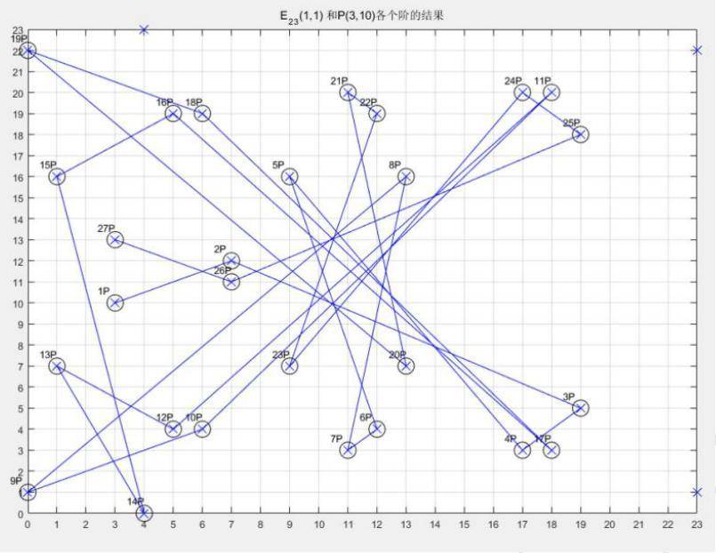

### Message Integrity and Digital Signatures

The purpose of message integrity is to make sure the message is indeed originated from sender and not tampered through the transmission. In this chapter we’ll focus on digital signature and end-point authentication.

#### Cryptographic hash function

Cryptographic hash function is required to have H(x)=H(y) that x and y are two different messages. If sender sends out a pair (m, H(m)), intruder cannot edit two of them secretly as message y can proof the correction of message.

**The MD5 hash algorithm** computes 128-bit hash in a four-step process. It has been used for such as storing password in UNIX system.

1. Padding: Adding extra bits to message.

append "1" bit to message

append "0" bit until message length in bits ≡ 448 (mod 512)

1. Append Length: 64 bits for recording the length of original message.

append original length in bits mod 264 to message

1. Initialize MD buffer: A four-word buffer (A, B, C, D) is used to compute the values for the message digest.
2. Buffer operation: doing these functions and additional exchange according to there buffer locations.

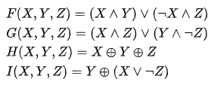

Although MD5 is easy and can compress the size of messages, it cannot avoid the hash collision and relatively high time-consuming.

**Secure hash algorithm (SHA)** is the major hash algorithm in use today. There are four standards for SHA by NIST.

* SHA-0: A prototype but with a significant flaw. (Easily to break)
* SHA-1: A 160-bits hash function was designed for Digital Signature Algorithm. This is no longer approved after 2010 due to cryptographic weakness.
* SHA-2: Designed by NSA. Allow different block sizes, such as SHA-256, SHA-512.
* SHA-3: It has totally different algorithm from former 3 standards. Called as Keccak.

#### Message Authentication Code

Now, Alice can send (m, H(m)) to Bob and Bob can ensure the coming message (m, h) with hash standard algorithm. But what if intruder assumes to be Alice and send a fake pair of (m’, H(m’))?

A secret key for identify sender is called the authentication key. Alice instead sends (m, H(m+s)), which H(m+s) is known as message authentication code (MAC). Bob then can verify the coming message with this secret key whether it is sent by Alice or not. There are multiple MAC standards nowadays. HMAC is the most popular standard used MD5 or SHA-1 through hash algorithm twice.

#### Digital Signatures

Suppose that Bob wants to digitally sign a document, m. We can think of the

document as a file or a message that Bob is going to sign and send. Bob simply uses his private key to encrypt his message as a digital signature. (In RSA, sender encrypts message with PUBLIC KEY FROM RECEIVER) Alice now can verify the digital signature with Bob’s public key and get the message m.

The following graph is the normal approach for digital signatures.

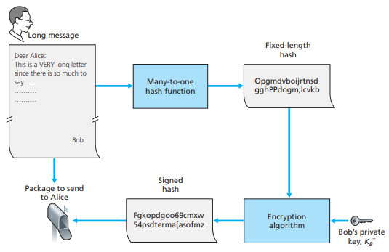

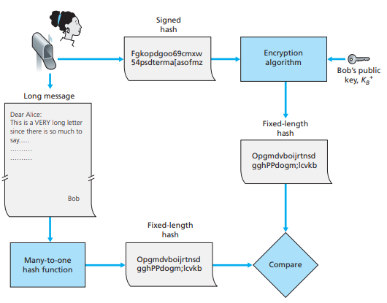

|  |  |
| --- | --- |
| MAC | Signature |
| Quicker | Slower |
| Repudiation | Non-repudiation |
| Doing BEFORE hash | Doing AFTER hash |

#### Public Key Authentication

What if the intruder, write the message, sign digital signature with his own private key, and include his public key to pretend to be Bob? Alice would have no idea it is not from Bob. Here comes public key authentication.

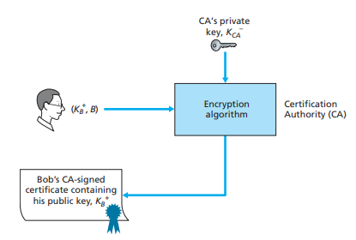

Binding a public key to a particular entity is typically done by a **Certification**

**Authority (CA)**, whose job is to validate identities and issue certificates. As every one can be CA and certificate the public key, it is important to find the TRUSTFUL CA.

A CA certificate includes the certificated user’s public key, a public key for CA certificate itself which is signed digitally with CA’s private key.

In conclusion: three types of technique are shown in this table.

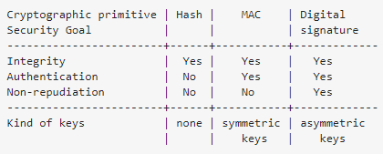.

### End-Point Authentication

Typically, an authentication protocol (ap) would run before the two communicating parties run some other protocol. The authentication protocol first establishes the identities of the parties to each other’s satisfaction; only after authentication do the parties get down to the work at hand.

We can divide the level of ap:

|  |  |
| --- | --- |
| ap1.0  Send identification of user.  But we cannot ensure the man behind machine. |  |
| ap2.0  Sending identification of user and other information like IP address.  IP spoofing is a well-known problem as intruder can fake the IP datagram. |  |
| ap3.0  Using a password.  Intruder can still sniff the packet or eavesdrops on communications.  ap3.1  Encrypting the password.  Intruder can do **playback attack** by sending encrypted password. |  |
| ap4.0  Check for Alice is “live”.  A **nonce** is a number that protocol will use only once in a lifetime.  It can be encrypted, too. | |

### Secure Email: PGP

Pretty Good Privacy (PGP) is an e-mail encryption scheme that has become a de facto standard. The PGP design is shown in Figure 8.21.

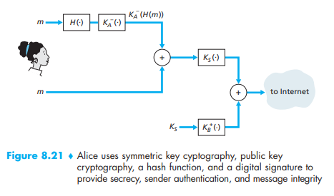

Depending on the version, the PGP software uses MD5 or SHA for calculating the message digest; CAST, triple-DES, or IDEA for symmetric key encryption; and RSA for the public key encryption.

### Secure TCP Connection: SSL

Cryptography can enhance TCP with security services, including confidentiality, data integrity, and end-point authentication. This enhanced version of TCP is commonly known as **Secure Sockets Layer (SSL)**. A slightly modified version of SSL version 3, called **Transport Layer Security (TLS)**, has been standardized by the IETF [RFC 4346].

Let’s give a example for the need of SSL. Bob purchases perfumes at Alice’s website using credit cards. Then:

* If no confidentiality (encryption) is used, an intruder could intercept Bob’s order and obtain his payment card information.
* If no data integrity is used, an intruder could modify Bob’s order.
* If no server authentication is used, a server from Trudy could display Alice’s website, carrying out an identity theft.

SSL addresses these issues by enhancing TCP with confidentiality, data integrity,

server authentication, and client authentication.

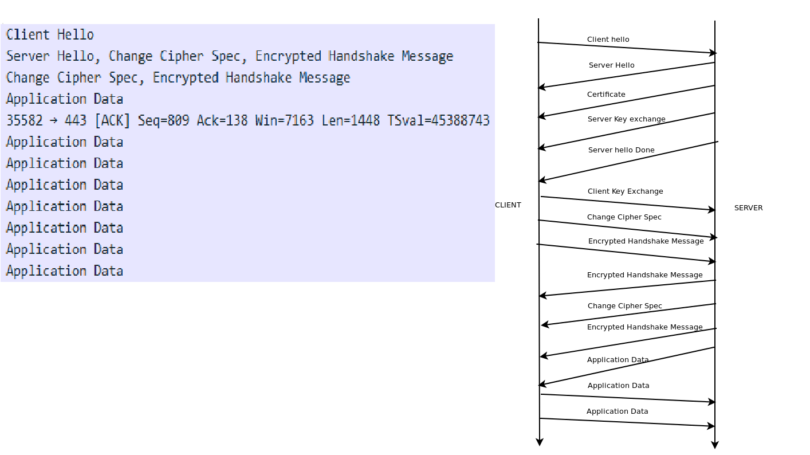

The steps of the SSL are as follows:

1. The client sends a list of cryptographic algorithms it supports, along with a client nonce. (Client Hello)
2. From the list, the server sends back its choices of symmetric, asymmetric and MAC algorithm, as well as a certificate and a server nonce.

(Server Hello, etc.)

1. The client verifies the certificate, extracts the server’s public key, generates a Pre-Master Secret (PMS), encrypts the PMS with the server’s public key, and sends the encrypted PMS to the server.

(Client Key Exchange)

1. Using the same key derivation function, the client and server independently compute the Master Secret (MS) from the PMS and nonces. The MS is then sliced up to generate the two encryption and two MAC keys for different usages.

MAC keys are used for encrypting sliced data called records.

(Change Cipher Spec)

1. The client sends a MAC of all the handshake messages.

(Encrypted Handshake)

1. The server sends a MAC of all the handshake messages.

(Encrypted Handshake)

1. Records are now sending with MAC.
2. Before sending TCP FIN, an encrypted closure record will be sent by one of the connector.



### Network-Layer Security: IPsec and Virtual Private Networks

The IP security protocol, more commonly known as IPsec, provides security at the network layer. IPsec secures IP datagrams between any two network-layer entities, including hosts and routers. Many institutions use IPsec to create

virtual private networks (VPNs) that run over the public Internet.

#### IPsec and VPNs

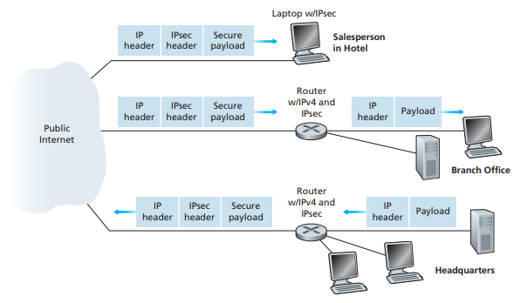

#### The AH and ESP Protocols

In the IPsec protocol suite, there are two principal protocols: the Authentication Header (AH) protocol and the Encapsulation Security Payload (ESP) protocol.

When a source router sends secure datagrams to a destination router, it does so with either the AH protocol or the ESP protocol.

The AH protocol provides source authentication and data integrity but does not provide confidentiality. The ESP protocol provides source authentication, data integrity, and confidentiality. Because confidentiality is often critical for VPNs

and other IPsec applications, the ESP protocol is much more widely used than the AH

protocol.

#### Security Associations

Before sending IPsec datagrams from source entity to destination entity, the source and destination entities create a network-layer logical connection. This logical connection is called a **security association (SA)**.

An SA is a simplex logical connection; that is, it is unidirectional from source to destination. If both entities want to send secure datagrams to each other, then two SAs need to be established, one in each direction.

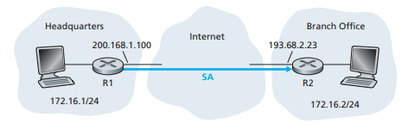

Assume a SA from router R1 to router R2 in Figure. Router R1 will maintain state

information about this SA, which will include:

* A 32-bit identifier for the SA, called the **Security Parameter Index (SPI)**.
* The origin interface of the SA (200.168.1.100) and the destination interface of the SA (193.68.2.23)
* The type of encryption to be used (for example, 3DES with CBC)
* The encryption key
* The type of integrity check (for example, HMAC with MD5)
* The authentication key

Whenever router R1 needs to construct an IPsec datagram for forwarding over this SA, it accesses this state information to determine how it should authenticate

and encrypt the datagram.

An IPsec entity (router or host) often maintains state information for many SAs.

An IPsec entity stores the state information for all of its SAs in its **Security Association Database (SAD)**, which is a data structure in the entity’s OS kernel.

#### The IPsec Datagram

IPsec has two different packet forms, one for the so-called tunnel mode and the other for the so-called transport mode. The tunnel mode, being more appropriate for VPNs, is more widely deployed than the transport mode.

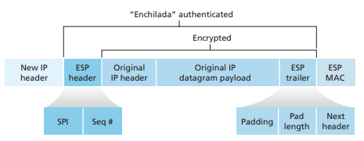

Suppose router R1 receives an ordinary IPv4 datagram from host 172.16.1.17 which is destined to host 172.16.2.48. Router R1 uses the following recipe to convert this “original IPv4 datagram” into an IPsec datagram:

1. Appends to the back of the original IPv4 datagram an “ESP trailer” field.
2. Encrypts the result using the algorithm and key specified by the SA
3. Appends to the front of this encrypted quantity a field called “ESP header”; the resulting package is called the “enchilada”
4. Creates an authentication MAC over the whole enchilada using the algorithm and key specified in the SA
5. Appends the MAC to the back of the enchilada forming the payload
6. Finally, creates a brand new IP header with all the classic IPv4 header fields (together normally 20 bytes long), which it appends before the payload.

The new IP header will include new source IP and destination IP with the address of ROUTERS. The protocol number for IPsec is set on new header as port 50.

In the ESP header, it consists of two fields: **the SPI** and **the sequence number field**. The SPI indicates to the destination receiving entity, the receiving entity can then index its SAD with the SPI to determine the appropriate authentication algorithms and keys. The sequence number field is used to defend against replay attacks.

The ESP trailer consists of three fields: **padding**; **pad length**; and **next header**.

Padding is an integer number of blocks for block cipher. The pad-length field indicates how much padding was inserted. The next header identifies the type (e.g., UDP) of data contained in the payload-data field.

But how does the router know which of the incoming datagrams from LAN should be converted into IPsec? In which SA should it be? Along with a SAD, another data structure called the **Security Policy Database (SPD)**. The SPD indicates what types of datagrams (as a function of source IP address, destination IP address, and protocol type) are to be IPsec processed; and for those that are to be IPsec processed, which SA should be used.

#### IKE: Key Management in IPsec

The SA information (encryption algorithms and keys, and the SPIs) of the SADs should be managed automatically if there is a large number of hosts. IPsec does this with the **Internet Key Exchange (IKE)** protocol, specified in RFC 5996.



The IKE protocol has the two entities exchange certificates: negotiate authentication and encryption algorithms, and securely exchange key material for creating session keys in the IPsec SAs.

Same example for R1 and R2.

1. During the first exchange of messages, the two sides use Diffie-Hellman to create a bi-directional IKE SA between the routers. The IKE SA provides an authenticated and encrypted channel between the two routers.

During this first message-pair exchange, keys are established for encryption and authentication for the IKE SA. Also established is a master secret used for Phrase 2.

1. During the second exchange of messages, both sides reveal their identity to each other by signing their messages through the secured IKE SA channel. Also during this phase, the two sides negotiate the IPsec encryption and authentication algorithms to be employed by the IPsec SAs.

The authentication between two router in Phrase 1 uses RSA public and private key encryption, while Phrase 2 doesn’t. As the result, two routers don’t need plenty of time for setting SAs.



### Securing Wireless LANs

#### Wired Equivalent Privacy (WEP)

The IEEE 802.11 WEP protocol was designed in 1999 to provide authentication and data encryption between a host and a wireless access point **using a symmetric shared key approach**. *WEP does not specify a key management algorithm*, so it is assumed that the host and wireless access point have somehow agreed on the key via an out-of-band method.

Authentication is carried out as follows:

1. A wireless host requests authentication by an access point.
2. The AP responds to the authentication request with a 128-byte nonce value.
3. The wireless host encrypts the nonce using the shared symmetric key.
4. The access point decrypts the host-encrypted nonce.

If the decrypted nonce matches the nonce value originally sent to the host, then the host is authenticated by the access point.

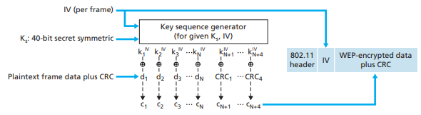

In addition, a 24-bit Initialization Vector (IV) is appended to the 40-bit key to create a 64-bit key that will be used to encrypt a single frame. Each IV is different from one frame to another.

First a 4-byte CRC value is computed for the data payload. The payload and the four CRC bytes are then encrypted using the RC4 stream cipher. These operations being performed a byte at a time. Encryption is performed by XOR-ing the ith byte of data with the i-th key IV to produce the i-th byte of ciphertext.

There is a major problem with WEP. If intruder uses chosen-plaintext attack to send a request to victim, victim may respond the cipher text, which can calculate the keys by XOR the plaintext and cipher text and guess the message!

Somehow, 40-bit key is relatively easy to break nowadays, WEP is no longer suitable for wireless security.

#### Wi-Fi Protected Access (WPA)

WPA has discrete modes for enterprise users and for personal use. The enterprise mode, WPA-EAP, uses more stringent 802.1x authentication with the **Extensible Authentication Protocol (EAP)**. The personal mode, WPA-PSK, uses preshared keys for simpler implementation and management among consumers and small offices. Enterprise mode requires the use of an authentication server.

WPA's encryption method is the **Temporal Key Integrity Protocol (TKIP)**. TKIP includes a per-packet mixing function, a message integrity check, an extended initialization vector and a re-keying mechanism. TKIP is actually quite similar to WEP encryption. WPA depends on a central authentication server, such as RADIUS, to authenticate each user.

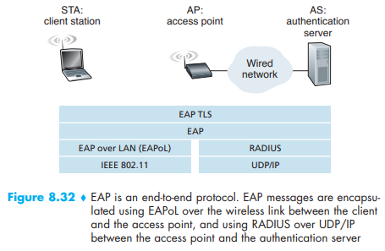

The **Extensible Authentication Protocol (EAP)** [RFC 3748] defines the end-to-end message formats used in a simple request/response mode of interaction between the client and authentication server.

EAP messages are encapsulated using EAPoL and sent over the 802.11 wireless link. These EAP messages are then decapsulated at the access point, and then re-encapsulated using the **RADIUS** or **Diameter** protocol for transmission over UDP/IP to the authentication server.

With EAP, the authentication server can choose one of a number of ways to perform authentication. The EAP-TLS authentication scheme [RFC 5216] is often used. EAP-TLS uses public key techniques and to derive a Master Key (MK) that is known to both parties. (Similar to TCP-SSL)

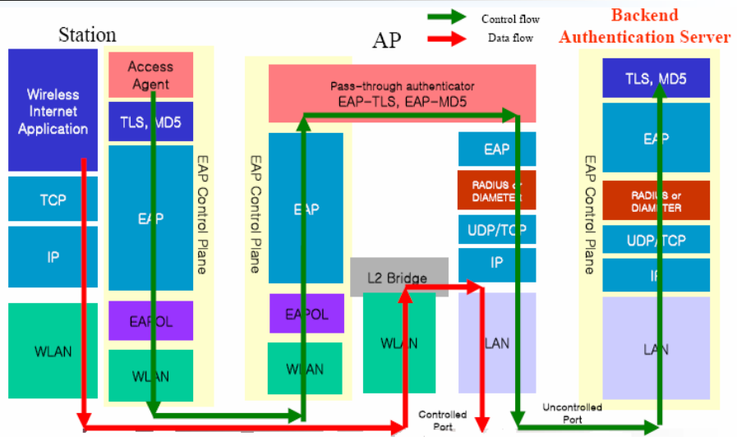

#### IEEE 802.11i

**IEEE 802.11i**, also known as **WPA2** by the WiFi Alliance, provides for much stronger forms of encryption, an extensible set of authentication mechanisms, and a key distribution mechanism. This is how it works for wireless 4-way handshake.

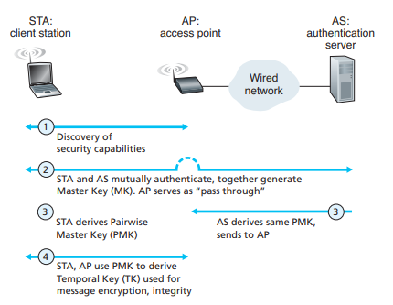

1. Discovery

The AP advertises its presence and authentication for wireless client node.

1. Mutual authentication and Master Key (MK) generation

Authentication takes place between the wireless client and the authentication server using EAP. MK is also called **Pre-shared Key (PSK)**.

1. Pairwise Master Key (PMK) generation.

The MK is a shared secret known only to the client and the authentication server, which they each use to generate a second key, the **Pairwise Master Key (PMK)**. The authentication server then sends the PMK to the AP.

1. Temporal Key (TK) generation.

With the PMK, the wireless client and AP can now generate additional keys that will be used for communication. Temporal Key (TK) will be used to perform the link-level encryption of data sent over the wireless link.

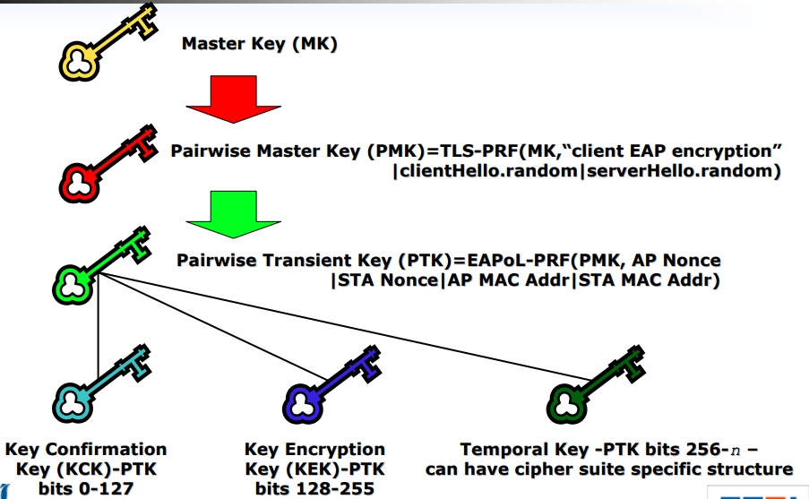

In this decades, brute-force attacks on WPA2-Personal “Packet” has been a serious problem. In the following graph, intruder can grab the data and brute-force attack the TK password, thus all the data can be decrypted with TK. In 2018, here comes WPA3.

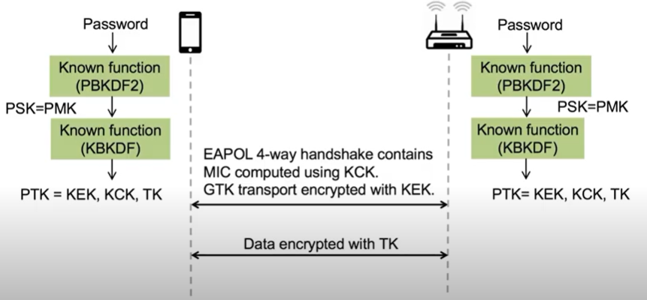

#### Wi-Fi Protected Access 3

Besides longer-bit cryptographic strength, WPA3 provides improvements to the general Wi-Fi encryption, thanks to **Simultaneous Authentication of Equals (SAE)** replacing the Pre-Shared Key (PSK) authentication method used in prior WPA versions. Personal network can’t ever snoop on another’s WPA3-Personal traffic, even when the user has the Wi-Fi password and is successfully connected.

**Simultaneous Authentication of Equals (SAE)** is based on Dragonfly Key Exchange. The shared key can generate a session key EACH TIME they commit and confirm from each other. Easier to say, Alice and Bob turn their password into group password P on their own by hunting-and-pecking procedure, intruder now cannot guess the password as he can only try one password at a time.

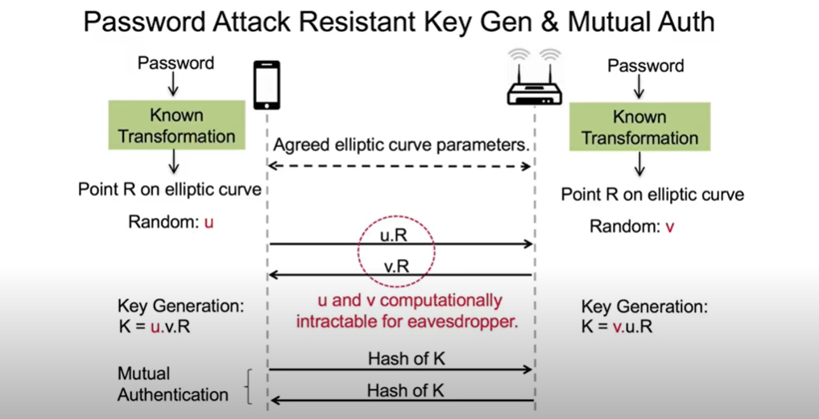

This is Simple Password Exponential Key Exchange (SPEKE), the former version of Dragonfly. The difference is the key generation function is quite different. Even intruder finds the u.R, he cannot compute key K because the random number v.

### Operational Security: Firewalls and Instruction Detection Systems

#### Firewalls

A firewall allows a network administrator to control access between the outside world and resources within the administered network by managing the traffic flow to and from these resources.

Firewalls can be classified in three categories: **traditional packet filters**,

**stateful filters**, and **application gateways**.

**Traditional Packet Filters** make decisions based on: IP address, Protocol, port, TCP flag, ICMP type, flow directions and interfaces.

**Stateful filters** is similar to packet filters, but it can check packet’s relationship. TCP three-way handshake can be indicated with SYN, SYNACK and ACK, so “check connection” is also in the access control list (ACL).

For example, internal user try to surf external Website, then the HTTP responds may be block in the packet filter, but not in stateful filter as knowing it begins with user’s request.

**Application Gateway** checks to see if the user has permission to access to the certain applications inside a firewall. It is a proxy server for connecting application. A session is established between the remote user and the proxy application, while a separate, independent session is established between the proxy application and the internal web server. The remote user makes a request to the proxy, the proxy acts as a go-between and obtains the information from the internal web server, and then the proxy returns the result to the remote user.

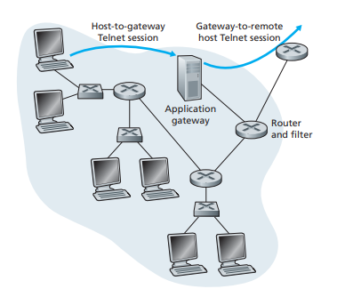

#### Netfilter

Netfilter offers various functions and operations for packet filtering, network address translation, and port translation in Linux kernal. Different kernel modules are used for different protocols; iptables applies to IPv4, ip6tables to IPv6, arptables to ARP, and ebtables to Ethernet frames. These tables use the same core structure named as Xtables.

Packets are processed by sequentially traversing the rules in chains. A rule in a chain can cause a goto or jump to another chain. There are five predefined chains, though a table may not have all chains:

* PREROUTING: Packets will enter this chain before a routing decision is made.
* INPUT: Packet is going to be locally delivered. It does not have anything to do with processes having an opened socket; local delivery is controlled by the "local-delivery" routing table: ip route show table local.
* FORWARD: All packets that have been routed and were not for local delivery will traverse this chain.
* OUTPUT: Packets sent from the machine itself will be visiting this chain.
* POSTROUTING: Routing decision has been made. Packets enter this chain just before handing them off to the hardware.

A chain does not exist by itself; it belongs to a table. There are three tables: nat, filter, and mangle. Each table stores chain in it.

* iptable_raw module

Filter packets before they reach more memory-demanding operations.

For instance, a web server may mark port 80 packets for not doing further filtering.

* iptable_mangle module

This enables additional modifications by rules that follow, such as NAT or further filtering. It also modifies entries in packet header (ToS, TTL).

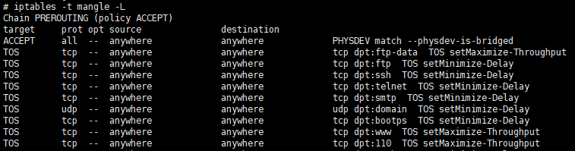

* iptable_nat module

Registers two hooks: Destination Network Address Translation-based transformations ("DNAT") are applied before the filter hook, Source Network Address Translation-based transformations ("SNAT") are applied afterwards.

The NAT table is merely a "configuration database" for NAT mappings only.

* iptable_filter module

Registers the filter table, used for general-purpose filtering (firewalling).

* connection_tracking module

This is based on stateful packet. User can modify it as conntrack. iptables can make use of checking the connection's information.

NEW, ESTABLISHED, RELATED, INVALID, UNTRACKED.

* ebtables module

It enables transparent filtering of network traffic passing through a Linux bridge.

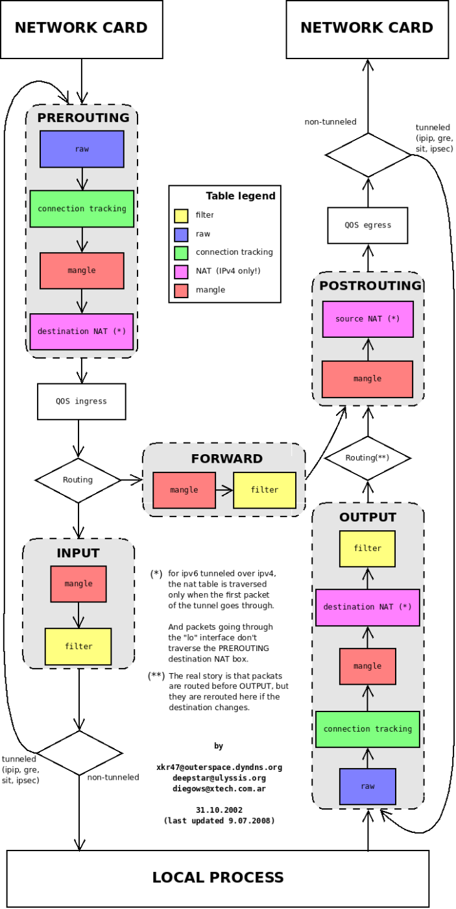

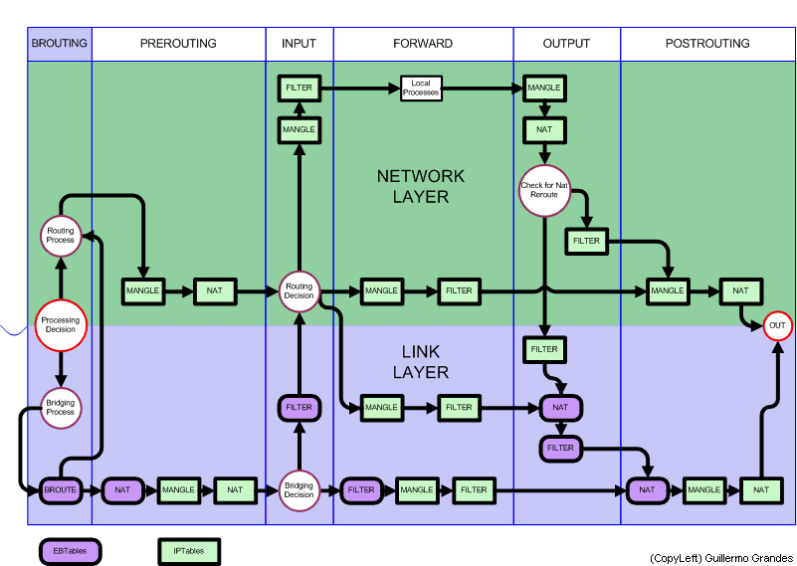

## Network Management

The International Organization for Standardization (ISO) has created a network management model. Five areas of network management are defined:

* **Performance management.**

The goal of performance management is to quantify, measure, report, analyze, and control the performance of different network components.

* **Fault management.**

The goal of fault management is to log, detect, and respond to fault conditions in the network.

* **Configuration management.**

Configuration management allows a network manager to track which devices are on the managed network and the hardware and software configurations of these devices.

* **Accounting management.**

Accounting management allows the network manager to specify, log, and control user and device access to network resources.

* **Security management.**

The goal of security management is to control access to network resources according to some well-defined policy.

## Network devices

### Introduction

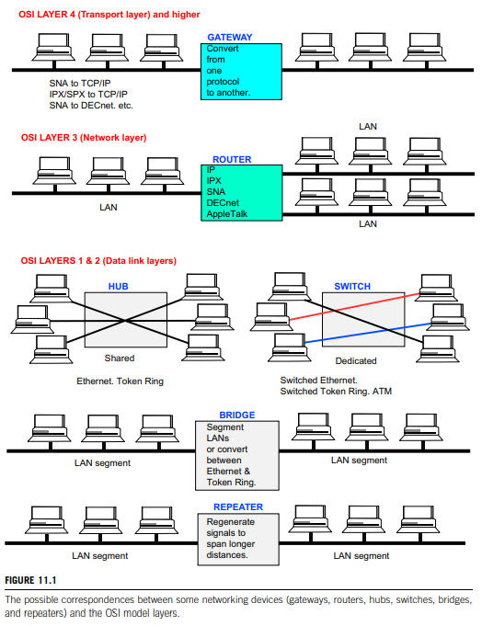

### Hubs and Switches

#### Hubs

Hub is a physical-layer repeaters. Bits coming in one link go out all other links at same rate. All nodes connected to hub can collide with one and another. There is no frame buffer or CSMD/CD.

#### Switches

This link-layer device is smarter than hub, taking active role. Switches not only store and forward Ethernet frames but examine incoming frame’s MAC address, selectively forward frame to one-or-more outgoing links when frame is to be forwarded on segment by CSMA/CD.

Hosts attached with same switch are transparent as they are in the same subnet. Switches do not need to be configured for new hosts, the feature of plug-and-play is pretty convenient for network users. It can create its switch table by storing the transmission history or broadcasting (flooding to all) for the destination. Switches also support packets buffer.

### Network Routers

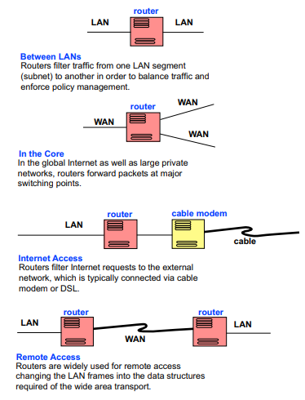

To be added.

### Bridges, Gateways and Repeaters

To be added.

#### Gateways

A network gateway is a device with dedicated hardware and software that translates between two different protocols, making communication possible between networks of different architectures and protocols.

Network gateways are also called protocol converters or translators, and can *operate at any layer of the OSI mode*l.

There are three main categories of gateways: **protocol gateways**; **application gateways**; and **security gateways**.

Three functions can be found in gateways:

* **Data tunneling**: Tunneling is a relatively common technique for passing data through an otherwise incompatible network region.

Data packets are encapsulated with framing that is recognized by the network that will be transporting it. Unacceptable packets are disguised in an acceptable format by encapsulated with framing that can be transported. It can also be used to defeat firewalls by encapsulating protocols that would be blocked from entry to a private network region.

* **Resolve frame format mismatches**. Different networks have frame structures and media access mechanisms that make them unable to interoperate directly. The current generation of multiple protocol switches usually provides a high-bandwidth backplane that functions as a layer 2 protocol converting gateway which provides on-the-fly translation of the dissimilar portions of the frame structures.
* **Resolve transmission rate mismatches.** The memory buffers in network devices can resolve the transmission rate differences. This memory buffers incoming and outgoing packets long enough for the gateways to determine which, if any, of the access list permissions apply. It can also be used to buffer the speed mismatches that may exist between the various network technologies.

(a) Protocol gateways

Protocol gateways usually convert (or translate) between protocols.

An example of protocol gateways used in industrial control networks: a serial gateway can collect data from the devices on the serial RS232/422/485/ASCII subnetwork, where the data are stored in the memory, which can be accessed by the Fieldbus/Ethernet network.

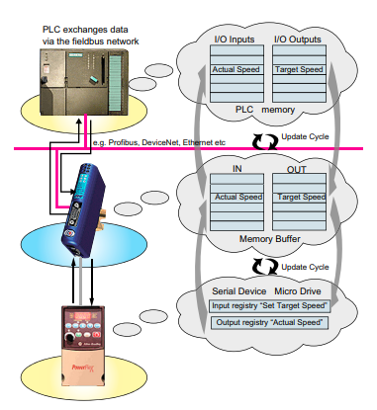

(b) Application gateways

Application Gateway is a type of firewall that provides application-level control over network traffic. The typical application gateway accepts inputs in one format, translates it, and ships the outputs in a new format. The input and output interfaces can either be separate, or use the same network connection. A single application can have multiple application gateways.

For example, electronic mail can be implemented in a wide variety of formats. Servers that provide electronic mail may be required to interact with other electronic mail servers, regardless of their format. The only way to do this is to support multiple gateway interfaces.

Application gateways can be used to connect LAN clients to external data sources. This type of gateway provides for local connectivity to an interactive application. Keeping the logic and executable code of the applications on the same LAN as the client base avoids lower bandwidth, higher-latency WANs, which in turn, enables better response time to clients. The application gateway would then ship an I/O request to the appropriate networked computer that housed the data requested by the client. The data are fetched and reformatted as needed for presentation to the client.

(c) Security gateways

The security gateway is a network gateway that acts as a firewall to filter packets and separate a proprietary network, such as an intranet, from a public one, such as the Internet.

To protect a local network, a gateway is usually used to connect between the local and public network. Through the use of network address translation techniques, a gateway provides security as a firewall while enabling machines with local IP addresses to access the Internet through the unique global address of the gateway. The gateway will receive the packet from the local machine, and substitute its external IP address and a new port address into the source fields of the IP and UDP headers. Data packets entering or exiting a local network are screened or filtered in a firewall.

A gateway may also secure data packets transmitted between, for example, certain local networks, so acting as both a firewall and a VPN (virtual private network) gateway.

In the network for an enterprise, a gateway computer is often also acting as a proxy server and a firewall server. A gateway is often associated with both a router, which knows where to direct a given packet of data that arrives at the gateway, and a switch, which furnishes the actual path in and out of the gateway.

## Ex. Package or Code Manual

#### Iptables

iptables –L // list all rules

iptables –t filter –L // list certain table rules

iptables –F // delete all rules in this table

iptables –X // delete all rules in all tables

iptables –Z // delete all analysis history

// Default policy

iptables -P INPUT DROP

iptables -P OUTPUT ACCEPT

iptables -P FORWARD ACCEPT

// add rule (exculsive)

iptables [-AI 鏈名] [-io 網路介面] [-p 協定] \

[-s 來源IP/網域] [--sport 埠口範圍] [-d 目標IP/網域] [--dport 埠口範圍] -j [ACCEPT|DROP|REJECT|LOG]

-A 新增規則(插入到最後) –I 新增規則(插入到最前)

-i 對應鏈名 INPUT -o 對應鏈名 OUTPUT

iptables -A INPUT -i eth1 -s 192.168.100.0/24 -j ACCEPT

iptables -A INPUT -i eth0 -p tcp --dport 21 -j DROP

iptables -A INPUT -p icmp --icmp-type 3 -j ACCEPT

## Ex. Uncategorized Memo

OFDM: FDM without guard band between each subchannel

Orthognal makes different signals peak will not colliside with other signals (0)

BPSK: 波相偏移調變(shifting)

(sin(theta)) 1bit:

(theta,signal) =(0,0),(180,1)

QPSK: 波相偏移調變(shifting)

(sin(theta)) 2bit:

(theta,signal)=(0,00),(90,01),(180,10),(270,11)

DQPSK: Differnetial Encoding+QPSK (用前時項Xor編碼，重視訊號”變化”)

OQPSK: offset QPSK, limit the phase-shift to no more than 90°

QAM: 正交振幅調變 (QPSK+Altitude)

(*sin(theta)) 4bit: (m,a,theta,signal)= A: Altitude ex:(-1,-0.5,0.5,1)

(+, 0, 0,0000)(+, 0, 90,0001)(+, 0,180,0010)(+, 0,270,0011)

(+, 1, 0,0100)(+, 1, 90,0101)(+, 1,180,0110)(+, 1,270,0111)

….just example, something like that

Bufferbloat: 因過多Buffer導致轉發嚴重延遲

(buffer如高速公路閘道，閘道管制控制速度，非容量)

# Abbreviation

|  |  |
| --- | --- |
| Name | Full information |
| ABR | available bit rate |
| ACK | acknowledgement |
| ADSL | Asymmetric Digital Subscriber Line |
| AFTR | Address Family Transition Router |
| AIMD | Additive increase, Multiplicative decrease |
| API | Application Programming Interface |
| ARP | Address Resolution Protocol |
| AS | autonomous system |
| ATM | Asynchronous Transfer Mode |
| B4 | Basic Bridging BroadBand |
| BGP | Border gateway protocol |
| CDMA | code-division multiplexing access |
| CIDR | Classless Interdomain Routing |
| CMTS | cable modem termination system |
| CPE | Customer’s Premises Equipment |
| CRC | cyclic redundancy check |
| CSMA | Carrier Sense Multiple Access |
| CSMA/CD | Carrier Sense Multiple Access with Collision Detection |
| DHCP | Dynamic Host Configuration Protocol |
| DNS | Domain Name Server |
| DOCSIS | Data-Over-Cable Service Interface Specifications |
| DSL | Digital Subscriber Line |
| DVMRP | Distance Vector Multicast Routing Protocol |
| EDC | error detection and correction bits |
| EWMA | exponential weighted moving average |
| FDMA | Frequency-Division Multiplexing Access |
| FEC | forward error correction |
| FQDN | Fully Qualified Domain Name |
| FTP | File Transfer Protocol |
| HOL | Head-of-the-Line |
| HTTP | HyperText Transfer Protocol |
| ICMP | Internet Control Message Protocol |
| IEEE | Institute of Electrical and Electronics Engineers |
| IETF | Internet Engineering Task Force |
| IGD | Internet Gateway Device |
| IGMP | Internet Group Management Protocol |
| IGP | Interior Gateway Protocol |
| IP | Internet Protocol |
| ISP | Internet Service Provider |
| JPEG | Joint Photographic Experts Group |
| LAN | Local Area Network |
| MAC | medium access control |
| MIME | Multipurpose Internet Mail Extensions |
| NAT | Network Address Translation |
| NIC | network interface card |
| OSPF | Open Shortest Path First |
| OWD | one-way delay |
| P2P | Peer-to-Peer |
| PIM | Protocol Independent Multicast |
| PQDN | Partially Qualified Domain Name |
| QoS | Quality of Service |
| rdt | Reliable data transfer |
| RFC | Requests for Comment |
| RIP | Routing Information Protocol |
| RR | Resource Records |
| RTT | Round Trip Time |
| SMTP | Simple Mail Transfer Protocol |
| UPnP | Universal Plug-and-Play |
| VLSM | Variable Length Subnet Mask |
| VoIP | Voice-over-IP |
|  |  |
|  |  |

# Reference

1. Nen-Fu Huang, “Introduction to Computer Networks”, Lecture Recording,

OCW09801, National Tsing Hua University, delivered December 2010.

1. James F. Kurose, Keith W. Ross, “Computer Networking: A Top-Down Approach Featuring the Internet”, 6th Ed., Addison Wesley, 2013.
2. Andrew S. Tanenbaum, “Computer Networks”, 4th Ed., Prentice Hall, 2003.
3. Larry L. Peterson & Bruce S. Davie, “Computer Networks: A Systems Approach”, 3rd Ed., Morgan Kaufmann, 2003.
4. A. Udaya Shankar, “Computer Networks”, Lecture Notes, CMSC 417-0101, The University of Maryland, December 2001.

Delivered from <https://www.cs.umd.edu/~shankar/417-F01/>

1. Matt Shatley & Chris Hoffman, “The interactive animations”,

Delivered from <https://wps.pearsoned.com/ecs_kurose_compnetw_6/216/55463/14198700.cw/index.html>

1. WECO Social Learning Space, “Network Techniques”, June 2008.

<https://sls.weco.net/CollectiveNote20/Network>

1. Peng Zhang, “Advanced Industrial Control Technology”, 1st Ed., Elsevier, 2010.